MODULE LESSONS
Grade 1: Module 3: Unit 2: Lesson 1
Reading, Speaking, and Listening: Bird Feathers and Beaks
Language Arts Curriculum
“Mystery Bird Body Parts”
We are birds.
We have unique body parts that help us survive.
One of our body parts can be soft and fluffy; it can be vibrant and full of color.
These parts help some of us fly and others of us float on the water.
Another body part of ours can be light or mighty; it can be tiny or massive, straight or curved.
They help some of us crush, build, scoop, and pull.
What are these special body parts?

Close Viewing Protocol Anchor Chart
(Example, for Teacher Reference)
Zoom in on one part of the picture. | 
Look closely at the details in that part of the picture. | 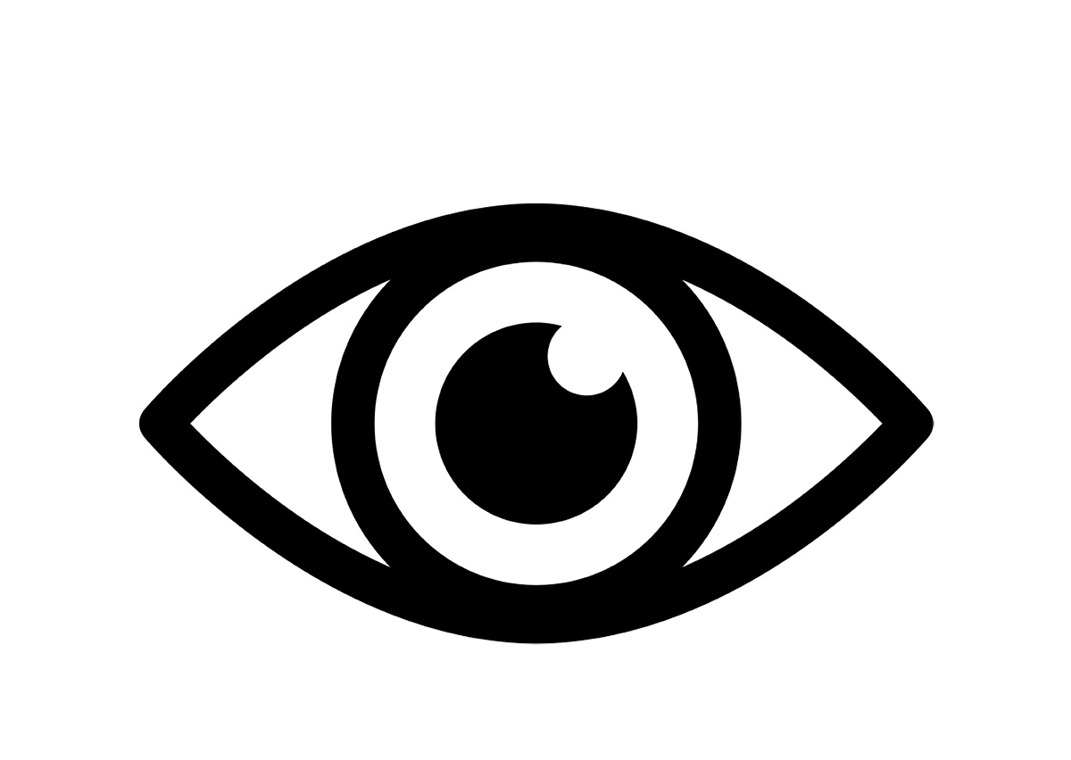
Think about what those details helped you learn. | 
Tell a partner about your details. | 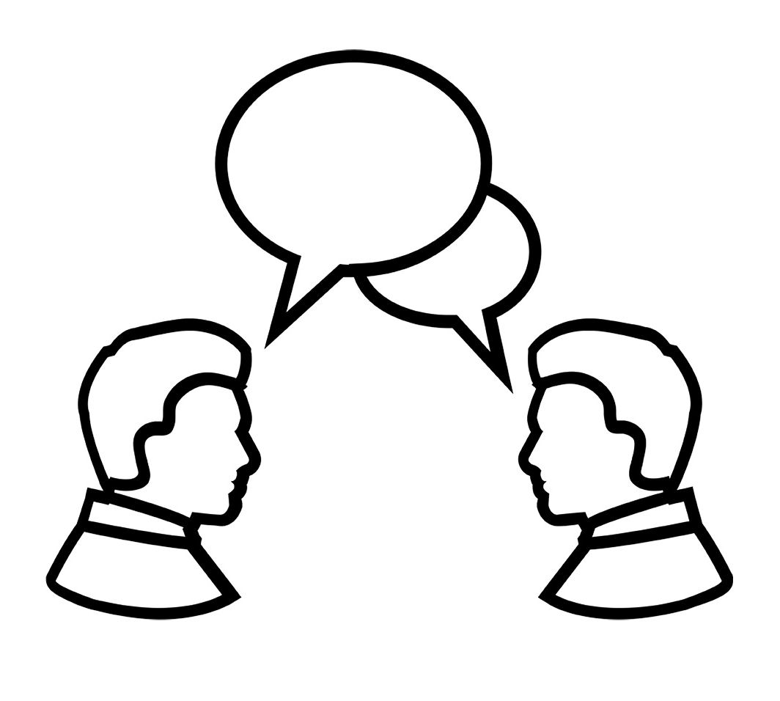
Draw and write a note about the details. | 
Beak Pictures: Teacher Model
Note to Teachers: Copy this set in color (if possible).
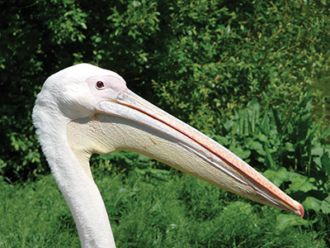 | Pelican Beak
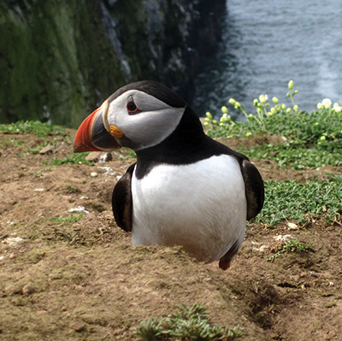 | Puffin Beak
Beak Pictures, Set 1
Note to Teachers: Copy this set in color (if possible).
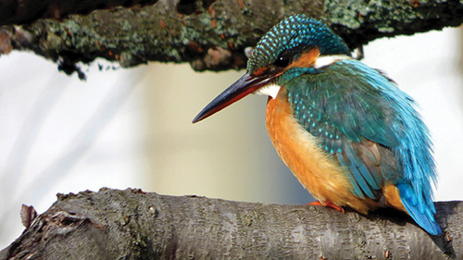 | Kingfisher Beak
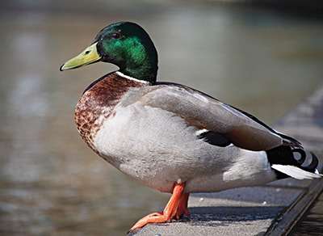 | Mallard Duck Beak
Beak Pictures, Set 2
Note to Teachers: Copy this set in color (if possible).
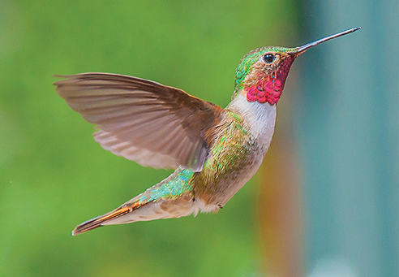 | Hummingbird Beak
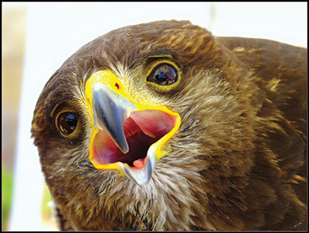 | Harris Hawk Beak
Feather Pictures, Set 1
Note to Teachers: Copy this set in color (if possible).
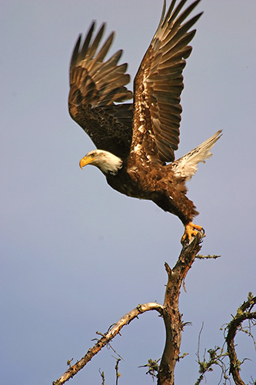 | Bald Eagle Feathers
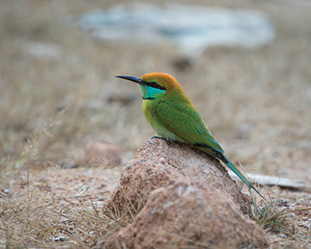 | Green  Bee Eater Feathers
Feather Pictures, Set 2
Note to Teachers: Copy this set in color (if possible).
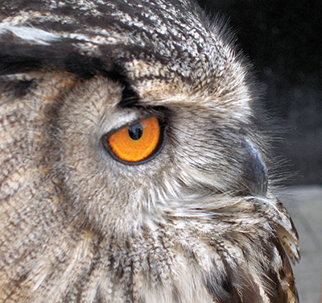 | European Eagle Owl Feathers
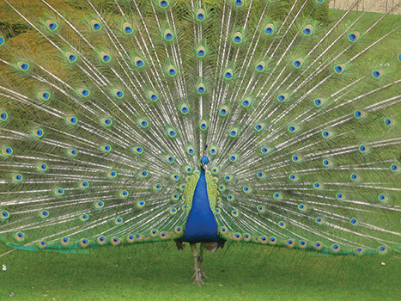 | Peacock Feathers
Birds Research Notebook, Part II - Cover Page
(Example, for Teacher Reference)
Birds Research Notebook
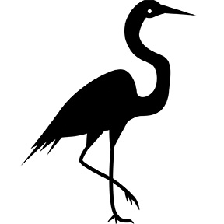
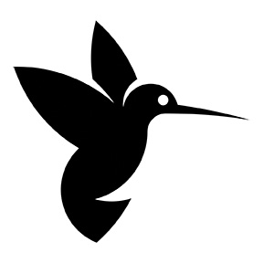

Birds Research Notebook, Part II - Page 1
(Example, for Teacher Reference)
W.1.8
Observations from Close Viewing Protocol
 | I notice | Sketch
Beaks | I notice  beaks can be large and long.
Feathers | I notice  feathers can be different colors.
Birds Research Notebook, Part II - Page 2
(Example, for Teacher Reference)
W.1.8, L.1.5g
Steps for drawing:
Trace the outline | 
Draw the outline | 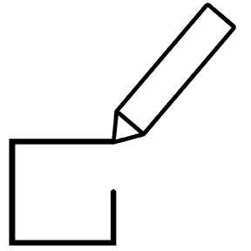
Look for details | 
Draw the details | 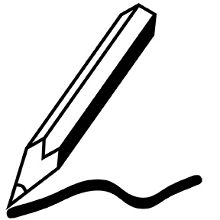
Draw a Semiplume Feather
(sketch of semiplume feather)

Some birds have semiplume feathers so
the birds can stay warm and dry.
Birds Research Notebook, Part II - Page 3
(Example, for Teacher Reference)
W.1.8, L.1.5g
Contour Feather
Create a drawing of a contour feather in the box below.
(sketch of contour feather)

Some birds have contour feathers so
they can give a bird its shape and colors.
Birds Research Notebook, Part II - Page 4
(Example, for Teacher Reference)
W.1.8, L.1.5g
Flight Feather
Create a drawing of a flight feather in the box below.
(sketch of flight feather)

Some birds have flight feathers so
they can help steer the bird and help the bird keep its balance.
Birds Research Notebook, Part II - Page 5
(Example, for Teacher Reference)
W.1.8, L.1.5g
Hummingbird Beak
Add a detailed hummingbird beak to the
silhouette below.
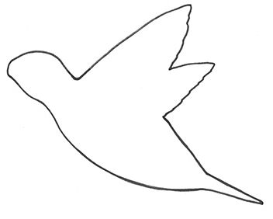
What is the purpose of the beak?
Some birds have long, curved beaks so they can drive up nectar in flowers.
Birds Research Notebook, Part II - Page 6
(Example, for Teacher Reference)
W.1.8, L.1.5g
Spoonbill Beak
Add a detailed spoonbill beak to the silhouette below.
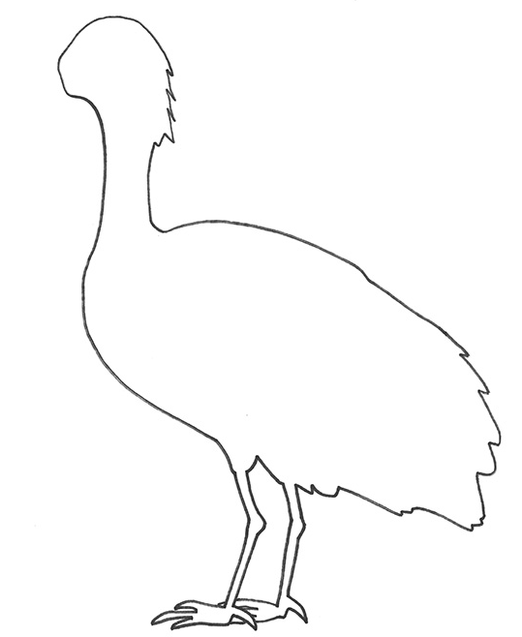
What is the purpose of the beak?
Some birds have long, curved beaks so they can drive up nectar in flowers.
Birds Research Notebook, Part II - Page 7
(Example, for Teacher Reference)
W.1.8, L.1.5g
Heron Beak
Add a detailed heron beak to the silhouette below.
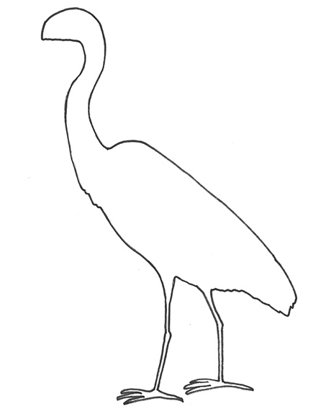
What is the purpose of the beak?
Some birds have pointy, stabbing beaks so they can stab their beak into the water to catch their prey.
Birds Research Notebook, Part II - Page 8
(Example, for Teacher Reference)
W.1.8
Refer to the Unit 2 Learning Plan anchor chart.
What is my personal goal?
Answers will vary

Birds Research Notebook, Part II - Page 9
(Example, for Teacher Reference)
W.1.8
Beaks That Crush Challenge
Tool | Number of Seeds Cracked
Pliers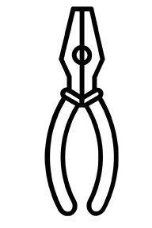
Tweezers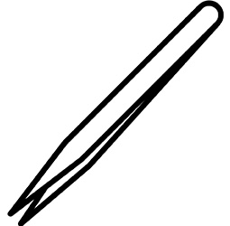
Pasta Server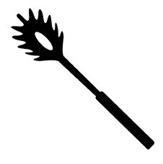
I think the best tool for crushing seeds was
the pliers because
they helped get the seed out the best.
Birds Research Notebook, Part II - Page 10
(Example, for Teacher Reference)
W.1.8
Beaks That Scoop Challenge
Tool | Number of “Fish” Scooped
Pliers
Tweezers
Pasta Server
I think the best tool for scooping fish was
the pasta server because
it helped scoop the fish out the best.
Birds Research Notebook, Part II - Page 11
(Example, for Teacher Reference)
W.1.8
Beaks That Dig Challenge
Tool | Number of Worms Dug Out
Pliers
Tweezers
Pasta Server
I think the best tool to dig for worms was
the tweezers because
they helped dig out the worms the best.
Observations about Beaks and Feathers
Anchor Chart
(Example, for Teacher Reference)
SL.1.2
Unit guiding question: How do birds use their body parts to survive?
We observe that  beaks and feathers ... | We wonder if  beaks and feathers ...
Birds Research Notebook, Part II - Cover Page
Name: ___________________________ Date: _____________
Birds Research Notebook, Part II - Page 1
W.1.8
Observations from Close Viewing Protocol
 | I notice | Sketch
Beaks | I notice ________  ____________________________________________________________
Feathers | I notice ________  ____________________________________________________________
Birds Research Notebook, Part II - Page 2
W.1.8, L.1.5g
Steps for drawing:
Trace the outline
Draw the outline
Look for details
Draw the details
Draw a Semiplume Feather

Some birds have semiplume feathers so ______________
______________________________________________________________________________________________
Birds Research Notebook, Part II - Page 3
W.1.8, L.1.5g
Contour Feather
Create a drawing of a contour feather in the box below.
Some birds have contour feathers so ______________
______________________________________________________________________________________________
Birds Research Notebook, Part II - Page 4
W.1.8, L.1.5g
Flight Feather
Create a drawing of a flight feather in the box below.
Some birds have flight feathers so ______________
______________________________________________________________________________________________
Birds Research Notebook, Part II - Page 5
W.1.8, L.1.5g
Hummingbird Beak
Add a detailed hummingbird beak to the
silhouette below.
What is the purpose of the beak?
______________________________________________________________________________________________
Birds Research Notebook, Part II - Page 6
W.1.8, L.1.5g
Spoonbill Beak
Add a detailed spoonbill beak to the silhouette below.
What is the purpose of the beak?
______________________________________________________________________________________________
Birds Research Notebook, Part II - Page 7
W.1.8, L.1.5g
Heron Beak
Add a detailed heron beak to the silhouette below.
What is the purpose of the beak?
______________________________________________________________________________________________
Birds Research Notebook, Part II - Page 8
W.1.8
Refer to the Unit 2 Learning Plan anchor chart.
What is my personal goal?
______________________________________________________________________________________________
______________________________________________________________________________________________

Birds Research Notebook, Part II - Page 9
W.1.8
Beaks That Crush Challenge
Tool | Number of Seeds Cracked
Pliers
Tweezers
Pasta Server
I think the best tool for crushing seeds was
the ___________________ because _________________
______________________________________________________________________________________________
Birds Research Notebook, Part II - Page 10
W.1.8
Beaks That Scoop Challenge
Tool | Number of “Fish” Scooped
Pliers
Tweezers
Pasta Server
I think the best tool for scooping fish was
the ___________________ because _________________
______________________________________________________________________________________________
Birds Research Notebook, Part II - Page 11
W.1.8
Beaks That Dig Challenge
Tool | Number of Worms Dug Out
Pliers
Tweezers
Pasta Server
I think the best tool to dig for worms was

the ___________________ because _________________
______________________________________________________________________________________________
Image Credits
gssavage. “Pelican.” Photograph. Flickr. 31 May 2008. Web.
Britton, Matthew. “puffin.” Photograph. Flickr. 2 June 2012. Web.
coniferconifer. “Kingfisher close up.” Photograph. Flickr. 25 Jan 2015. Web.
Oliver, Gordon. “Mallard Drake.” Photograph. Flickr. 27 March 2016. Web.
CintheaFox. “Hummingbird of Silver Plume.” Photograph. Flickr. 13 Oct 2013. Web.
Borg, Michael. “Harris Hawk close up.” Photograph. Flickr. 26 May 2012. Web.
USFWS Midwest. “Bald Eagle.” Photograph. Flickr. 4 June 2006. Web.
Thompson, Jason. “Green Bee-Eater.” Photograph. Flickr. 31 Jan 2013. Web.
Haslam, John. “Eye of the Hunter.” Photograph. Flickr. 22 June 2007. Web.
V. “Peacock.” Photograph. Flickr. 25 May 2009. Web.
Illustration by Anna Loring for EL Education.

