MODULE LESSONS
Kindergarten: Module 3: Unit 2: Lesson 8
Speaking, Listening, and Writing: Preparing to Write about How Animals Depend on Trees
Language Arts Curriculum

“We Depend on Trees” Version 1
L.K.5d

Note to Teachers: Create a class copy on chart paper.

We Depend on Trees
(to the tune of “The Farmer and the Dell”)
We depend on trees. We depend on trees.
We eat fruits, and nuts, and chocolates.
We depend on trees.
Caterpillars depend on trees. Caterpillars depend on trees.
They munch on leaves just as they please.
Caterpillars depend on trees.
Deer depend on trees. Deer depend on trees.
They feed on bark in day or dark.
Deer depend on trees.
Squirrels depend on trees. Squirrels depend on trees.
They scarf down seeds and nuts with ease.
Squirrels depend on trees.
Birds depend on trees. Birds depend on trees.
They fly in line to eat and dine.
Birds depend on trees.

Written by EL Education. 150L
Charades Animal Cards
Note to Teachers: Copy onto cardstock, cut out each card, and distribute to students for use in Work Time A.

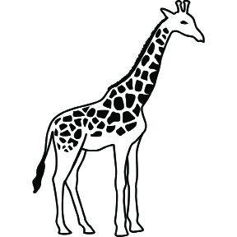 | 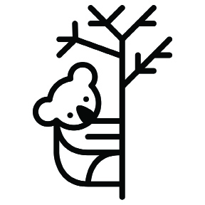 | 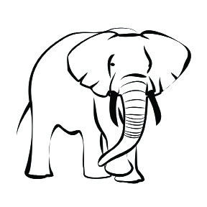
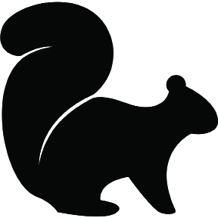 | 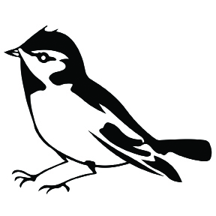 | 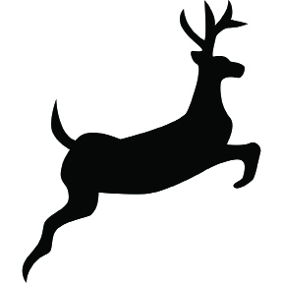
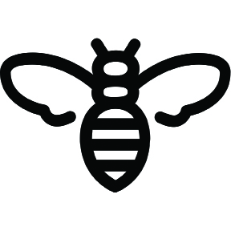 | 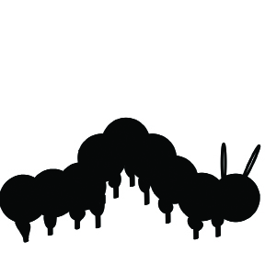 | 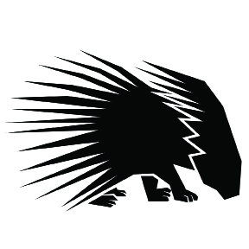
Charades Food Cards
Note to Teachers: Copy onto cardstock and cut out each card.

  leaves | leaves | leaves | leaves
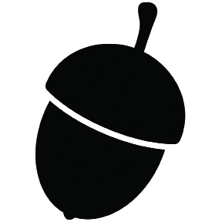  nuts |   flowers | 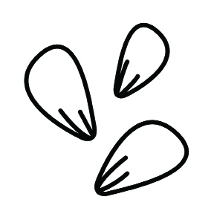  seeds | 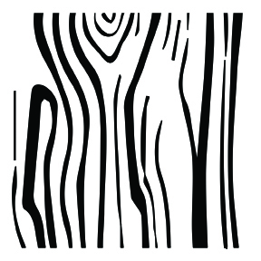  bark
leaves | leaves | leaves | leaves
nuts | flowers | seeds | bark
Animals, Trees, and Food: Student Notes
(Example, for Teacher Reference)

Animal | Verb: “to eat” | Food
koalas | eat | leaves  from trees
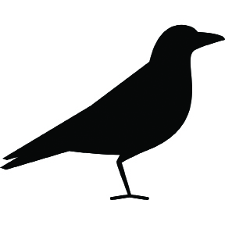  birds | eat | seeds  from trees
caterpillars | eat | leaves  from trees
Animals, Trees, and Food: Student Notes
Name: ___________________________ Date: _____________
Animal | Verb: “to eat” | Food
__________________ | eat | __________________  from trees
__________________ | eat | __________________  from trees
__________________ | eat | __________________  from trees
Animals, Trees, and Food: Symbols
Note to Teachers: These symbols are intentionally out of order. Copy and precut these symbols into strips for students to cut and paste into their individual note-catchers.

Animal | Food from Trees

Animal | Food from Trees

Animal | Food from Trees

