MODULE LESSONS
Grade K: Module 3: Unit 2: Lesson 1
Reading, Speaking, and Listening: Discovering the Unit 2 Guiding Question
Language Arts Curriculum
Mystery Photos
Note to Teachers: Copy onto cardstock and cut out, at least one image per student.
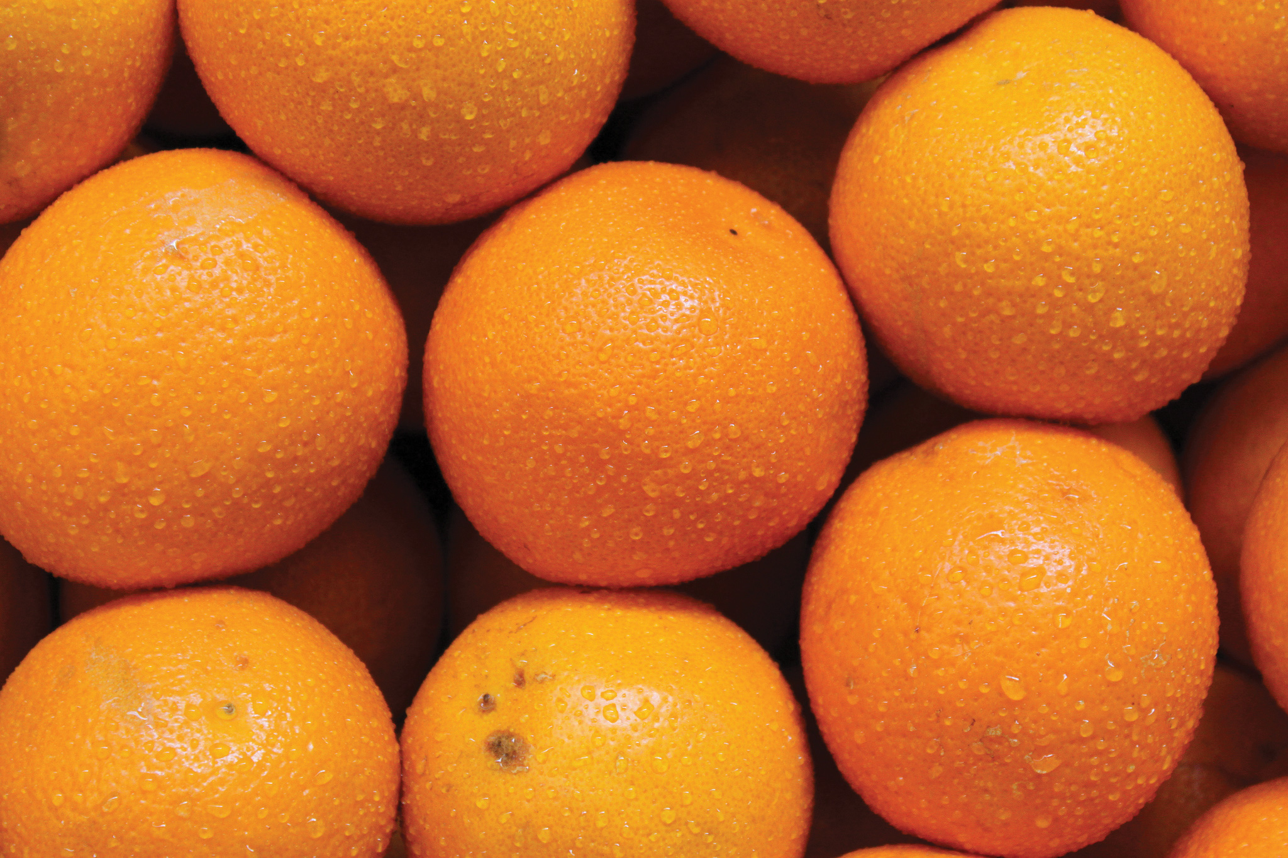 | 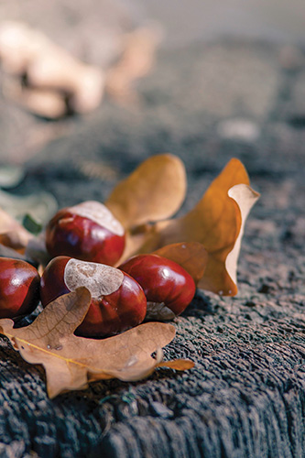
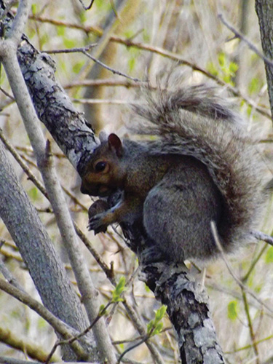 | 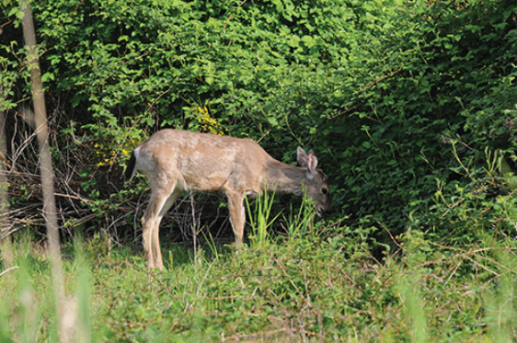
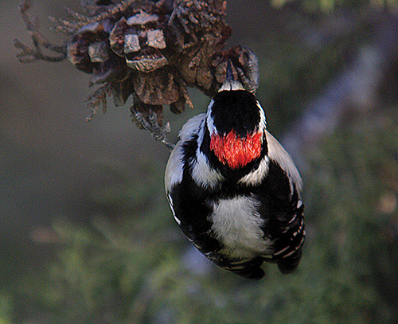 | 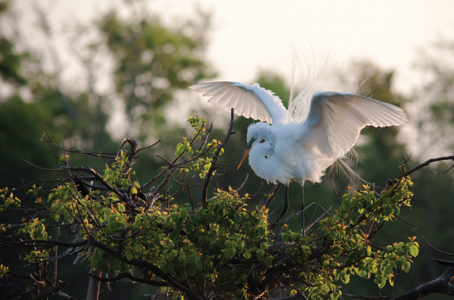

Collaboration Anchor Chart
I collaborate with my classmates. This means …
I listen to others. | 
I work well with others to get something done. | 
I share materials. | 
I share my ideas with others. | 

Unit 2 Guiding Question Anchor Chart
Note to Teachers: This anchor chart will be kept throughout the unit and added to with information from Be a Friend to Trees. Students’ answers may vary slightly.
Unit 2 guiding question:
How do living things depend on trees to meet their needs?
Trees provide ... | Living things depend on trees for ... | Picture:

Image Credits
Dious. “Oranges.” Photograph. Flickr. 3 Dec 2012. Web.
Cristian, Militaru Alin. “autum arrangement.” Photograph. Flickr. 19 Sept 2015. Web.
Whelan, David. “Grey Squirrel and Nut.” Photograph. Flickr. 9 May 2014. Web.
Coetzee, D. “Deer foraging profile 5.” Photograph. Flickr. 16 May 2009. Web.
Schmierer, Alan. “WOODPECKER, DOWNY (1-7-07) morro bay, slo co, ca.” Photograph. Flickr. 7 Jan 2007. Web.
Ketchum, Bobby. “High Island.” Photograph. Flickr. 11 April 2010. Web.

