MODULE LESSONS
Kindergarten: Module 3: Unit 2: Lesson 1
Reading, Speaking, and Listening: Discovering the Unit 2 Guiding Question
Language Arts Curriculum

Mystery Photos
Note to Teachers: Copy onto cardstock and cut out, at least one image per student.

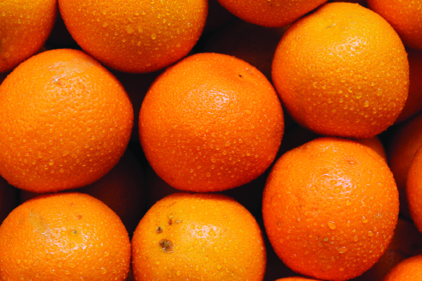 | 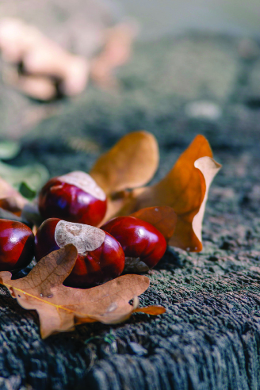
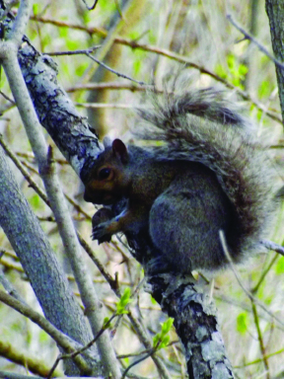 | 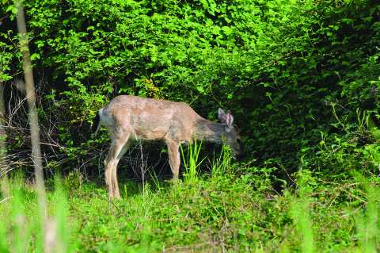
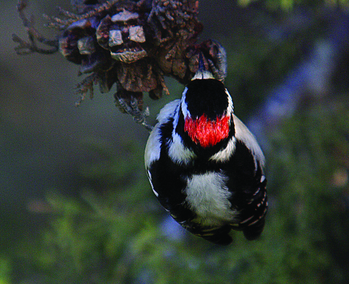 | 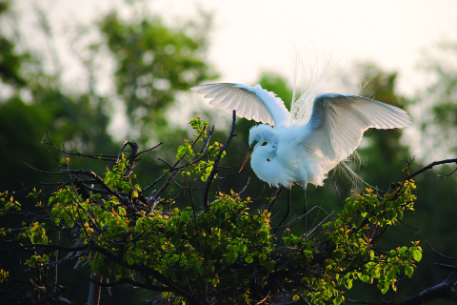
Collaboration Anchor Chart
I collaborate with my classmates. This means …

I listen to others. | 
I work well with others to get something done. | 
I share materials. | 
I share my ideas with others. | 
Unit 2 Guiding Question Anchor Chart
Note to Teachers: This anchor chart will be kept throughout the unit and added to with information from Be a Friend to Trees. Students’ answers may vary slightly.
Unit 2 guiding question:
How do living things depend on trees to meet their needs?

Trees  provide ... | Living things depend on trees for ... | Picture

Image Credits
Page 2. Dious. “Oranges.” Photograph. Flickr. 3 Dec 2012. Web.
Page 2. Cristian, Militaru Alin. “autum arrangement.” Photograph. Flickr. 19 Sept 2015. Web.
Page 2. Whelan, David. “Grey Squirrel and Nut.” Photograph. Flickr. 9 May 2014. Web.
Page 2. Coetzee, D. “Deer foraging profile 5.” Photograph. Flickr. 16 May 2009. Web.
Page 2. Schmierer, Alan. “WOODPECKER, DOWNY (1-7-07) morro bay, slo co, ca.” Photograph. Flickr. 7 Jan 2007. Web.
Page 2. Ketchum, Bobby. “High Island.” Photograph. Flickr. 11 April 2010. Web.

