MODULE LESSONS
Kindergarten: Module 3: Unit 1: Lesson 7
Reading and Writing: Unit 1 Assessment, Part I and Preparing for a Science Talk
Language Arts Curriculum

Interactive Word Wall Cards
Note to Teachers: Copy onto cardstock, cut out, and make sets. Provide one set of cards per small group.

living | nonliving
growing | leaves
roots | wilt
seedling | breathe
air | water
Arrow Cards
Note to Teachers: Copy onto cardstock, cut out, and make sets. Provide one set of arrow cards per pair.


Plant Diagram

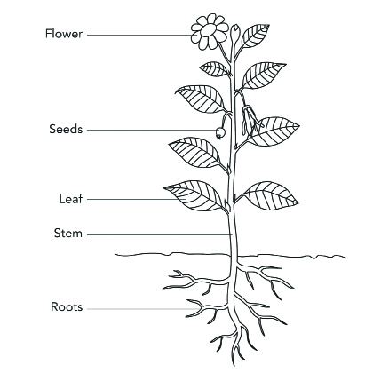
Tree Diagram

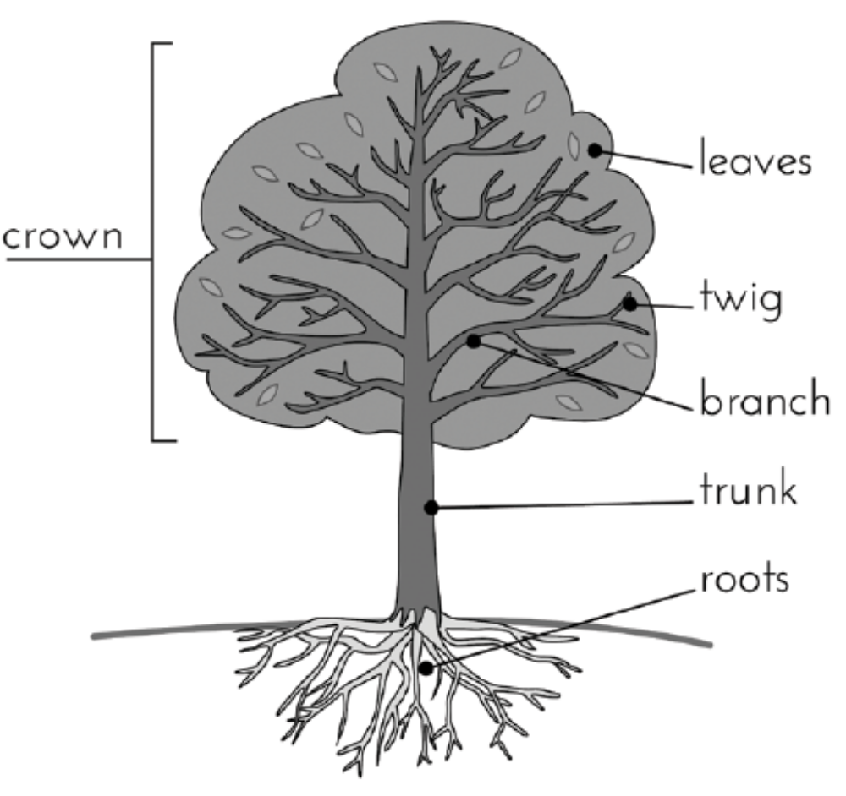
Is a Tree Living? Note-catcher
(Example, for Teacher Reference)
W.K.8
Is a Tree Living? How Do You Know?
ASK: | Yes | No | Sketch how you know
Does it need food?   |  |  | Sketch of soil and roots  Labels to show roots take in food
Does it need water?   |  |  | Sketch of water coming up through roots
Does it need air?   |  |  | Sketch of leaves giving off air or bubbles
Can it grow or move by itself?   |  |  | Sketch of tree growing toward sun
 | It is living. | It is nonliving.

A tree is (living/nonliving) because it needs wter and air. It muves and growz twrd the sun.
Is a Tree Living? Note-catcher
Name: _________________________ Date: _______________
W.K.8
Is a Tree Living? How Do You Know?

ASK: | Yes | No | Sketch how you know
Does it need food?
Does it need water?
Does it need air?
Can it grow or move by itself?
 | It is living. | It is nonliving.

A tree is (living/nonliving) because _________________________

With guidance and support from adults, recall information from experiences or gather information from provided sources to answer a question.
Shared Writing: Patterns with Living Things
(For Teacher Reference)
Note to Teachers: Create this template on chart paper.

We have observed, read about, and written and drawn about living things and learned what makes something a living thing.

Living things
.

Living things
.

Living things .

The pattern we see is that
.
.
Shared Writing: Patterns with Living Things
(Example, for Teacher Reference)

We have observed, read about, and written and drawn about living things and learned what makes something a living thing. Living things take in food and water. Living things take in and need air. Living things can move and grow on their own. The pattern we see is that all living things need the same things.
Image Credits
Page 4. Siyavula Education. “Plant parts.” Illustration. Flickr. 2 April 2014. Web.
Page 5. Illustration by Stacey Posnett for EL Education.

