MODULE LESSONS
Kindergarten: Module 3: Unit 1: Lesson 4
Reading and Writing to Research: Living Things Need Air
Language Arts Curriculum

“What’s Alive and What’s Not?”
Version 2
(For Teacher Reference)
L.K.1c
Note to Teachers: Copy the text of this poem on chart paper.

What’s Alive and What’s Not?

I was playing with my truck in the park by a tree
When a line of tiny ants marched right in front of me.
I watched them moving all around
As I rolled my truck along the ground.
“Are they alive?” I wondered. How do I know?
I’m alive—I eat, drink, breathe, and grow!
What about the ___________ or those ___________?
Or even the ___________, the ___________, or the ___________?
They don’t move like my truck or like me!
I sat down with my truck and thought,
“How can I tell what’s alive and what’s not?”

Created by Anne Simpson for EL Education.
“What’s Alive and What’s Not”
Verse 4 Template
L.K.1c

What about the ____________________ or those ____________________?
Or even the __________________, the __________________,
or the ____________________?
They don’t move like my truck or like me!
“What’s Alive and What’s Not?” Noun Cards
L.K.1c

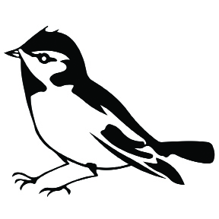  bird | 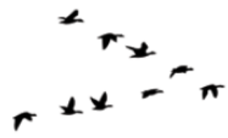  birds
  bench | 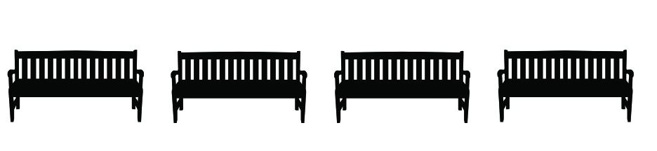  benches
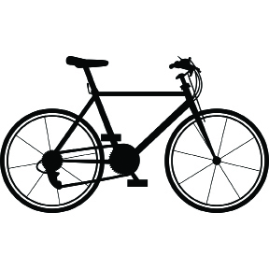  bike | 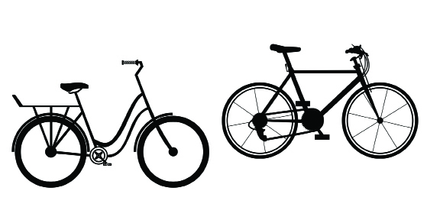  bikes
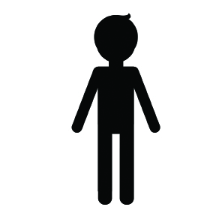  kid | 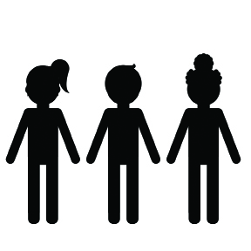  kids
  flower |   flowers
  bus |   buses
Whales! Photograph

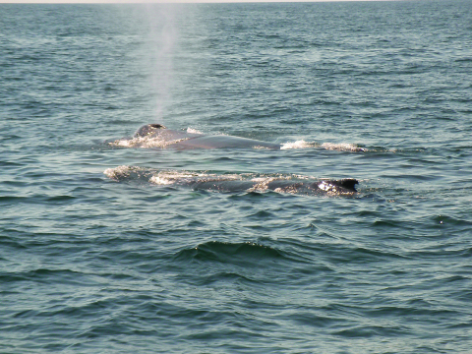
Alligator Photograph

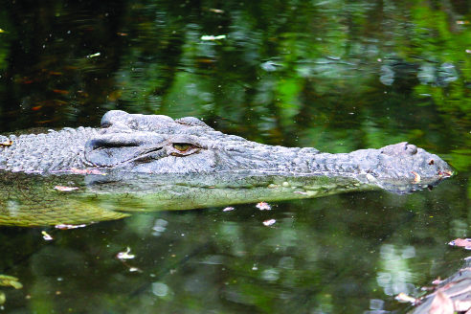
For ELLs: Language Dive Guide II:
What’s Alive?
Notes | Modifications from Modules 1 and 2:  - In addition to teacher-led questions and answers as in Modules 1 and 2, there are suggested language goals that students should try to understand and apply for each chunk. (Consider referring to the range of questions students might ask one another in Questions We Can Ask During a Language Dive in the Module 1 Appendix.)  - This format attempts to encourage students to take more of the lead in the conversation and to build greater independence by taking an inquiry-based approach to language in general, and the selected sentence in particular.  - This format provides greater freedom to choose how to help students understand the suggested language goals.  - Continue to employ a number of approaches to enable students to understand these goals, including grappling, displaying a list of the language goals for students to consider, asking questions and using Conversation Cues, or a combination of these approaches. At the same time, draw on your understanding and experience of Language Dives from Modules 1 and 2 as you work with the new format.
Sentence | - If you look at the underside of a leaf with a magnifying glass, you will see tiny holes. (from page 18 of What’s Alive? by Kathleen Weidner Zoehfeld)
Language Learning Target | - I can understand and practice using if to talk about two things that must happen together.  - I can understand and practice using the English language to tell how I know something is alive.
Rationale | - This sentence was chosen for its complexity and connection to the guiding question. It is complex because it has a conditional clause, and it is compelling because it uses a compound word and because it helps students understand that plants breathe—a concept that is not obvious but is a criterion for plants to meet the patterns of living things.  - Invite students to discuss each chunk briefly but encourage extended conversation and practice with the focus structure If you look at the underside of a leaf. Note that the chunk you will see is presented out of order to establish the subject and main clause of the sentence. Students will apply their understanding of the meaning and structure of this sentence when making observations about plants during the Science Talk protocol and when preparing to write in the research notebook.
Time | 10 minutes
Throughout the Language Dive | - When referring to a chunk on display, point to it or invite students to place their finger by the same chunk.  - Record and display student discussion next to or underneath each chunk on display for visual reference.
Deconstruct | Use the Sentence Strip Chunks.  - Whole group: display all chunks, sequenced as a sentence. Read aloud the sentence twice; students read aloud the sentence with a partner.  - Whole group: students briefly grapple with the meaning of the sentence and connection to the guiding question or big idea.  - Whole group: consider pre-teaching one or two key vocabulary words.  - Whole group or small group: display each chunk, chunk by chunk. Students briefly grapple with the meaning of each chunk. Use the Chunk Chart to guide student grappling.  - As students discuss the focus structure, be sure they slow down for extended conversation and practice of the focus structure. See suggested questions and Conversation Cues (underlined) in the chunk chart.  - To provide lighter support: Display one or more of the key suggested language goals provided in the chunk chart, or an adaptation of it, to prompt student grappling.  - To provide heavier support: Consider using visuals or realia to help convey meaning. Use the suggested language goals provided in the chunk chart to pose questions requiring careful consideration. Monitor with total participation techniques and Conversation Cues. Provide think time and invite partners to discuss in English or in home language groups.
Practice  (focus structure) | - Small group: students play with the focus structure using the suggestions in the chunk chart. Refer to the Chunk Chart for specific Practice suggestions on this sentence.
Reconstruct | - Whole group: consider scrambling the chunks. Several students each take a chunk and display it in front of the class, thinking aloud to rearrange themselves to reconstruct the sentence. To provide lighter support, consider also completing this step at the beginning of the Language Dive.  - Whole group: students reconstruct the meaning of sentence and connection to guiding question, big idea, learning target. Refer to the Chunk Chart for specific Reconstruct suggestions on this sentence.
Practice  (Sentence) | - Whole group: students synthesize and play with the sentence. Refer to the Chunk Chart for specific Practice suggestions on this sentence.
Language Dive Chunk Chart II:
What’s Alive?
you will see
Deconstruct: Language Goals | - you: “Who is this sentence about?” You, the reader. you could be referring to one person or more than one person. (plural and singular noun/pronoun)  - will see: “What will the reader do?” The reader is going to see something. (future modal verb)  - Students can put their hands around their eyes like they are using binoculars to mime seeing something.
tiny holes.
Deconstruct: Language Goals | - “What will you see?” Very small holes or little dots. (noun phrase; direct object)  - Show or sketch what tiny holes look like.  - “Why did the author use a period?” to tell the reader it is the end of a sentence. Together the first two chunks form a complete idea. This is a complete sentence on its own, but the author has included more information. Where and how are still unknown. (independent clause)
If you look at the underside of a leaf
Deconstruct: Language Goals | - “How will you see tiny holes?” You have to look under a leaf. (subordinate clause; conditional clause)  - “Why did the author use if?” to tell us that something has to happen first before another thing happens; to tell what has to happen before we can see tiny holes. (subordinating conjunction)  - “The word underside has two words inside it. What are they? How do they help us understand this chunk?” under and side; they tell us where to look on the leaf.  - “How do we look at the underside of something?” (turn it over, look underneath)  - “What if we replaced the underside of a leaf with a leaf’s underside? How would that change its meaning?” It would mean the same thing because the underside belongs to the leaf. (possessive)  - “What if we remove the underside of from this chunk? How would that change its meaning?” (We’d just look at a leaf; we wouldn’t know specifically where to look on the leaf for the tiny holes.)  - Students can show a partner the underside of something. (hands, shoes)
with a magnifying glass,
Deconstruct | - “How can you see the tiny holes on the underside of the leaf?” with a magnifying glass, or tool that makes very small things look bigger. (prepositional phrase)  - “What if we removed magnifying? How would that change the meaning of the chunk?” We wouldn’t know what kind of glass to use; it would seem like we could use any glass. (adjective)  - Students can make a motion with theirs hands and arms to show getting bigger and bigger.
If you look at the underside of a leaf
Practice (Focus Structure) | - If you look at ________, you will see ________. (If you look at the rug, you will see lots of colors.)  - To provide lighter support: If you look at the underside of ________, you will see ________. (If you look at the underside of the rug, you will see dirt from the floor.)  - To provide heavier support: Provide a word/phrase bank for students to use when completing the sentence frame.
If you look at the underside of a leaf with a magnifying glass, you will see tiny holes.
Reconstruct | - “How can you say this sentence in your own words?” If you look at the bottom of a leaf you will see little holes.  - “How does this Language Dive add to your understanding of the guiding question?” It tells one way you can tell that leaves are alive: they breathe through tiny holes.  - Distribute the Language Dive Chunk Pictures II: What’s Alive?. Tell students they will place them in the correct order of the sentence. Then, they will tell a partner what is happening in the picture frames using the words from the sentence.  - Students can each hold a chunk and switch places to show the sentence in a different, correct order.
Practice (Whole Sentence) | - Display the two clauses (If you look at the underside of a leaf with a magnifying glass, and you will see tiny holes.). Ask: “We looked at the sentence in a different order than the author wrote it. Did that change its meaning? Why or why not?” (No, it still makes sense and tells the same information whether “you will see tiny holes” is first or last.)  - Act out the sentence with the students.  - Language Chunk Wall suggestions:  - Verbs and verb phrases (actions, states of being):  you will see  - Adjectives and language to describe: tiny holes.  - Language to talk about using something (e.g., prepositions):  with a magnifying glass  - Language to talk about conditional situations: If you look at the underside of a leaf
For ELLs: Language Dive Sentence Strip Chunks II: What’s Alive?

you will see
tiny holes
If you look at the underside of a leaf
with a magnifying glass,
For ELLs: Language Dive Chunk Pictures II:
What’s Alive?

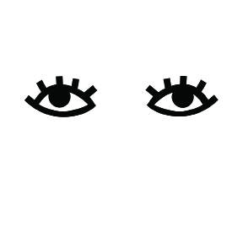 | 

 | 

Image Credits
Page 5. Noah. “Whales!” Photograph. Flickr. 29 Aug 2006. Web.
Page 6. Koefender, Julia. “Alligator.” Photograph. Flickr. 11 March 2012. Web.

