MODULE LESSONS
Kindergarten: Module 3: Unit 1: Lesson 3
Reading and Writing to Research: Living Things Need Food and Water
Language Arts Curriculum

Singular and Plural Nouns Anchor Chart
(Example, for Teacher Reference)
L.K.1c
Singular and Plural Nouns

Singular: one | Plural: many
Truck    Ant  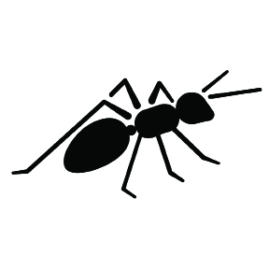  Park    Swing   | Trucks    Ants  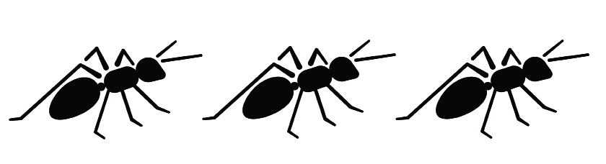  Parks    Swings  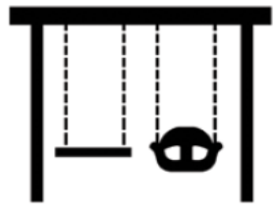
Bee    Plant    Tree   | Bees    Plants    Trees  
Singular and Plural Nouns Anchor Chart
L.K.1c
Note to Teachers: Create this anchor chart on chart paper for easy display. As students discover different singular and plural nouns in the poem, add them to
the chart.
Singular and Plural Nouns

Singular: one | Plural: many
Singular and Plural Noun Cards
L.K.1c

Truck | Trucks
Ant | Ants
Park | Parks
Swing | Swings
Bee | Bees
Plant   | Plants
Tree | Trees
Living Things Criteria Anchor Chart
(Example, for Teacher Reference)
RI.K.1, RI.K.2, RI.K.3
Note to Teachers: Create this on large chart paper for display.
Living Things Criteria:
How do we know that something is alive?

ASK: | Yes | No
Does it need food?

Does it need water?

Does it need air?

Can it grow or move by itself?

 | It is living. | It is nonliving.
Language Dive Guide I:
What’s Alive?
(For Teacher Reference)
Notes | Modifications from Modules 1 and 2:  - In addition to teacher-led questions and answers as in Modules 1 and 2, there are suggested language goals that students should try to understand and apply for each chunk. (Consider referring to the range of questions students might ask one another in Questions We Can Ask During a Language Dive in the Module 1 Appendix.)  - This format attempts to encourage students to take more of the lead in the conversation and to build greater independence by taking an inquiry-based approach to language in general, and the selected sentence in particular.  - This format provides greater freedom to choose how to help students understand the suggested language goals.  - Continue to employ a number of approaches to enable students to understand these goals, including grappling, displaying a list of the language goals for students to consider, asking questions and using Conversation Cues, or a combination of these approaches. At the same time, draw on your understanding and experience of Language Dives from Modules 1 and 2 as you work with the new format.
Sentence | “As the kitten grows bigger, it begins to lap up water and nibble on food from a bowl.” (from page 13 of What’s Alive? by Kathleen Weidner Zoehfeld)
Language Learning Target | - I can understand and practice using as to talk about different things that happen at the same time.  - I can understand and practice using the English language to tell how I know something is alive.
Rationale | This sentence is compelling and complex because it uses an adverbial subordinate clause and because it helps students understand the criteria of living things being discussed throughout the unit. Invite students to discuss each chunk briefly but encourage extended conversation and practice with the highlighted focus structure As the kitten grows bigger,. Students will apply their understanding of the meaning and structure of this sentence when writing in Work Time C.
Time | 10 minutes
Throughout the Language Dive | - When referring to a chunk on display, point to it or invite students to place their finger by the same chunk.  - Record and display student discussion next to or underneath each chunk on display for visual reference.
Deconstruct | Use the Sentence Strip Chunks.  - Whole group: display all chunks, sequenced as a sentence. Read aloud the sentence twice; students read aloud the sentence with a partner.  - Whole group: students briefly grapple with the meaning of the sentence and connection to the guiding question or big idea.  - Whole group: consider pre-teaching one or two key vocabulary words.  - Whole group or small group: display each chunk, chunk by chunk. Students briefly grapple with the meaning of each chunk. Use the Chunk Chart to guide student grappling.  - As students discuss the focus structure, be sure they slow down for extended conversation and practice of the focus structure. See suggested questions and Conversation Cues (underlined) in the chunk chart.  - To provide lighter support: Display one or more of the key suggested language goals provided in the chunk chart, or an adaptation of it, to prompt student grappling.  - To provide heavier support: Consider using visuals or realia to help convey meaning. Use the suggested language goals provided in the chunk chart to pose questions requiring careful consideration. Monitor with total participation techniques and Conversation Cues. Provide think time and invite partners to discuss in English or in home language groups.
Practice  (Focus Structure) | - Small group: students play with the focus structure using the suggestions in the chunk chart. Refer to the Chunk Chart for specific Practice suggestions on this sentence.
Reconstruct | - Whole group: consider scrambling the chunks. Several students each take a chunk and display it in front of the class, thinking aloud to rearrange themselves to reconstruct the sentence. To provide lighter support, consider also completing this step at the beginning of the Language Dive.  - Whole group: students reconstruct the meaning of sentence and connection to guiding question, big idea, learning target. Refer to the Chunk Chart for specific Reconstruct suggestions on this sentence.
Practice  (Sentence) | - Whole group: students synthesize and play with the sentence. Refer to the Chunk Chart for specific Practice suggestions on this sentence.
Language Dive Chunk Chart I:
What’s Alive?
(For Teacher Reference)
As the kitten grows bigger,
Deconstruct: Language goals | - “Who or what is this chunk about?” the kitten (subject/singular noun)  - “What does the kitten do?” It grows; it gets bigger. (verb)  - “How does the kitten grow?” bigger (adverb)  - “Why does the author use the word as?” as tells us that something else is happening at the same time; connects the who parts of the sentence (subordinating conjunction)  - Students can make themselves small and meow like a kitten and then grow bigger into cats.
it begins to lap up water
Deconstruct: Language Goals | - “What does the kitten do as it grows bigger?” It starts to drink water. (independent clause)  - To lap up water: “What does this phrase tell us?” tells us what the kitten begins to do; uses its tongue to pick up and drink water. (infinitive phrase)  - Students can use their tongues and hands cupped to imitate lapping up water.
and
Deconstruct: Language Goals | - “Why does the author use and?” and is a linking word that signals there is additional information; there is something else the kitten will begin to do. (conjunction)
nibble on food
Deconstruct: Language Goals | - “What else does the kitten begin to do as it grows bigger?” take small bites of food. (verb phrase)  - Practice with the students how a kitten nibbles on something. Take your hand and show nibbling. Ask how nibble is different from lap up.
from a bowl.
Deconstruct: Language goals | - “Where does the kitten get the water and the food?” from a bowl; this chunk signals the source of the water and food. (prepositional phrase)  - Point to the bowls in the picture on Page 13 in the book. Notice aloud how instead of repeating it begins and from a bowl twice, the words from a bowl go with both food and water. Water is in one bowl, and food is in another. (elided phrase)
As the kitten grows bigger,
Practice (Focus Structure) | - As I grow bigger, ___________ [I + begin to + action word]. (As I grow bigger, I begin to read.)  - To provide lighter support: “Can you extend the sentence frame by adding and + another action word? How?” (Example: As I grow bigger, I begin to read and write sentences.)  - To provide heavier support: Provide a word/phrase bank for students to use when completing the sentence frame.
As the kitten grows bigger, it begins to lap up water and nibble on food from a bowl.
Reconstruct | - “How can you say this sentence in your own words?” (The kitten will get bigger and bigger and will start to drink and eat from a bowl.)  - “How does this Language Dive add to your understanding of the guiding question?” (It tells one way you know that the kitten is alive; it grows bigger and learns to eat and drink by itself.)  - Distribute the Language Dive Chunk Pictures I: What’s Alive?. Tell students they will place them in the correct order of the sentence. Then, they will tell a partner what is happening in the picture frames using the words from the sentence.  - Students can each hold a chunk and switch places to show the sentence in a different, correct order. (It begins to lap up water and nibble from food from a bowl as the kitten grows bigger.)
Practice (Whole Sentence) | - Act out the sentence with the students.  - Language Chunk Wall suggestions:  - Verbs and verb phrases (actions, states of being): it begins to lap up water, nibble on food  - Adverbs and adverbial phrases and clauses (describing verbs, adjectives, adverbs): As the kitten grows bigger,  - Language to connect words, phrases, clauses: and  - Language to talk about location: (prepositions) from a bowl.
Language Dive Sentence Strip Chunks I:
What’s Alive?

As the kitten grows bigger,
it begins to lap up water
and
nibble on food
from a bowl.
Language Dive Chunk Pictures I:
What’s Alive?
 | 

 | 

