MODULE LESSONS
Kindergarten: Module 3: Unit 1: Lesson 2
Reading and Writing: What Are Living and Nonliving Things?
Language Arts Curriculum

“What’s Alive and What’s Not?” Version 1
L.K.1c
Note to Teachers: Copy the text of this poem on chart paper.

What’s Alive and What’s Not?

I was playing with my truck in the park by a tree
When a line of tiny ants marched right in front of me.
I watched them moving all around
As I rolled my truck along the ground.
“Are they alive?” I wondered. How do I know?
I’m alive—I eat, drink, breathe, and grow!
What about the swings or those bees?
Or even the benches, the plants, or the trees?
They don’t move like my truck or like me!
I sat down with my truck and thought,
“How can I tell what’s alive and what’s not?”

Created by Anne Simpson for EL Education. 500L
Sorting Living and Nonliving Things
Anchor Chart
(Example, for Teacher Reference)
L.K.5a

Living | Nonliving | Not Sure Yet
 | 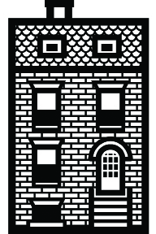 | 
Grow/Change | Doesn’t Move | Move
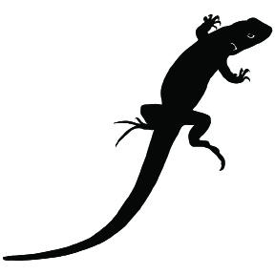 | 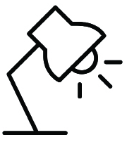 | 
Eats | Doesn’t Eat | Make Noise
Sorting Living and Nonliving Things
Anchor Chart
L.K.5a
Note to Teachers: Fill in this chart before the lesson by synthesizing the information students sorted in Lesson 1. Use blue painter’s tape to temporarily place the pictures in the categories. Place any pictures on which the class did not agree (i.e., different pairs of students placed that photo in different categories) in the Not Sure Yet category.

Living | Nonliving | Not Sure Yet
Plant Photographs
Plant 1:

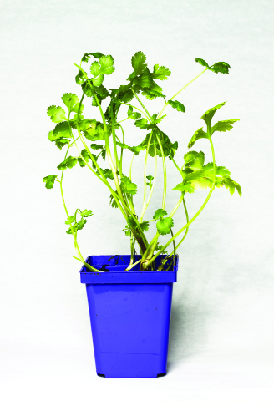
Plant Photographs
Plant 2:

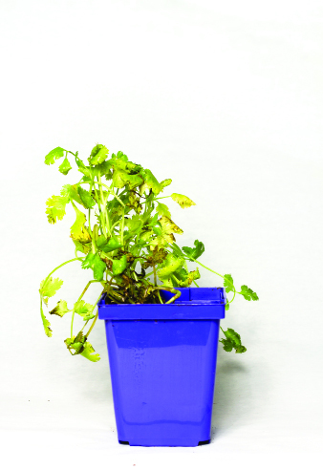
Plant Photographs
Plant 3:

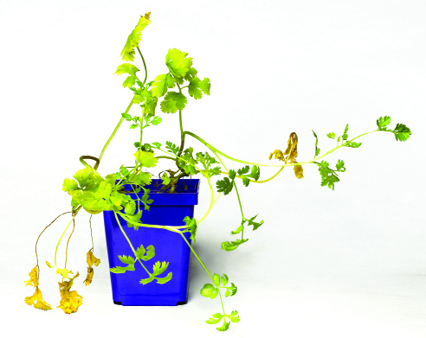
Living Things Research Notebook Cover Page
W.K.7, W.K.8
(For Teacher Reference)

Name: ______________________________________________

Living Things Research Notebook - Page 1
(Example, for Teacher Reference)
Date: 9/6/17
I observed a …
Circle one:

 |  |  | 
plant | person | animal | toy

(drawing of seedlings)

I think this plant is (living / nonliving) because we hve to gv it wtr to gro up and up.
Living Things Research Notebook - Page 2
(Example, for Teacher Reference)
Date: 9/7/17
I observed a …
Circle one:

 | 
healthy plant | unhealthy plant

(drawing of dry, wilting plant)

Living things need food and water. The plant (did / did not) get food and water. It looks dri and the lvs are foling off.
Living Things Research Notebook - Page 3
(Example, for Teacher Reference)
Date: 9/8/17
I observed a …
Circle one:

healthy plant | unhealthy plant

(drawing of healthy plant with nice, green leaves and a
sturdy stem)

Living things need air to breathe. The plant (did / did not) get air to breathe. It looks happy and ther r lots of green lvs.
Living Things Research Notebook - Page 4
(Example, for Teacher Reference)
Date: 9/9/17
I observed a …
Circle one:

plant | person | animal | toy

(drawing of a conifer branch with buds and pine needles)

Living things move and grow. The plant (did / did not) move and grow. It looks like it grows litl bals then it grows spikee needls.
Living Things Research Notebook - Page 5
(Example, for Teacher Reference)
I observed a …
Circle one:
plant | person | animal | toy
Living Things Criteria:
Is it alive? ASK: | Yes | No
Does it need food?   |  | 
Does it need water?   |  | 
Does it need air?   |  | 
Can it grow or move by itself?   |  | 
 | It is living. | It is nonliving.
Living Things Research Notebook - Page 6
(Example, for Teacher Reference)
Date: 9/12/17
I observed a …
Circle one:

plant | person | animal | toy

(drawing of toy: block, doll, matchbox car, figurine)

I think this Batman toy is (living / nonliving) because it does not need food, water, or air. It can move if I hld it.
Living Things Research Notebook Cover Page
W.K.7, W.K.8
Name: ______________________________________________
Living Things Research Notebook - Page 1
Date: ________________________
I observed a …
Circle one:
plant | person | animal | toy

I think this ________________ is (living / nonliving) because

Living Things Research Notebook - Page 2
Date: _____________________
I observed a …
Circle one:
healthy plant | unhealthy plant

Living things need food and water. The plant (did / did not)

get food and water. It looks ____________________________

___________________________________________________.
Living Things Research Notebook - Page 3
Date: __________________
I observed a …
Circle one:
healthy plant | unhealthy plant

Living things need air to breathe. The plant (did / did not)

get air to breathe. It looks _____________________________

___________________________________________________.
Living Things Research Notebook - Page 4
Date: ___________________________
I observed a …
Circle one:
plant | person | animal | toy

Living things move and grow. The plant (did / did not)

move and grow. It looks _______________________________

___________________________________________________.
Living Things Research Notebook - Page 5
Date: __________________
I observed a … Circle one:

plant | person | animal | toy
Living Things Criteria:
Is it alive? ASK: | Yes | No
Does it need food?
Does it need water?
Does it need air?
Can it grow or move by itself?
 | It is living. | It is nonliving.
Living Things Research Notebook - Page 6
Date: _________________
I observed a …
Circle one:
plant | person | animal | toy

I think this ______________________ is (living / nonliving)

because _________________________________________

__
Image Credits
Page 5-7. Photographs by Leigh Hagan for EL Education.

