Grade 4: Life Science Module
Lesson Sequence 4: Sensory Structures in Animals
Life Science Module
Scientists Do These Things Anchor Chart
(For Teacher Reference)
Scientists Do These Things anchor chart
Engaging in Argument  What’s needed for a scientific argument?  Preparing for the argument:  - Pose the question.  - Identify evidence that answers the question.  - Evaluate whether or not that evidence is sufficient to support the claim. “Is this good evidence?”  Making the argument:  - Make a claim.  I’m arguing that…  - Use the evidence and scientific reasoning to support the claim.  The evidence I have is…  This evidence shows...  - Explain why the evidence is sufficient and relevant.  This evidence is sufficient because… | Modeling  - A model has limitations because it is used to study one part of a system or object while not paying attention to other parts.  - A model can be a drawing or diagram, a physical replica, or a simulation. | Planning an Investigation:  - Pose a question that can be investigated with trials.  - Decide what can be changed (variables).  - Set up the procedure.  - Record observations.
Example:  Ecosystem and organism argument | Example:  Obtaining food simulation | Example:  Earthworm investigation
Earthworm Diagram
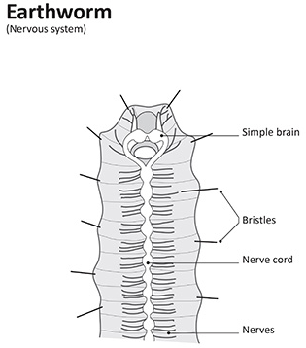

Created by Stacey Posnett for EL Education
Sensory Structures Flow Chart

Stimulus
from the environment

Structures that sense stimulus
Nervous system that makes sense of the stimulus

Response
of the animal

Memory is made
Sensory Structures Flow Chart:
Earthworm Model

Stimulus
Structures
Nervous system
Response
Memory
Poster Session Images
Directions: Print out and post these posters around the room.
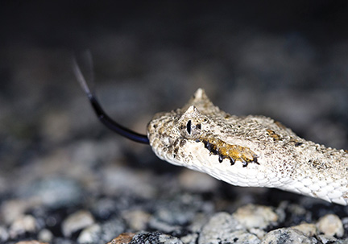
Sidewinder Snake

The snake is on the hunt! Snakes use their forked tongue to smell prey in their environment. Sidewinders are a kind of pit viper. They have small openings (a pit) on either side of their head that allow them to sense heat and strike at it. As a result, in a pitch-dark, but cool night (remember, we’re in the desert so it’s cool at night), the sidewinder can detect the body heat from a small mammal, such as a mouse, and accurately strike it.
Image from: Hannawacker, Robb. “Side-winder, Bajada, Joshua Tree National ParkCalifornia_4.” Photograph. 31 March 2015. Flickr. Web. 5 Feb 2016.
https://www.flickr.com/photos/39422575@N02/16849654778/
Raccoon
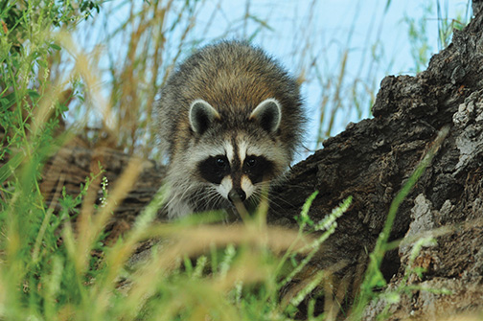
The raccoon is on the prowl! Usually raccoons are active at night, meaning they are nocturnal. They use their huge eyes to watch for predators at night and have a great sense of smell to hunt for small animals and find plants, such as nuts and berries. They use their highly sensitive paws to catch frogs, crayfish, or other critters in the water for a tasty dinner.
Image from: USFWS Mountain-Prairie. “On the Prowl.” Photograph. 3 Aug 2010. Flickr. Web. 5 Feb 2016.
https://www.flickr.com/photos/usfwsmtnprairie/15112936014/
Bald Eagle
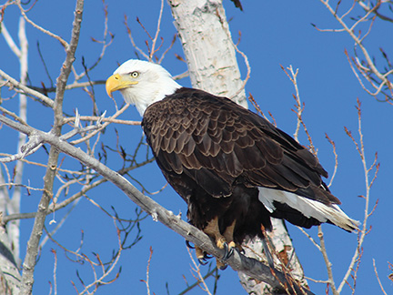
Have you ever wondered how an eagle high up in a tree can see a fish in the water? Eagles have excellent vision. They can see up to four times as well as you can! They also are able to see more colors and more shades than you can, and they can even see ultraviolet light. They use their ability to move one eye at a time to see almost all the way around them without moving their head. When the eagle senses a fish, it will swoop down from above at fast speeds and grab it with its claws.
US Forest Service. “Eagle in Early Spring.” Flickr. 27 February 2013.
https://www.flickr.com/photos/107640324@N05/11656090643/
Coyote
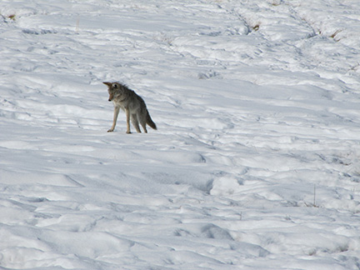
Coyotes do not hibernate, and need to eat all year long. However, their prey, mice, live under the snow all year long. How does a coyote catch the mice, then? It can’t see it! This coyote listens intently as it detects movement under the snow. Seconds after this picture was taken, the coyote pounced and was successfully rewarded with a small animal that had been burrowing in the snow. Coyotes have a really good sense of hearing.
Image from: USFWS Mountain-Prairie. “Ready to Pounce.” Photograph. 4 March 2010. Flickr.
Web. 5 Feb 2016. https://www.flickr.com/photos/usfwsmtnprairie/8470841021/

Springbok
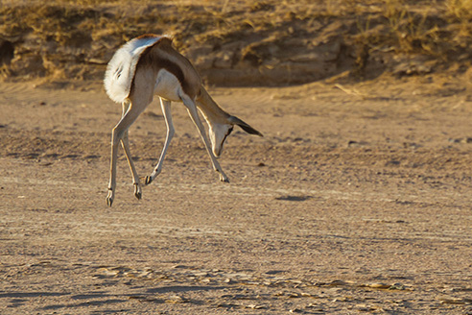
Springboks live in wide-open areas, such as grasslands and deserts in southern Africa. There are many predators of the springbok, including leopards, cheetahs, lions, and hyenas. When a springbok senses a predator through sight or smell, white hairs on its back are erected in alarm. The springbok will also start jumping around like this. It is called pronking. When springboks are pronking, they can jump up to 13 feet! That is higher than a typical ceiling.
S9-4PR. “Springbok, Damaraland.” Flickr. December 1 2015.
https://www.flickr.com/photos/119983612@N04/23240941419/
White-tailed Jackrabbit
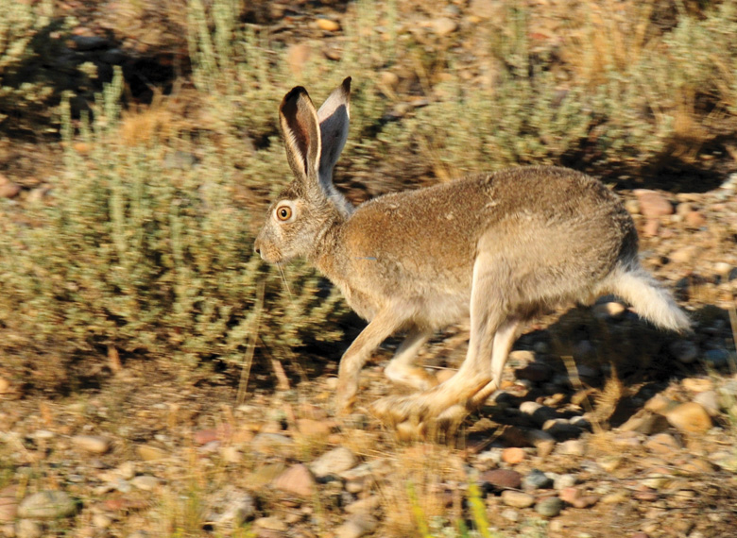
When looking at the picture, you probably noticed its big ears. What big ears it has! If you guessed that it has a good sense of hearing, you are right. But hearing isn’t the jackrabbit’s only keen sense. It has to have good senses to detect the many predators that call the rabbit dinner. Foxes, coyotes, cougars, badgers, snakes, and owls are a few of the rabbit’s predators. So, this rabbit uses all of its senses to find stimuli, such as predators, in its environment. It has sharp eyesight, and a keen sense of smell and whiskers to sense its environment. If a predator is detected, the white-tailed jackrabbit uses its powerful feet to run as fast as 40 miles per hour. Think about that the next time you are riding in a car!
Image from: USFWS Mountain-Prairie. “White-tailed jackrabbit on Seedskadee NWR.” Photograph. 28 July 2014. Flickr. Web. 5 Feb 2016.
https://www.flickr.com/photos/usfwsmtnprairie/14880304492/
Meerkat
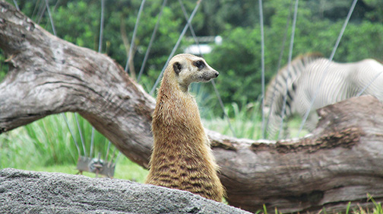

Meerkats work as a team and use their keen senses of hearing and seeing as they work together. They are a diurnal group, meaning they come out to forage or look for food when the sun is setting or rising. They will listen and look for small invertebrates to eat, but they will also eat plants too. Usually, while most of the group forages for food, one or two of the meerkats will sit upright and watch for predators, as the meerkat is doing in this picture. As the group hunts for food, the meerkats are constantly communicating to one another through grunts and squeaks. If this meerkat calls out a special squeak that communicates that a predator is near, all of the meerkats return to their burrows in the ground in a hurry!
Image from: Sparkes, Chad. “On Guard (Explored).” Photograph. 15 Aug 2015. Flickr. Web.
5 Feb 2016.
https://www.flickr.com/photos/chad_sparkes/20649188825/
Desert Tortoise
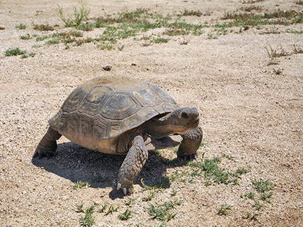

Did you know that a tortoise can sense its environment in a way that is similar to how a snake senses its environment? A snake uses its tongue and another internal structure, called a Jacobson organ, to smell its environment. Tortoises also have a Jacobson organ—but instead of flicking their tongues, they blow air through their mouth and throat to smell. If this tortoise senses a threat, it will retreat into its armored shell. But don’t be fooled: Tortoises and turtles have nerves in their shell so they can feel something touching their shell. Some tortoises have even been known to enjoy a pet or scratch on the back!
Hannawacker, Robb. “Desert tortoise (Gopherus agassizii) at Burrow.” Flickr. 29 May 2008.
https://www.flickr.com/photos/joshuatreenp/12488844305/
Musk Ox
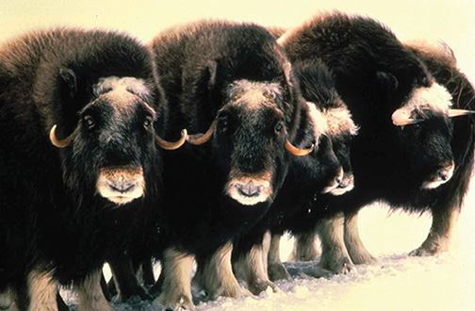

Musk oxen work as a group to respond to predators in the Arctic tundra where they live. They are constantly on the lookout for hungry predators, such as wolves who feed on young calves. When the oxen catch a whiff of a wolf or spot one with their keen sense of sight, they group into a circle with their large heads and horns facing out, as seen here. Inside the circle are their calves, protected.
Keller, Jo. “Musk Oxen Mammals Ovibos Moschatus.” Flickr. 26 February 2013.
https://commons.wikimedia.org/wiki/File:Musk_oxen_mammals_ovibos_moschatus.jpg
Bee
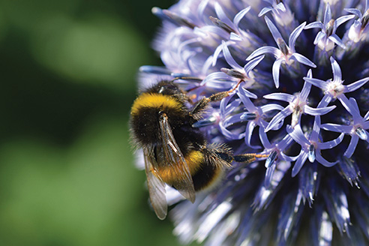

Have you ever wondered why bees, or other insects, have antennae? You may already know this, but a bee uses its antennae to smell flowers in its environment. That is how this bumblebee found this flower!
Campbell, John. “Bumblebee.” Flickr. 20 July 2017.
https://www.flickr.com/photos/104346167@N06/35662485290/
Concepts Scientists Think About Anchor Chart
Concepts Scientists Think About
Systems | Cause and Effect
Definition:  A set of different parts that work together | Definition:  Studying the relationship between the actions or events of at least two things.
Examples:  Human Body:  Feet work with the legs to help a body move.  Ecosystem:  Plants use water to survive well.  Animals eat plants to survive well.  Nervous System | There is a relationship between getting enough food and surviving well.

Animal Structures and Functions Anchor Chart
Function | Structure | Reasoning
Animals need to be able to: | What internal and external structures can fulfill the function? | How do the structures work? How do they meet the function?
Obtain enough of the food available where they live | A long tube  A set of pinchers  A beak for pinching small seeds  Large flat teeth for grinding | The long tube sucks up liquid food like a straw.  Pinchers cut and tear food.  The two sides of the beak squeeze together to grab the seed.  The large teeth smash up plant material. The jaw muscles help them go up and down to smash.
Sense their surroundings | Responses will vary.  Possibilities might include but are not limited to:  Big ears that can move in lots of directions.  Additional student responses | Responses will vary.  Possibilities might include but are not limited to:  The ears can collect sounds from far away. They can move to face the sound so the ear works more efficiently.  Additional student responses
Move
Regulate their temperature
Regulate their moisture
Have protection

