Grade 4: Life Science Module 2
Lesson Sequence 3:
Animal Structures to Obtain Food
Life Science Module

Handling Live Animals in the Classroom
(For Teacher Reference)
Overview:
Having live animals in your classroom is a wonderful way to foster respect and wonder for the natural world. Animals will give your students authentic scientific experiences as they observe them and design experiments where they can collect valuable information about the animals. To ensure that students have a positive experience with the animals, please follow the guidelines and suggestions outlined below. For more information, please see Grades 3-5 Life Science Curriculum Modules Guidance Document.

Guidelines:
- Follow the guidelines from NSTA’s position statement concerning live specimens in the classroom: <http://www.nsta.org/about/positions/animals.aspx>.
- Consider the animal’s needs when establishing its classroom habitat—For example: water, food, shelter, bedding material, light/dark preferences, heat, and moisture requirements. Often, if specimens are ordered, you can follow the directions provided.
- Establish expectations and guidelines with students around respecting and handling live specimens.
  - Before handling, propose questions to spark curiosity and compassion toward the animal.
  - Guide the children to not be afraid of the animal, but rather to respect the animal.
  - Guide students to feel a sense of responsibility for caring for the animal.
  - Consider making an “Agreements” chart on the treatment/handling of live animals in your classroom. For example:
We agree to:
- Always be gentle when handling the animal so that it is not hurt.
- Pay attention to what the animal needs and provide for the animal.
- Take care of its home in the classroom.
- Consider what will be done with the animal at the end of the study:
  - With permission, send home with students.
  - Keep as classroom pets.
  - Return animals to local habitats—only if they were originally collected from that place.
Invertebrate Chart

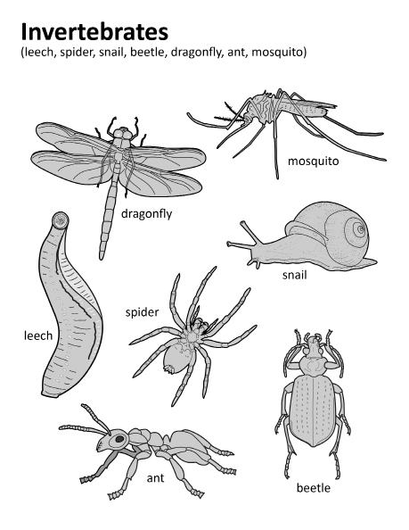

Created by Stacey Posnett for EL Education

Animal Structures and Functions Anchor Chart
Function | Structure | Reasoning
Animals need to be able to: | What internal and external structures can fulfill the function? | How do the structures work? How do they meet the function?
Obtain enough of the food available where they live | Responses will vary.  Possibilities might include but are not limited to:  A long tube  A set of pinchers  A beak for pinching small seeds  Large flat teeth for grinding  Additional student responses | Responses will vary.  Possibilities might include but are not limited to:  The long tube sucks up liquid food like a straw.  Pinchers cut and tear food.  The two sides of the beak squeeze together to grab the seed.  The large teeth smash up plant material. The jaw muscles help them go up and down to smash.  Additional student responses
Sense their surroundings
Move
Regulate their temperature
Regulate their moisture
Have protection

Scientists Do These Things Anchor Chart
(For Teacher Reference)

Scientists Do These Things anchor chart
Engaging in Argument:  What’s needed for a scientific argument?  Preparing for the argument:  - Pose the question.  - Identify evidence that answers the question.  - Evaluate whether or not that evidence is sufficient to support the claim. “Is this good evidence?”  Making the argument:  - Make a claim.  I’m arguing that…  - Use the evidence and scientific reasoning to support the claim.  The evidence I have is…  This evidence shows...  - Explain why the evidence is sufficient and relevant.  This evidence is sufficient because… | Modeling:  - A model has limitations because it is used to study one part of a system or object while not paying attention to other parts.  - A model can be a drawing or diagram, a physical replica, or a simulation. | Planning an Investigation:  - Pose a question that can be investigated with trials.  - Decide what can be changed (variables).  - Set up the procedure.  - Record observations.
Example:  Ecosystem and organism argument | Example:  Obtaining food simulation | Example:
Station 1 Pictures
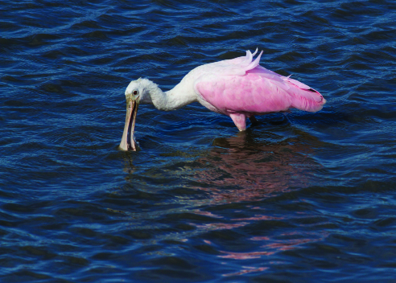  Notice the beak of the spoonbill. | 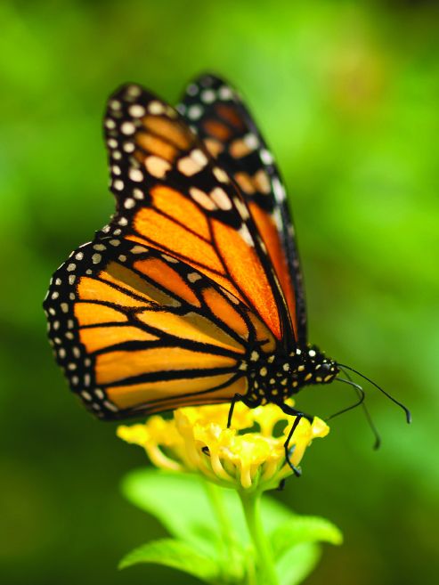  Notice the proboscis of the monarch butterfly.
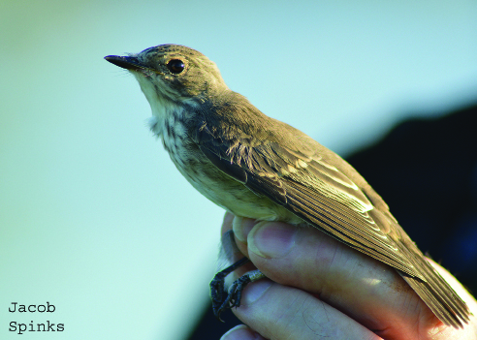

Notice the beak of the flycatcher.

Station 2 Pictures

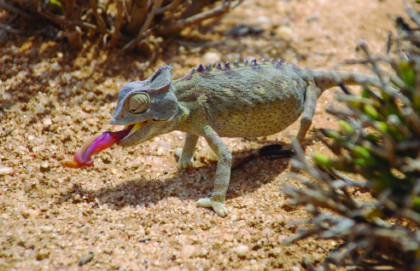  Notice the sticky tongue of the chameleon. | 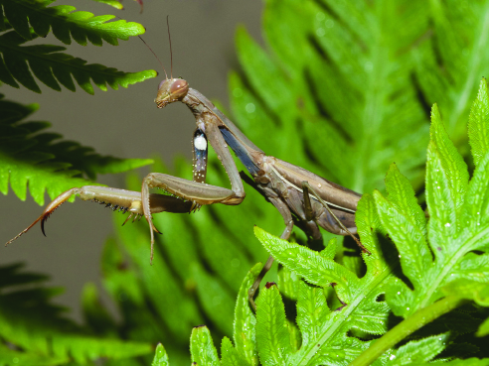  Notice the legs of the praying mantis.
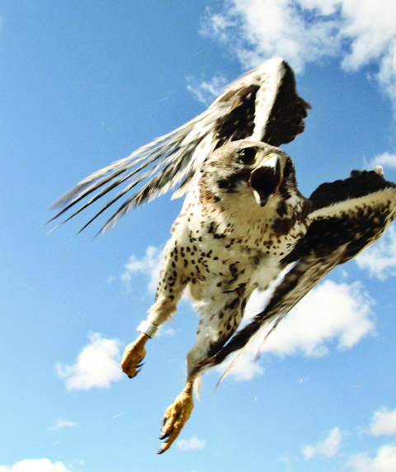

Notice the claws of the prairie falcon.
Station 3 Pictures

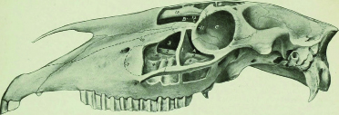  Skull of horse | 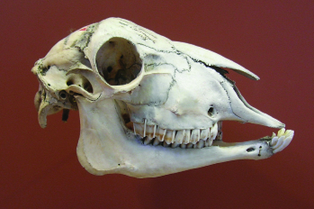  Skull of sheep
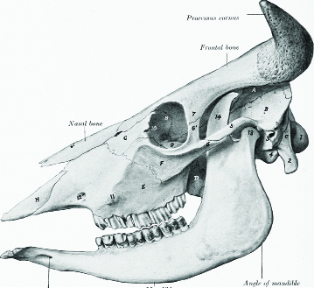  Skull of ox | 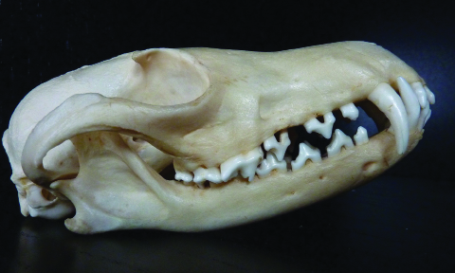  Skull of fox
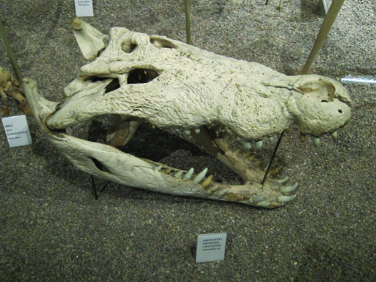  Skull of crocodile | 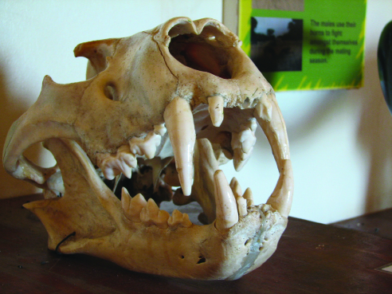  Skull of lion
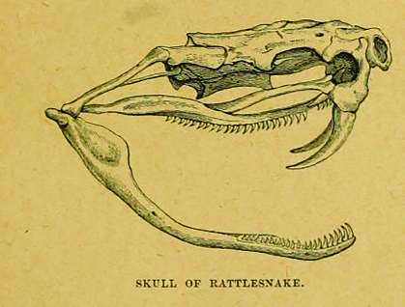  Skull of rattlesnake | 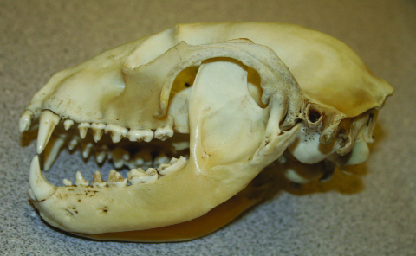  Skull of raccoon

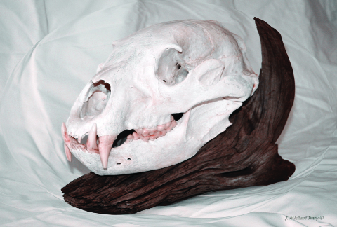  Skull of bear | 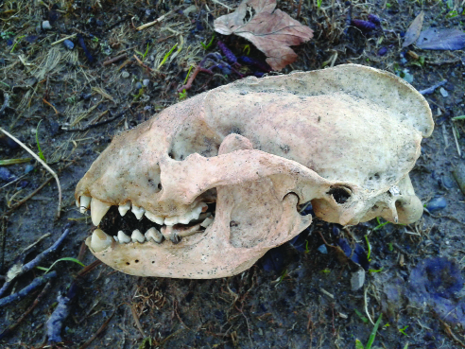  Skull of badger
Obtaining Food Structures Stations Image Citations
Station 1
Spoonbill — Diedrick, James. “Roseate Spoonbill eating.” Photograph. 25 May 2012. Flickr. Web. 10 Feb 2016.
Warby, William. “Monarch Butterfly.” Photograph. Flickr. 5 Nov 2012.
Spinks, Jacob. “Spotted Flycatcher.” Flickr. 22 September 2013. <https://www.flickr.com/photos/wildlife_boy1/9881289096/>

Station 2
Chameleon — Granycome, Caroline. “Chameleon.” Photograph. 28 Feb 2011. Flickr. Web. 10 Feb 2016.
JKehoe Photos. “Praying Mantis on Chain Fern.” Flickr. 22 August 2015. <https://www.flickr.com/photos/johnjkehoe_photography/20176891673/>
Prairie falcon - Nelson, Jon. “PRFA.” Photograph. Flickr. Oct 2014. Web. 14 Feb 2016.

Station 3
Skull of horse — Sisson, Septimus. The anatomy of the domestic animals. Philadelphia: W.B. Saunders Company, 1914. Library of Congress. Internet Archive. <https://archive.org/stream/anatomyofdomesti01siss/#page/83/mode/1up>
Vassil. “Sheep Skull.” Wikimedia Commons. 3 May 2007. <https://commons.wikimedia.org/wiki/File:Cr%C3%A2ne_mouton.jpg>
Skull of ox — Sisson, Septimus. The anatomy of the domestic animals. Philadelphia: W.B. Saunders Company, 1914. Library of Congress. Internet Archive. <https://archive.org/stream/cu31924001263270/#page/n133/mode/1up>
Xocolatl. “Skull of a Fox.” Wikimedia Commons. 5 September 2009. <https://commons.wikimedia.org/wiki/File:Fuchssch%C3%A4del.jpg>
Artethgray. “Crocodile Skull.” Flickr. 17 August 2010. <https://www.flickr.com/photos/36397453@N00/4916126240/>
Dauterive, Sarah. “Lion Skull.” Photograph. 12 Oct 2006. Flickr. Web. 10 Feb 2016.
Duncan, P. Martin. “Skull of Rattlesnake.” Cassell’s Natural History. Metcalf Collection (North Carolina State University). NCRS. 1896. <https://archive.org/stream/cassellsnaturalh03dunc/#page/274/mode/2up>
Brandt, Tom. “Raccoon Skull.” Photograph. 13 Jan 2011. Flickr. Web. 11 Feb 2016.
Tracy, John. “Bear Skull on cedar root.” Photograph. 3 Dec 2008. Flickr. Web. 11 Feb 2016.
Cant, Chris. “Badger skull.” Photograph. 11 Jan 2014. Flickr. Web. 11 Feb 2016.
Concepts Scientists Think About Anchor Chart
(For Teacher Reference)

Concepts Scientists Think About
Systems | Cause and Effect
Definition:  A set of different parts that work together | Definition:  Studying the relationship between the actions or events of at least two things.
Examples:  Human Body:  Feet work with the legs to help a body move.  Ecosystem:  Plants use water to survive well.  Animals eat plants to survive well. | Responses will vary.  Possibilities might include but are not limited to:  There is a relationship between getting enough food and surviving well.

