Grade 4: Life Science Module 2
Lesson Sequence 2: Ecosystems
Life Science Module

Researching the Grassland Ecosystem
Photographic Evidence
Scientists use photographs to learn about remote areas of the earth that they cannot visit. Drones, small unmanned flying vehicles, can be sent anywhere in the world to collect data, even into the middle of an erupting volcano!

You are going to work like scientists and collect data about a specific ecosystem by closely examining photographs. As you look, think about the characteristics of the ecosystem and all the abiotic (non-living) and biotic (living) parts of the ecosystem.

Carefully examine the pictures of your ecosystem and ask yourself:
- What biotic components, plants and animals, do I see?
What types of plants? Describe the height of the plants. What colors are visible?
What types of animals do I see? What do they look like? What structures do they have?
- What abiotic, or non-living, features are part of the ecosystem?
What evidence do I see of precipitation or water?
What evidence do I see of temperature?
What does the land look like (rocky, sandy, flat, mountainous)?
Record your observations and include as much detail as possible.

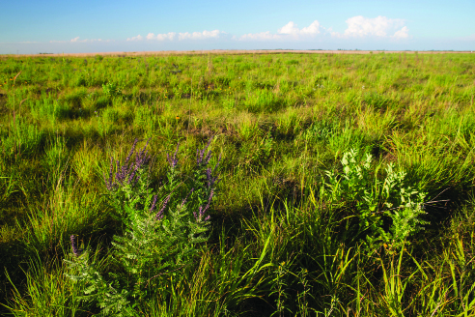

USFWSmidwest. Blooming lead plant at Glacier Ridge NWR. 25 July 2012. Flickr. Web. 10 Feb 2016.

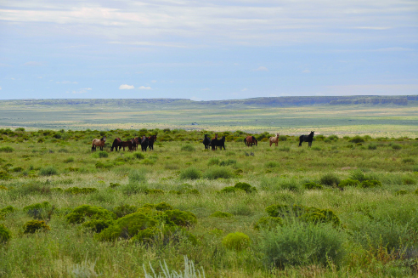

Bureau of Land Management. Kevin Kunkel, BLM New Mexico Intern. 24 June 2009. Flickr. Web. 10 Feb 2016

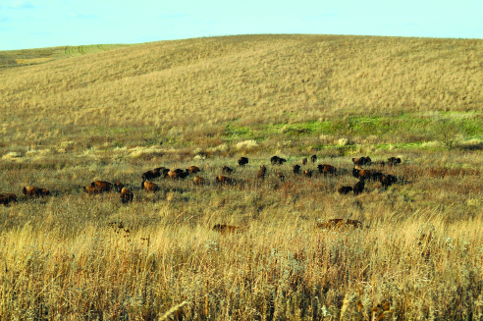

USFWSmidwest. Bison. 6 Nov 2013. Flickr. Web. 10 Feb 2016.
Grasslands Overview
Grasslands have several names, including prairie, steppe, and savannah, depending upon where they are in the world. Regardless of the name, all grasslands have common characteristics. For instance, they always contain a variety grasses as well as short, non-woody plants such as clover. Grasslands are typically open and flat. There are no natural barriers, like trees, to stop the wind.

Grasslands: Grasses and Other Plants
One of the reasons there are so many grasses in these ecosystems is because grass has special adaptations. One of these adaptations is that grass grows from the bottom up. This allows grasses to grow back after being grazed by animals or burned by a fire. Grass is certainly very resilient!

Let’s take a closer look at the massive root system of grassland plants. Their root systems are often larger than the part of the plant we can see above ground! The roots provide water to plants during times of drought by reaching deep into the ground. If water is not available, the plant above ground dies. The root system, however, remains alive underground and can start a new plant growing when it rains again. The network of roots also helps keep the soil in place and protect the plant from gusting winds and flooding.

Grassland Temperature:
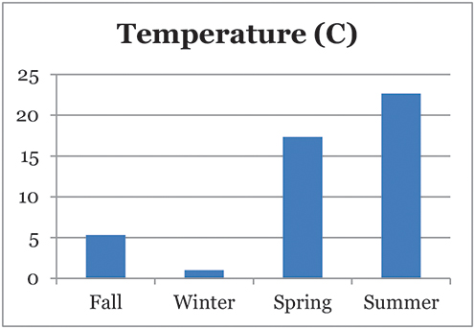
Grasslands can be found bordering deserts or forests. The temperature over the course of the year varies in grasslands. The data below are for a grassland in Kansas. The temperature ranges from an average low of –5°C (26°F) to a high of 25°C (77°F).

- What do you notice about the pattern of temperature over the year?
- Which months are the coldest?
- Which months are the warmest?

Temperate grasslands like this one in Kansas have a season when the temperature is warm. There is also enough rain to support the growth of plants. Additionally, this grassland has a dormant season. This means temperatures are too cold for plants to grow and so the plants aren’t active. When it gets warm again, they start to grow.

Grassland Rainfall:
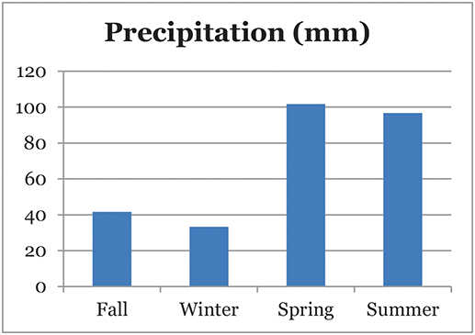
Grasslands do not receive enough rainfall for large numbers of trees to grow. The precipitation for this grassland in Kansas ranges from a high of almost 140 mm (5 inches) to a low of 20 mm (less than 1 inch).

- What do you notice about the pattern of rainfall over the year?
- When does this grassland receive the most precipitation?
- When does it receive the least precipitation?
- What adaptations would animals need to survive in this ecosystem, with the range in precipitation?

When the rainy season arrives, the rolling fields of grasslands can become covered with flowers. The brightly colored flowers attract pollinators, such as bees and wasps. These wildflowers may also have structures on their stems (like thorns or spikes) to discourage grazers, such as buffalo or wild horses, from eating them. The height of the plants in grasslands is directly related to the amount of rainfall the area receives. The grasslands that receive the most rain have the tallest plants.
Grasslands: Types of Animals
Sheep, horses, cows, bison, zebras, and antelopes are among the grazers that depend on grasslands for survival. A grazer is a type of animal that eats a lot of grass. Adaptations that allow these animals to eat the grasses include broad, flat-topped teeth to chew and grind the plant material, and digestive systems specifically adapted for grasses. Some animals that live in the grasslands are built for speed to escape predators. Some animals form large herds to help them survive. It’s difficult for predators to sneak up on a herd when multiple animal sentries, or lookouts, are on guard.

Animal Shelters in the Grassland:
Other smaller animals, such as prairie dogs, have powerful front legs and paws designed for digging burrows in the ground. They can build elaborate tunnels that connect to create a complex network of tunnels. This network includes multiple entrances and exits—a good idea in case a predator arrives! Some owls, such as burrowing owls, take advantage of holes dug by other animals. They use them as places to build their nests.

Lacking trees, rocks, or other structures to hide behind, many grassland animals have very effective camouflage. Their body coverings blend into their surroundings. This allows them to hide in plain sight.

Researching the Grassland Ecosystem
Because there are very few trees, grassland birds must build their nests on or under the ground. They use the dense vegetation of grasslands to hide their eggs. If the nest is approached by a predator, some birds will actually pretend to be wounded. They pretend to have a broken wing and the predator follows them as they walk away from the nest. When the predator gets close, they fly away!

Grasslands: Important Ecosystems
Grasslands are extremely important ecosystems. They provide habitats for a variety of wildlife, grazing areas for cattle, and rich farmland to grow our food. In fact, the grasslands in the Midwestern United States are among the richest agricultural areas in the world. We are fortunate to have such a valuable resource nearby!
Glossary
prairie, steppe, savannah = other names for a grassland
resilient = able to recover quickly
root system = a group of roots that anchor the plant in the soil and absorb water and nutrients
pollinators = animals that carry pollen from one flower to another
average = a math term to describe the median temperature or number of something: all of the values in the list added up and then divided by their number
temperate grassland = have a warmer season than most grasslands
dormant season = a season when the plants don’t grow

Written by Pat Fitzsimmons for EL Education

Sources:

“Grassland.” Earth Observatory. NASA. Web. 12 Feb 2016. <http://earthobservatory.nasa.gov/Experiments/Biome/biograssland.php>
“Grasslands.” Habitats. World Wildlife Federation, 2016. Web. 12 Feb 2016. <http://www.worldwildlife.org/habitats/grasslands>
“Grasslands.” National Geographic. Web. 12 Feb 2016. <http://environment.nationalgeographic.com/environment/habitats/grassland-profile/>
“The Great Graph Match (basic version).” NASA Earth Observatory. NASA. Web. 14 Feb 2016. <http://earthobservatory.nasa.gov/Experiments/Biome/graphmatch_basic.php>
“NASA - NASA Flies Dragon Eye Unmanned Aircraft Into Volcanic Plume.” NASA News & Features. 2 Apr 2013. NASA. Web. 12 Feb 2016. <https://www.nasa.gov/topics/earth/earthmonth/volcanic-plume-uavs.html#.VqqUq5orLZ4>
“Prairie Ecosystems.” Museumlink Illinois. Illinois State Musem, 2000. Web. 12 Feb 2016.
<http://www.museum.state.il.us/muslink/prairie/htmls/eco_adapt.html>
“Robots Explore the Farthest Reaches of Earth and Space.” NASA Spinoff Technology Transfer Program. NASA. Web. 12 Feb 2016. <https://spinoff.nasa.gov/Spinoff2008/er_3.html>

Researching the Tundra Ecosystem
Photographic Evidence
Scientists use photographs to learn about remote areas of the earth that they cannot visit. Drones, small unmanned flying vehicles, can be sent anywhere in the world to collect data, even into the middle of an erupting volcano!

You are going to work like scientists and collect data about a specific ecosystem by closely examining photographs. As you look, think about the characteristics of the ecosystem and all the abiotic (non-living) and biotic (living) parts of the ecosystem.

Carefully examine the pictures of your ecosystem and ask yourself:
- What biotic components, plants and animals, do I see?
What types of plants? Describe the height of the plants. What colors are visible?
What types of animals do I see? What do they look like? What structures do they have?
- What abiotic, or non-living, features are part of the ecosystem?
What evidence do I see of precipitation or water?
What evidence do you I of temperature?
What does the land look like? Rocky? Sandy? Flat? Mountainous?

Record your observations and include as much detail as possible.

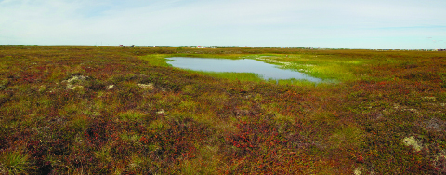

Pokrzywinski, Andrea. Tundra Panorama 1. 2 Sept 2011. Flickr. Web. 11 Feb 2016.
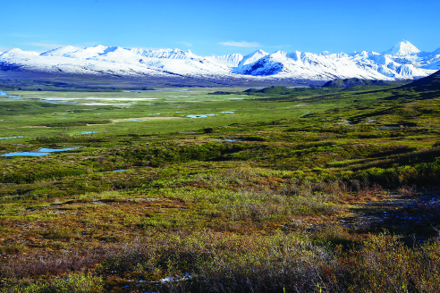

Bureau of Land Management. Delta WSR. 20 June 2014. Flickr. Web. 11 Feb 2016.

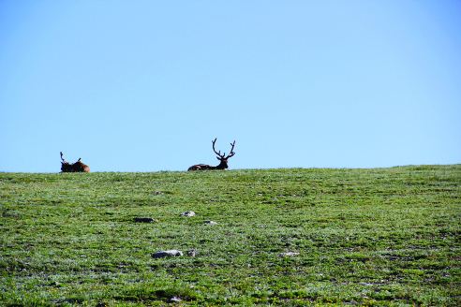

Fulmer, David. Bull Elk on Alpine Tundra. 9 July 2013. Flickr. Web. 11 Feb 2016.
Tundra Overview
Some people refer to the tundra as a cold desert. In addition to being extremely cold, the tundra is also very dry. There is little precipitation, which means the amount of water that rains or snows on the tundra is low. The growing season is very short, and the topsoil, or the dirt where the plants grow, has few nutrients. Yet, despite these harsh conditions, a variety of plants and animals live in the tundra. There are two types of tundra, the Arctic tundra and the Alpine tundra. The Arctic tundra surrounds the North Pole.

Arctic Tundra Temperatures:
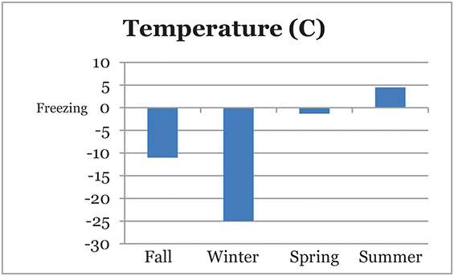
The Arctic tundra’s average winter temperature is very cold, only –34°C (–29°F)! The warmer temperatures of the summer are still very cold, at 3–12°C (37–54°F), but they allow life to exist.

The data below show the average monthly temperature for the Arctic tundra in Barrow, Alaska. The temperature ranges from an average low of –25°C (–13°F) to a high of 5°C (41°F). Remember that 0°C is the temperature at which water freezes.

- What do you notice about the pattern of temperature over the year?
- Which months are the coldest?
- Which months are the warmest?
- What adaptations would animals need in order to survive in this ecosystem with this range of temperatures?
Arctic Tundra Rainfall:
The average monthly precipitation for this tundra in Alaska ranges from a high of 20 mm (less than 1 inch) to a low of 0 mm (0 inches).
- What do you notice about the pattern of rainfall over the year?
- When does the tundra receive the most precipitation?
- When does it receive the least precipitation?
- What adaptations would animals need to survive in this ecosystem with the lack of precipitation?

Arctic tundra has a permanent layer of frozen soil called permafrost. It is found under the top layer of soil. In the warmer summer months, permafrost prevents melting snow and ice from draining into the ground. For that reason, wetlands and swamps can appear. Swampy areas in the tundra are surprising because there is so little rain in this area. But the little rain that does fall collects into these swampy areas.
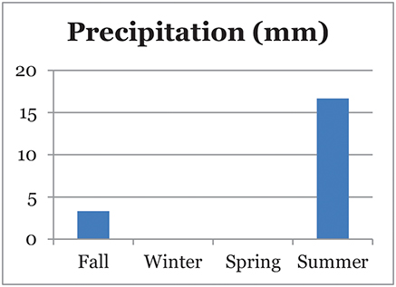

Arctic Tundra Plants:
Plants have adapted to take advantage of the long days and the moisture available in the summer. Because of the short summer, plants must either go through their life cycle quickly or take multiple years to complete a life cycle. The tundra is also open and lacks barriers, such as trees, to slow down the wind. Plants must be able to withstand strong gusts. As a result, the plants are short. Short woody shrubs, grasses, lichens, and mosses grow in clusters covering the tundra floor. This clustering also helps protect plants during the harsh winters.
Arctic Tundra Animals:
Few animals are year-round residents of the Arctic tundra. Most of them live in the tundra for the summer months to breed and raise their young. In the winter, many animals migrate south to warmer areas and with more food available. Those that do remain, have a short summer season to raise their offspring.
Animals that live in the Arctic tundra year-round have adaptations that allow them to survive severe winters. Some animals hibernate during the winter months when food is scarce, or hard to find. They also have layers of fat and feathers or fur to help keep them warm. The fat insulates their bodies, trapping body heat just like a thick, winter coat. The fur or feathers of certain animals vary in color with the seasons. Changing from brown in the summer to white in the winter helps animals blend into their habitat. One animal, the musk ox, even has two layers of fur! A short layer next to the body keeps the animal warm. A long outer layer protects the animal from wind and rain. Additionally, the musk ox has hard hooves that it uses to break ice. That can be helpful if you are a musk ox looking for a drink of water on a cold winter day in the tundra!

Arctic Tundra Animal Shelters:
Because the ground is frozen (permafrost), animals cannot borrow into the ground. They seek shelter and protection in other ways, such as migrating and camouflaging.

Alpine Tundra:
The Alpine tundra is found high in the mountains. Summer temperatures range from 10 to 15°C (50–59°F). In the winter, temperatures drop well below freezing. The temperature can be unpredictable at times and change from above freezing to below freezing in a single day.

The Alpine tundra is located high in the mountains where trees cannot grow. There are few animals adapted for living year-round in this ecosystem. For example, yellow-bellied marmots survive by hibernating eight months out of the year—that’s a long rest! Pikas, small animals without a tail that look like rodents, seek protection from the weather by hiding under rocks. They store food for the winter, just like squirrels. Because there aren’t many predators, the tundra is a good place for the little pikas to live.

The Alpine tundra has a longer growing season than the Arctic tundra does. There is no permafrost, so the soil is well-drained. The plants that grow there are similar to the ones in the Arctic. They need to survive strong winds and cold temperatures. For example, cushion plants hug the ground and grow in clumps like moss. They may also send a long taproot deep into the rocky soil. This taproot anchors the plant securely in the ground. Some of the flowering plants have dense hairs on their stems and leaves that allow them to trap heat. Another adaptation is a red pigment, or coloring, on plants that can change the sun’s light rays into heat. The adaptations that plants have in order to survive in the tundra are quite remarkable!

Important Ecosystems:
Alpine and Arctic tundra are important ecosystems. They provide habitats for a variety of plants and animals that could not survive successfully in other parts of the world. The tundra also creates an opportunity for scientists to learn more about how plants and animals have developed adaptations over time to live in an extreme ecosystem. Maybe someday you can go and study the plants and animals in the tundra! There are still discoveries waiting to be made.

Glossary
precipitation = rain, snow, sleet, and hail
Arctic tundra = tundra found in the Arctic
topsoil = layer of soil on the surface of the ground
Alpine tundra = tundra found at the tops of mountains
unpredictable = unable to predict
permafrost = a thick layer of soil that is frozen most of the year
clusters = groups
migrate = moving from place to place
hibernate = to sleep for a long period of time
insulates = to protect from losing heat
habitat = the natural home of an organism where its needs for food, water, shelter, and space are met
taproot = the root of a plant that grows directly down
Written by Pat Fitzsimmons for EL Education

Sources:

“All About Frozen Ground.” National Snow & Ice Data Center. Web. 14 Feb 2016. <https://nsidc.org/cryosphere/frozenground/plants.html>
“Alpine Tundra Ecosystem.” Rocky Mountain National Park, Colorado. National Park Service. Web. 14 Feb 2016. <http://www.nps.gov/romo/learn/nature/alpine_tundra_ecosystem.htm>
“Arctic Tundra Ecosystem.” Wild Tracks. Web. 14 Feb 2016. <https://wildtracks.wordpress.com/world-ecosystems/tundra-ecosystems/arctic-tundra-ecosystem/>
Biomes Group of the Fall 96 Biology 1B class, section 115, at UC Berkeley. Ed. Stephanie Pullen. “The Tundra Biome.” University of California Museum of Paleontology. University of California, Berkeley. Web. 14 Feb 2016. <http://www.ucmp.berkeley.edu/glossary/gloss5/biome/tundra.html>
“The Great Graph Match (basic version).” NASA Earth Observatory. NASA. Web. 14 Feb 2016. <http://earthobservatory.nasa.gov/Experiments/Biome/graphmatch_basic.php>
“NASA - NASA Flies Dragon Eye Unmanned Aircraft Into Volcanic Plume.” NASA News & Features. 2 Apr 2013. NASA. Web. 12 Feb 2016. <https://www.nasa.gov/topics/earth/earthmonth/volcanic-plume-uavs.html#.VqqUq5orLZ4>
Nelson, Rob. “Alpine Tundra.” Biomes of the World. The Wild Classroom & Explore Biodiversity. Web. 14 Feb 2016. <http://www.thewildclassroom.com/biomes/alpinetundra.html>
“Robots Explore the Farthest Reaches of Earth and Space.” NASA Spinoff Technology Transfer Program. NASA. Web. 12 Feb 2016. <https://spinoff.nasa.gov/Spinoff2008/er_3.html>
Researching the Desert Ecosystem
Photographic Evidence
Scientists use photographs to learn about remote areas of the earth that they cannot visit. Drones, small unmanned flying vehicles, can be sent anywhere in the world to collect data, even into the middle of an erupting volcano!

You are going to work like scientists and collect data about a specific ecosystem by closely examining photographs. As you look, think about the characteristics of the ecosystem and all the abiotic (non-living) and biotic (living) parts of the ecosystem.

Carefully examine the pictures of your ecosystem and ask yourself:
- What biotic components, plants and animals, do I see?
What types of plants? Describe the height of the plants. What colors are visible?
What types of animals do I see? What do they look like? What structures do they have?
- What abiotic, or non-living, features are part of the ecosystem?
What evidence do I see of precipitation or water?
What evidence do I see of temperature?
What does the land look like? Rocky? Sandy? Flat? Mountainous?

Record your observations and include as much detail as possible.

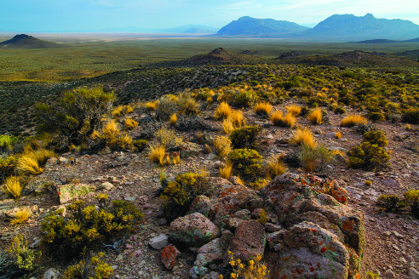

Bureau of Land Management. Basin and Range National Monument. Flickr. Web. 18 Oct 2015.
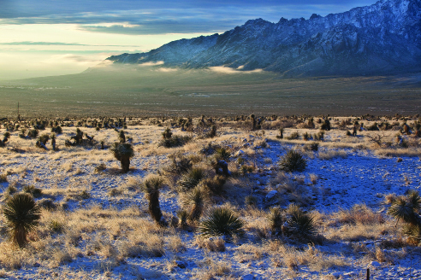

Bureau of Land Management. Organ Mountains WSA. 29 Jan 2010. Flickr. Web. 12 Feb 2016.

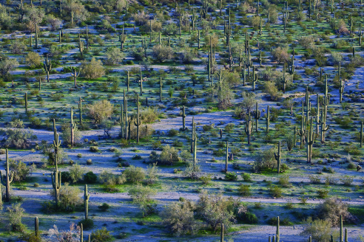

Bureau of Land Management. Sonoran Desert NM. 4 March 2010. Flickr. Web. 12 Feb 2016.
Desert Overview
Deserts are extremely hot and dry places. Take the Atacama Desert, in Chile for example. It gets only about 13 mm (half an inch) of precipitation, or moisture, a year! And it never even rains there—the precipitation comes from fog. In other deserts, hot winds quickly evaporate any available moisture. The dry heat makes it difficult for many types of plants and animals to survive.

There are very few plants and animals that can live in the desert. The ones that manage to survive have special adaptations. These adaptations allow them to handle large changes in temperatures. Additionally, desert dwellers must be able to survive with little food or water.

Deserts cover a large portion of the earth. Approximately one-fifth of the land on earth is desert. They are found on every continent.

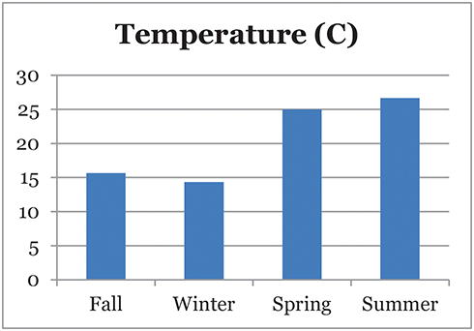
Desert Temperatures:
Although deserts are very hot during the day, they can become very cold at night. There are few trees or other structures to retain heat. Have you ever been in a hot city during the day and noticed how warm it stays once the sunsets? As the air cools at night, heat energy captured by the buildings and roads is slowly released. This helps keep the surrounding area warm. Deserts do not have natural features that can take advantage of the heat from the day to warm the chilly nights.

Below is the average monthly temperature for a desert in Australia. The temperature ranges from a low of 10°C (50°F) to a high of approximately 30°C (86°F). The average monthly temperature, however, does not show the extreme changes that can occur in a desert over the course of 24 hours.

- What do you notice about the pattern of temperature over the year?
- Which months are the coldest?
- Which months are the warmest?
- What adaptations would animals need in order to survive in an ecosystem with these temperatures?

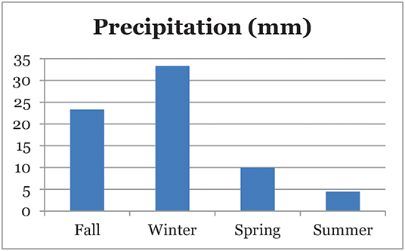

Desert Rainfall:
Deserts receive very little precipitation. The precipitation for this desert in Australia ranges from a high of 40 mm (1.5 inches) to a low of 0 mm (0 inches).

- What do you notice about the pattern of rainfall over the year?
- When does this desert receive the most precipitation?
- When does it receive the least precipitation?
- What adaptations would animals need to survive in this ecosystem with so little precipitation?

Desert Animals: Xerocoles
Animals that live in the desert have a special name. They are called xerocoles. “Xero” means “dry” and “coles” means “to live in.” Even though the desert is a harsh ecosystem, a variety of animals live there. Insects, reptiles, birds, and mammals can be found in deserts.

Because food and water are scarce, many animals in the desert are small. Rather than drinking from a pond, they often get their water from the food they eat.
Some xerocoles don’t avoid the sunlight. They have bodies built to deal with the heat. The thick shell of a tortoise insulates the animal and helps prevent water loss. Other animals appear to dance across the desert sand! For example, some lizards run with their legs lifted very quickly to avoid contact with the hot sand. Long ears of a jackrabbit help release heat.

Desert Animal Shelters:
These animals are usually nocturnal, which means they sleep in their burrows, protected underground from the heat of the day. Then they hunt or forage at night. A desert that seems empty during the day may become a very lively place at night.

There is even a lizard in Australia that has a system of tiny grooves and channels on its body to capture water. This system allows the water to flow toward the lizard’s mouth. After a rainfall, the lizard sucks the water into its mouth with a big gulp. What an interesting way to get a drink!

Camels are nicknamed the “ships of the desert.” They are efficient with their use of water and can therefore travel long distances in the hot desert sun. Camels have either one or two humps on their backs. People once thought that these humps were used to store water. Their humps actually store fat. When food and water are not available, camels change this stored fat into energy and moisture in order to survive. As the fat is used, the humps become floppy. When water is available again, camels’ bodies soak it up like a sponge. A thirsty camel can drink up to 30gallons of water in a short time! Can you imagine drinking 30 gallons of milk at one time?

The nostrils of camels are special, too. The nostrils can close to block out blowing sand. Thick, bushy eyebrows protect a camel’s eyes from the glare of the sun. Long eyelashes provide additional protection for delicate eyes. Additionally, large flat footpads prevent camels massive bodies from sinking into the sand. Their feet are also well suited for traveling on rough, rocky terrain. Camels have a lot of special adaptations that make them at home in the desert.

Desert Plants: The Struggle for Survival
There is a silent competition for water in the desert! It is essential for survival. In order for plants to meet their needs for water, they usually grow far apart from one another. This allows plants to obtain as much water as possible from the surrounding area. Plants must be able to collect and store water. Their survival also depends on adaptations that prevent water loss from their leaves. The leaves of plants, therefore, are often small and waxy.

Root systems of plants may be shallow because rain does not have a chance to soak deep into the ground. Some plants, however, have very deep roots that can reach water more than 30 meters (100 feet) under the ground! That is a long way for water to go.

A soaking rain can change a desert into a vibrant garden of flowers almost overnight. How can this happen? Many plants are annuals, meaning they live for only one season. They produce seeds that can lie dormant for years, just waiting for enough water. Once it rains, the seeds quickly sprout. They grow, produce flowers, create new seeds, and then die. This can all happen in a short amount of time and create amazing changes in the desert.

Cacti have interesting adaptations that make them the most common plant in some deserts. They have trunks and branches that conduct photosynthesis, which produces energy for the plant. The leaves have been modified into thorns that protect the plant from being eaten or trampled. A hairy texture helps reflect heat from the sun. Prickly thorns protect them from animals that may want to eat them. Their root systems spread out just below the surface of the desert. These roots can quickly absorb and store water. The Saguaro cacti have an interesting adaptation: They can expand and collapse like an accordion. This adaptation allows them to store a significant amount of water in their trunks and branches. A Saguaro cactus is like a large, living water tower!

The adaptations of desert plants are fascinating. Those that win the battle for water survive and reproduce. The losers, however, are not so fortunate.

Deserts: Important Ecosystems
Deserts are important ecosystems. They provide habitats for a variety of plants and animals that could not survive elsewhere. Scientists think that some of the adaptations that allow plants to live in the desert may actually help people. For example, a recent discovery shows that desert plants may help us fight diseases such as malaria. If you could visit the desert, what would you want to investigate?

Glossary
precipitation = rain, snow, sleet, and hail
adaptations = a structure that aids in survival

Written by Pat Fitzsimmons for EL Education

Sources:

“Desert Biome Facts.” BioExpedition. BioExpedition.com, 2015. Web. 14 Feb 2016. <http://www.bioexpedition.com/desert-biome/>
“Encyclopedic Entry: Desert.” National Geographic: Education. National Geographic, 1996-2016. Web. 14 Feb 2016. <http://education.nationalgeographic.com/encyclopedia/desert/>
Golan-Goldhirsh, A., Lugasi-Evgi, H., Sathiyamoorthy, P., Pollack, Y. and Gopas, J. (2000). BIOTECHNOLOGICAL POTENTIAL OF ISRAELI DESERT PLANTS OF THE NEGEV. Acta Hortic. 523, 29–36
DOI: 10.17660/ActaHortic.2000.523.3
<http://dx.doi.org/10.17660/ActaHortic.2000.523.3>
“The Great Graph Match (basic version).” NASA Earth Observatory. NASA. Web. 14 Feb 2016. <http://earthobservatory.nasa.gov/Experiments/Biome/graphmatch_basic.php>
“NASA - NASA Flies Dragon Eye Unmanned Aircraft Into Volcanic Plume.” NASA News & Features. 2 Apr 2013. NASA. Web. 12 Feb 2016. <https://www.nasa.gov/topics/earth/earthmonth/volcanic-plume-uavs.html#.VqqUq5orLZ4>
“Robots Explore the Farthest Reaches of Earth and Space.” NASA Spinoff Technology Transfer Program. NASA. Web. 12 Feb 2016. <https://spinoff.nasa.gov/Spinoff2008/er_3.html>
Concepts Scientists Think About Anchor Chart
(For Teacher Reference)

Concepts Scientists Think About
Systems | Cause and Effect
Definition:  A set of different parts that work together | Definition:  Studying the relationship between the actions or events of at least two things
Responses will vary.
Possibilities might include but are not limited to:
Examples:
Human Body:
Feet work with the legs to help a body move
* Insert additional student example

Ecosystem:
Plants use water to survive well.
Animals eat plants to survive well.
Animal Cards

Directions for teacher: Copy and cut up the animal cards. To print images in color, follow the URL on the card. Distribute among student groups. For your reference, the animals are matched to each ecosystem below.

Grasslands: | Desert: | Tundra:
pronghorn antelope  prairie falcon  great horned owl  red-tailed hawk  gray wolf  bison  bobwhite quail  honeybee  deer mouse  tiger salamander | greater roadrunner  great horned owl  red-tailed hawk  gray wolf  sidewinder snake  desert tortoise  black-tailed jackrabbit  chuckwalla  scorpion  honeybee  red-spotted toad  spadefoot toad  tiger salamander | grizzly bear  red-tailed hawk  gray wolf  polar bear  snowy owl  rock ptarmigan  ermine  Arctic hare

Pronghorn Antelope  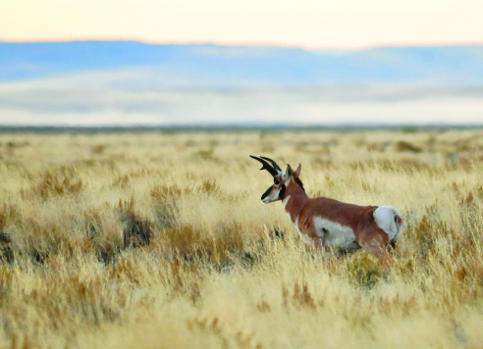  USFWS Mauntain-Prarie. Pronghorn Buck on Seddskadee National Wildlife Refuge. 18 Sept 2015. Flickr. Web. 14 Feb 2016.  <https://www.flickr.com/photos/usfwsmtnprairie/21995168375/> | The Pronghorn antelope is an herbivore, or plant eater, and eats mostly grasses and sage-brush. They prefer to live in environments that are open so that they can watch for predators. If startled by a predator, the pronghorn runs. It also has extra-long white hairs on its rump that the pronghorn can stick up. This signals to other pronghorns that danger is nearby. They flash their white tails and run. They are the second-fastest land mammal on the planet! The pronghorn needs water to live and will be found fewer than three or four miles from a water source. Pronghorns will migrate, or move to another location, in order to avoid the cold, snowy winters.
Prairie Falcon  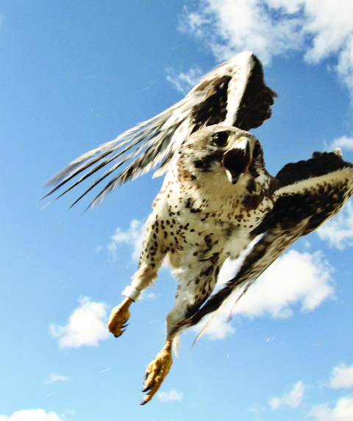  Nelson, Jon. PRFA. Oct 2014. Flickr. Web. 14 Feb 2016.  <https://www.flickr.com/photos/jondavidnelson/14302596508/> | Prairie falcons are carnivores, eating mostly small birds and small mammals. They live in wide-open spaces with high cliffs to perch on to watch for prey and to make nests. They catch their prey by swooping down from above in a surprise attack. These falcons like to take baths in rivers but will take baths in dust when water is scarce. The prairie falcon, although named “prairie,” can also tolerate a wide range of temperatures and can fly great distances in search of prey.
Greater Roadrunner  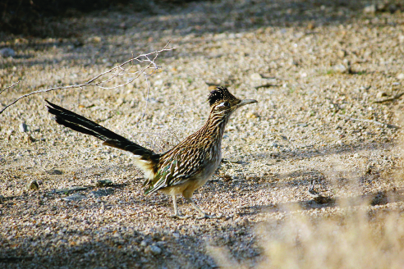  Sutton, Brad. “Greater Roadrunner (Geococcyx californianus).” Flickr.  28 January 2014.  <https://www.flickr.com/photos/joshuatreenp/20553531759/> | Greater roadrunners have a distinct shape and coloring with long legs, brown wings, and a white chest. They are very fast on foot and have been known to outrun humans! This makes them hard to catch, but excellent hunters of lizards and snakes. They are carnivores, or meat eaters, and get most of their water from eating moisture-rich lizards and snakes. Instead of urinating, they get rid of waste from their body through their eyes so that they don’t lose moisture. Roadrunners also have the ability to cool themselves down by fluttering the area underneath their chin.
Grizzly Bear  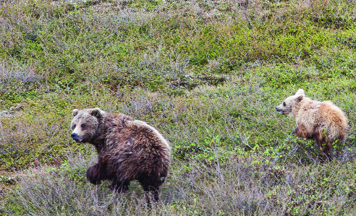  Bureau of Land Management. BLM Summer Roadtrip: Wildlife in the National Petroleum Reserve – Alaska. 28 June 2014. Flickr. Web. 14 Feb 2016.  <https://www.flickr.com/photos/mypubliclands/19342171222/> | Grizzly bears are omnivores and eat a variety of things, both plant and animal. They eat roots, grasses, berries and seeds, fungi, fish, deer, insects, and dead animals. In late summer, to prepare for the cold winters, the bears will eat a lot of food to gain weight mostly in the form of stored fat. Although they don’t truly hibernate, they do sleep a lot in a den during the winter months. The stored body fat becomes an insulator to keep them warm and a food source that keeps the bears healthy throughout the long, cold winter. Grizzly bears are mostly solitary animals, meaning they live alone. They make dens out of hollow trees, or caves, or dig dens in the ground to keep them safe from the cold and to give birth to cubs in January or February.
Great Horned Owl  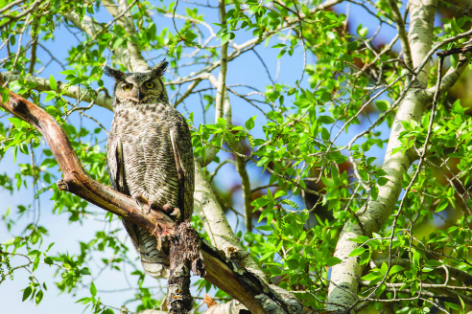  Herbert, Neal. “Great Horned Owl.” Flickr. 28 May 2014.  <https://www.flickr.com/photos/yellowstonenps/15138774802/> | When looking at a Great horned owl, you will notice it has tufts above its ears. These ear tufts help the animal in two ways: the ear tufts improve hearing and also camouflage the owls against a tree. Great horned owls have a coat layer of extremely small, soft feathers against their body covered by longer feathers to keep them warm against the cold and to help them fly silently as they hunt. Great horned owls will rest and use nests made by other animals. However, they hunt for prey in open areas. The owls eat many types of animals and will prey on scorpions, frogs, and mice, but they can even hunt and kill animals as big as themselves, using their powerful talons.
Red-tailed Hawk  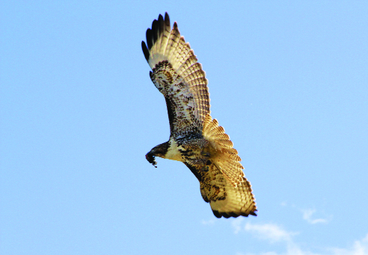  Nelson, Jon. Red-tailed Hawk. Oct 2014. Flickr. Web. 14 Feb 2016.  <https://www.flickr.com/photos/jondavidnelson/14558217651/> | The Red-tailed hawk is able to make its home in a lot of places. It eats a wide variety of animals, including small birds and mammals, reptiles and amphibians, insects, and even carrion, or dead animals that it has found. Because they are a bird of prey, these hawks are found along roadsides, in open country, and even in the woodlands with open areas to hunt. The Red-tailed hawk also has many kinds of feathers to help protect it from heat and cold. Downy feathers, under the hard feathers that you see here, can puff up to keep the bird warm or lay flat to cool down. The other feathers, on its wings and tail especially, allow it to be an excellent flier. It can soar and attack small prey with precision.
Gray Wolf  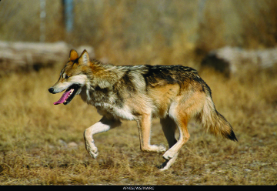  USDA APHIS Wildlife Services. “20140502-APHIS-UNK Gray Wolf.” Flickr. 2 May 2014.  <https://www.flickr.com/photos/usdagov/14086217382/> | The Gray wolf is an amazing hunter. Gray wolves live in packs, or groups. They will travel anywhere from 50 miles to 1,000 miles to find prey. They prefer hooved animals, such as moose, caribou, elk, and bison, but will dine on many small mammals. They are hardy animals, able to withstand a wide range of temperatures thanks to their fur. Their fur can range in color and have different patterns, depending on the ecosystem in which they live. In a pack, only one male and one female will reproduce and give birth to a litter of pups in March. They are born and stay in a den, protected from predators by the mother and the pack.
Sidewinder Snake  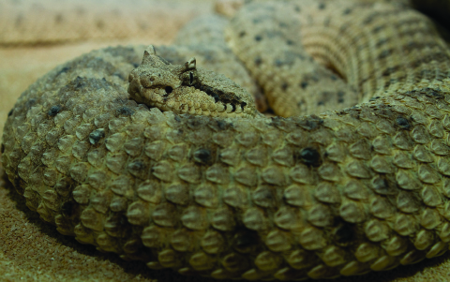  Gratwicke, Brian. Crotalus cerastes – sidewinder. 24 Oct 2010. Flickr. Web. 14 Feb 2016.  <https://www.flickr.com/photos/briangratwicke/5110918186/> | The Sidewinder snake got its name because of the way it moves. Instead of moving in a forward motion typical of most snakes, it moves its body in an S-shaped curve, leaving a continuous S pattern on the ground. It can move quickly across barren land, and often moves at night to find small prey like mice, lizards, and sometimes birds. Its coloration is also perfect for its habitat. It’s a tannish-red, so it camouflages well in sand. This snake also has triangular scales above its eyes that protrude out, almost like horns. These help the snake burrow into the sand to protect it from the heat. Because of these “horns,” the sidewinder is nicknamed the “horned snake.”
Bison  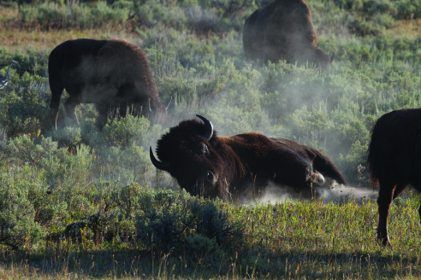  Gratwicke, Brian. Bison dust bath. 17 Aug 2012. Flickr. Web. 14 Feb 2016.  <https://www.flickr.com/photos/briangratwicke/7848240298/> | The Bison is considered a picky eater. Although it can eat other plants, it mostly eats grasses. Because it’s so gigantic, this animal will spend most of its day eating grasses and is called a grazer. Bison live in herds, or groups, and will roam great distances as they graze on grasses. Bison’s thick coat of fur help them survive well in the harsh temperatures of the winter and summer. They also do the behavior you can see in the photograph—when they roll around in the mud and dirt, it’s called wallowing. Scientists don’t really know why bison wallow, but they think it may be a way for them to cool down, to deter insects, to shed fur, or maybe just to have fun!
Desert Tortoise  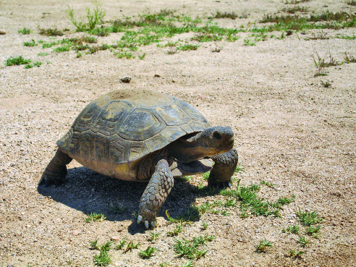  Hannawacker, Robb. “Desert tortoise (Gopherus agassizii) at Burrow.” Flickr. 29 May 2008.  <https://www.flickr.com/photos/joshuatreenp/12488844305/> | When looking at this photograph, you may notice the front legs of the tortoise. The front legs are very important. They have thick scales and long claws to help the tortoise burrow into the ground to find shelter. It can burrow up to 6 feet into the ground to survive very hot conditions. It will spend most of its life underground in its den, especially during the hottest part of year. In the spring and fall, the tortoise will come out of the den to eat plants. It gets most of the water that it needs from eating those plants! Occasionally after a passing thunderstorm, you might find a tortoise sneaking out of its den for a moment to drink some water from a puddle.
Black-tailed Jackrabbit  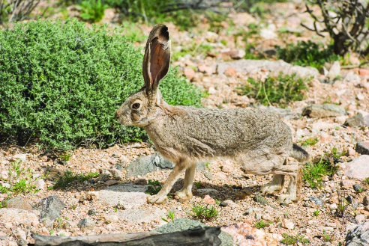  Sutton, Brad. “Black-Tailed Jackrabbit (Lepus Californicus).” Flickr. 15 March 2017.  <https://www.flickr.com/photos/joshuatreenp/33456196466/> | My, what big ears you have! This Black-tailed jackrabbit needs those ears to help it cool down. When the weather is really hot, more blood flows to the ears and cools down the temperature of the rabbit. The jackrabbit’s feet are also covered in hair to protect it from the hot ground. Black-tailed jackrabbits also have long legs and big eyes. This allows the jackrabbit to see predators in the open areas that it lives in and run away quickly. The hare can run up to 36 miles per hour! Jackrabbits aren’t picky eaters, even though they eat only plants. They can eat tough twigs, grasses, and even cacti. Jackrabbits also have one more trick to help them get enough water to survive: They will eat their own poop to get the moisture they need to survive. It’s gross, but that is what they do to survive well in a place with little water!
Polar Bear  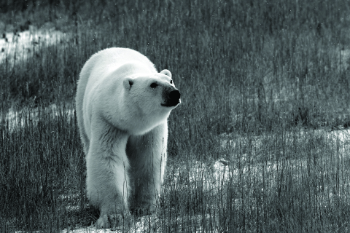  Bishop, Emma. Untitled. 9 Nov 2011. Flickr. Web. 14 Feb 2016.  <https://www.flickr.com/photos/emmabishop/6405913793/> | Polar bears are fascinating animals. One thing they are known for is their thick coat of fur. This fur serves them well to insulate them from extreme cold. It also covers their feet to protect them from the snowy ground and help provide a grip on ice. But under that thick coat of fur is black skin to help absorb the sun’s needed warm rays. Polar bears also use the snow to keep them warm. Have you ever built a snow den? That is what polar bears do to survive the cold, windy, snowy conditions of the Arctic winter. In these dens, females will give birth to and protect their cubs as they grow. Polar bears mainly dine on seals, so they often live close to the water’s edge and will travel many miles to find food.
Snowy Owl  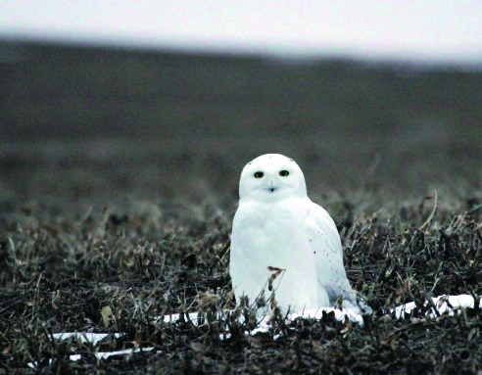  USFWS Mountain-Prairie. Snowy Owl. 29 Jan 2015. Flickr. Web. 14 Feb 2016.  <https://www.flickr.com/photos/usfwsmtnprairie/15804759224/> | The Snowy owl’s feathers get whiter as they get older, especially in the case of male birds. Their white color helps camouflage them in their white environment. It also helps them be good predators. They have a keen sense of sight and hearing and can hear small mammals burrowing underneath the snow, even though they can’t see them! When they hear or see a small mammal, they will dive-bomb the animal and snatch it up in its powerful talons. Sometimes the snowy owl will migrate south to avoid harsh winters.
Bobwhite Quail  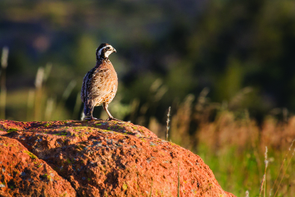  White, Larry. Quail 7-10-14. 10 July 2014. Flickr. Web. 14 Feb 2016.  <https://www.flickr.com/photos/lsmith2010/14442133530/> | The Bobwhite quail is extremely difficult to find because of its great camouflage. This is important because they make their nests on the ground and could easily be eaten. Quail travel in large groups (called coveys), dining on insects in the summer and seeds and other plant material in the winter. The coveys scurry from shrub to shrub, seeking shelter from predators (such as hawks). When startled, the entire covey will fly away in a burst of white because the bottom of their wings and breast are full of white feathers. All of this white confuses predators and makes it difficult for predators to track them in the sky. The quail can tolerate some cold, but they will die in harsh, cold winters.
Scorpion  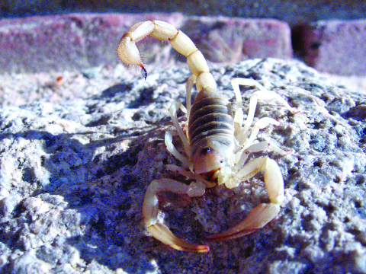  Hannawacker, Robb. “Giant Hairy Scorpion.” Wikimedia Commons. 25 June 2008.  <https://commons.wikimedia.org/wiki/File:Giant_hairy_scorpion,_Twentynine_Palms,_Ca_2813_RobbHannawacker.jpg> | The Scorpion is an interesting animal. It hunts at night by sensing creatures, such as insects or even other scorpions, through smell and feeling vibrations. After catching its dinner with its powerful claws, the scorpion will sting its prey, and the deadly venom will kill the animal. To prepare its insect meal, it will break it up into pieces, spit on it to digest it, and then suck up the digested insect with its mouthparts. Scorpions are hardy animals and can live for up to a year without a meal. They also can make a home out of many places, but prefer rock crevices, and other places that may be a little more wet and cool compared to their very hot and dry surroundings. Another fun fact about scorpions is that they carry their young on their back until their young molt, or shed their exoskeleton and grow a new one. Then the young are ready to live on their own.
Chuckwalla  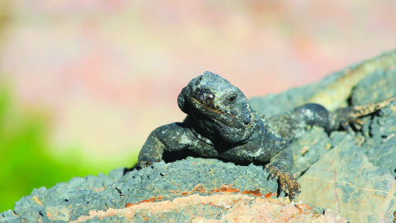  Pacific Southwest Region USFWS. Chuckwalla Lizard at Ash Meadows NWR. 30 May 2010. Flickr. Web. 14 Feb 2016.  <https://www.flickr.com/photos/usfws_pacificsw/5043086238/> | You might notice how the body of the Chuckwalla closely resembles the rock that it is on. This is good camouflage, and chuckwallas will use the rocks for shelter and protection, and are often found in or near rocks. In fact, if a predator is hunting them, they will scurry in between two rocks and inflate themselves so that even if the predator can get a grip on the animal, it will not be able to get it out! The chuckwalla is active during the day. At dawn, it will come out and first bask in the sun to warm up. Then it will forage for plants, such as fruits, seeds, twigs, and leaves, and get most of the water it needs from those plants to survive. Then it will seek the shelter of the shady, cool rocks during the extreme heat of the day.
Snowshoe Hare  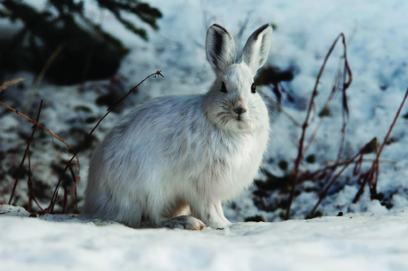  Denali National Park and Preserve. Snowshow Hare – Alert. 31 July 2011. Flickr. Web. 14 Feb 2016.  <https://www.flickr.com/photos/denalinps/6990916044/> | The Snowshoe hare is a non-picky herbivore, or plant eater. It will eat any plant material, such as seeds, leaves, twigs, and even bark, and will dig through snow to find plants to eat all throughout the winter. It gives birth in the spring, and the babies grow fast so they are ready to take care of themselves by fall. The snowshoe hare has short ears to help it keep warm and also a thick coat of fur. You will notice that its fur is also white, which is good camouflage. These hares spend a lot of time eating plant material and will stop eating and stand on their hind legs to survey the open landscape for predators. Their fat feet also act like snowshoes, allowing them to run very fast if spotted by a predator. They are also known to hop like a kangaroo on their fat feet!
Rock Ptarmigan  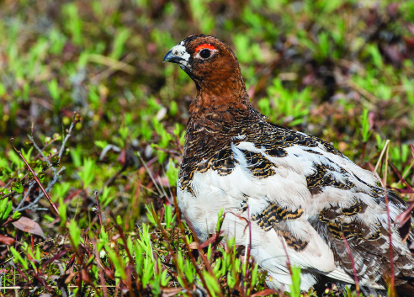  Bureau of Land Management. BLM Summer Roadtrip: Wildlife in the National Petroleum Reserve – Alaska. 25 June 2014. Flickr. Web. 14 Feb 2016.  <https://www.flickr.com/photos/mypubliclands/18725727734/> | The Rock ptarmigan is very capable of living in its harsh environment. Its white plumage helps it to camouflage in the snowy landscape. In the winter, it is often found among herds of muskox and caribou because these animals dig up the snow and leave behind plants that the rock ptarmigan can eat. In the summertime, they will also eat insects and snails found on the ground.
Ermine  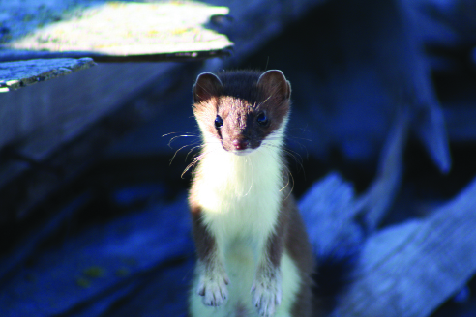  Bering Land Bridge National Preserve. Short-tailed Weasel. 27 Aug 2006. Flickr. Web. 14 Feb 2016.  <https://www.flickr.com/photos/bering_land_bridge/9514000664/> | The Ermine (also called stoat or short-tail weasel) is a small mammal and a sneaky predator. It has a great sense of hearing and can hear other small mammals burrowing through the snow. It has a terrible sense of sight, but can see better at night than during the day, and therefore can usually be found hunting at night. To survive the harsh cold winters, it does not hibernate, which is surprising for a small mammal. Instead, its brown summer coat is shed, and a thick, white fur grows in to keep the ermine warm and to camouflage it from predators on the snowy landscape. It has sharp claws, which makes it a great burrower and climber, and helps it find a den for shelter in the ground between rocks or in trees.
Deer Mouse  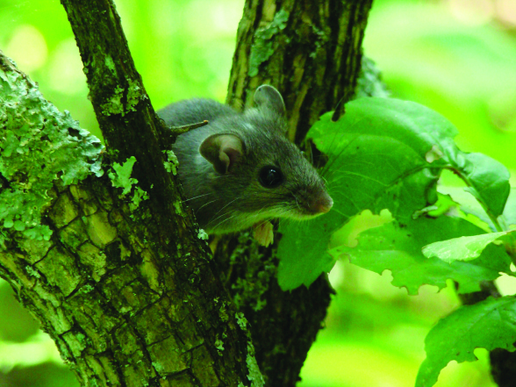  USFWS Mountain-Prairie. Deer Mouse in Tree. 22 June 2010. Flickr. Web. 14 Feb 2016.  <https://www.flickr.com/photos/usfwsmtnprairie/6438329699/> | Because it’s a small mammal, the Deer mouse is constantly eating. It will eat plant material and has hard teeth to crack through any seed coat or tougher plant material, such as twigs. It also will capture and eat small invertebrates, such as insects and other critters, that it finds as it scurries on the ground. But the deer mouse is also a favorite meal of many animals. It usually stays in its den during the day and comes out at night to hunt, allowing its brown upper coat to camouflage it well in a variety of settings. In the winter, it can burrow beneath the snow but cannot tolerate extremely cold ecosystems.
Spadefoot Toad  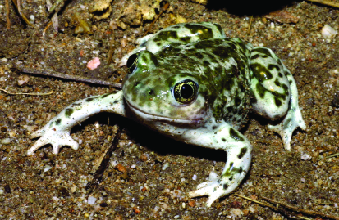  Brown, Chris. “A Western Spadefoot toad (Spea hammondii) Found Near Badger Canyon, CA.” USGS. 24 April 2002.  <https://www.usgs.gov/media/images/western-spadefoot-toad> | Spadefoot toads are one of the few amphibians that can tolerate very dry conditions. They can spend months at a time buried underground to avoid hot and dry conditions. Then, when enough rain falls to create small pools of water, they come out. These pools can dry up fast, so the toads lay their eggs immediately. Then their offspring go through metamorphosis faster than any amphibian—in only 14 days! Spadefoots dine on insects during this wetter season, and then they are back underground until the next period of significant rainfall.
Tiger Salamander  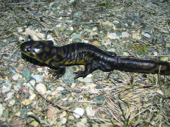  U.S. Fish and Wildlife Service Headquarters. Tiger Salamander. 11 Apr 2012. Flickr. Web. 14 Feb 2016.  <https://www.flickr.com/photos/usfwshq/6922589776/> | Tiger salamanders are appropriately named because of the pattern of color found on their back. They are the largest land-dwelling salamander on earth! They also have the largest range of any salamander in the United States. That means they can be found in many different ecosystems, but they must be able to borrow underground. Tiger salamanders will burrow up to 2 feet in the ground to protect themselves from heat or cold, or when there is a lack of food. They prefer to live near streams, ponds, or other water sources, but will survive in drier places too. They are nocturnal predators and will come out at night to eat worms, frogs, insects, and other salamanders.
Red-spotted Toad  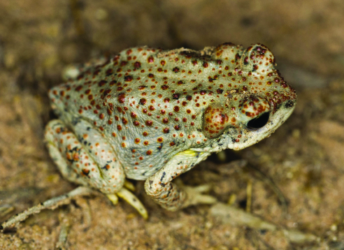  Hannawacker, Robb. Red Spotted Toad, Grand Canyon Inner Gorge. 10 Aug 2014. Flickr. Web. 14 Feb 2016.  <https://www.flickr.com/photos/39422575@N02/14766733088/> | The Red-spotted toad is a unique amphibian. Although it still depends on water to reproduce or find a mate, lay eggs, and grow as a tadpole, it can also be found up to a mile away from water when it’s an adult. To deal with the very dry season, the frog will burrow underground and stay in the cool ground until a rainfall. They even have been known to live underground in prairie dog towns. While underground, these frogs have a special flap of skin under their legs to allow them to absorb water and so that they can survive. After a significant amount of rainfall, they will emerge to eat insects and to reproduce.
Honeybee  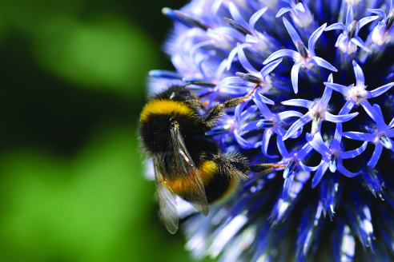  Campbell, John. “Bumblebee.” Flickr.  20 July 2017.  <https://www.flickr.com/photos/104346167@N06/35662485290/> | Honeybees are a common animal. They are often confused for wasps and hornets, but are very different. Honeybees are important to a plant’s lifecycle because they are pollinators, which means they move or carry pollen to a plant. They also collect pollen and nectar from the plants to make honey in the hive. You have probably heard the expression “busy bee.” This term comes from the fact that honeybees are very busy animals. They live in groups in a hive, and all have special and important jobs to ensure the hive survives well. In the summer, one special job of the worker bees is to group together and fan their wings to cool down the hive. In the winter, bees will feed on the extra honeycomb made from pollen and nectar of plants and will huddle together to keep each other warm to survive the coldest months. However, this strategy does not always work so well. They cannot survive the harshest, cold weather of the Arctic.
Plant Cards
Directions for teacher: Copy and cut up the plant cards. To print images in color, follow the URL on the card. Distribute among student groups. For your reference, the plants are matched to each ecosystem below.

Grasslands: | Desert: | Tundra:
little bluestem  prairie smoke  coneflower  kangaroo paw tree  aloe vera  Indian ricegrass | prickly pear cactus  barrel cactus  big sagebrush  aloe vera  Indian ricegrass | Antarctic hair grass  purple saxifrage  bear berry  diamond leaf willow

Little Bluestem  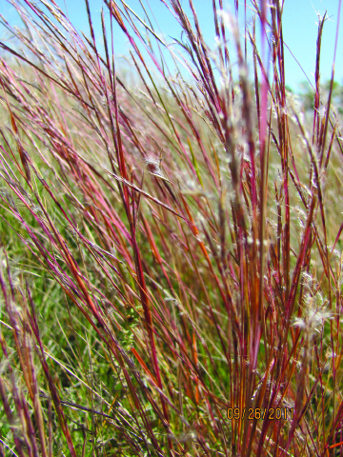  USFWS Mountain-Prairie. Little Bluestem (Andropogon scoparius). 26 Sept 2011. Flickr. Web. 14 Feb 2016.  <https://www.flickr.com/photos/usfwsmtnprairie/6188871250/> | Little bluestem grass has a large root system to keep it from being pulled up out of the ground by grazing animals. It also has narrow leaves so that it doesn’t lose too much water when conditions are dry. Little bluestem also takes advantage of windy conditions by being wind pollinated.
Prairie Smoke  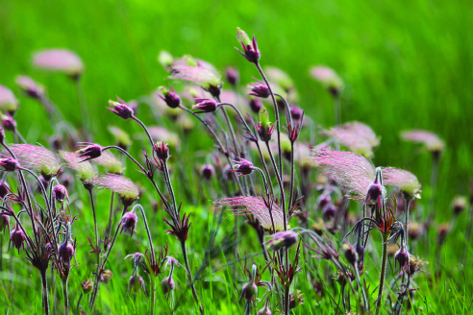  USFWS Mountain-Prairie. Prairie Smoke. 29 May 2014. Flickr. Web. 14 Feb 2016.  <https://www.flickr.com/photos/usfwsmtnprairie/14442675922/> | Prairie smoke gets its name because after its flowers are pollinated by bumblebees, the flowers go to seed and put out long tassel-like structures that look like smoke. Fuzz on its stems and leaves helps the plant keep the water it needs. The root system is fibrous and has rhizomes, which are like underground branches that allow prairie smoke to spread out over even more space by creating underground branches.
Coneflower  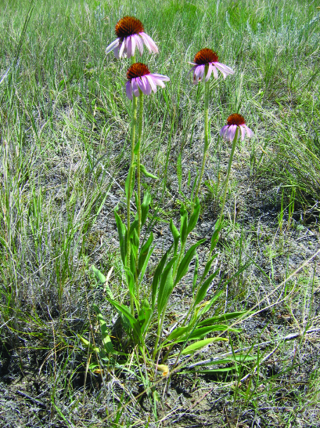  USFWS Mountain-Prairie. Purple Coneflower. 16 June 2014. Flickr. Web. 14 Feb 2016.  <https://www.flickr.com/photos/usfwsmtnprairie/14458960613/> | Grazing animals have learned that the prickly seed head of the Coneflower will hurt their lips and tongues, so they normally avoid eating this plant. Also, its leaves do not taste very good. This is another adaptation of the plant, as most animals prefer better-tasting plants (although some do eat the leaves). The coneflower has a large taproot that can absorb the tiniest amounts of moisture in the dry soil. The plant’s stem is thick, which protects it from losing water under hot, dry conditions. The coneflower also thrives in areas with fire because even though the above-ground part of the plant itself may be destroyed by fire, the roots survive.
Kangaroo Paw Tree  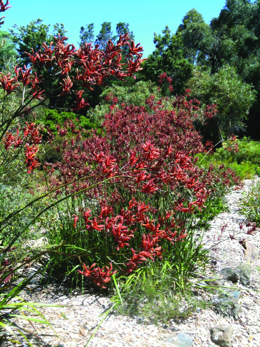  Ridgway, Stephan. Kangaroo Paw. 30 Jan 2011. Flickr. Web. 14 Feb 2016.  <https://www.flickr.com/photos/stephanridgway/5399559991/> | The kangaroo paw tree has a sturdy red stem that birds can perch on to easily access the nectar in its green flowers. This helps the plant because the bird’s movements pollinate the flower. The flowers are covered in little hairs that help protect the flower from being eaten because they taste weird to predators. The little hairs also help by holding on to water so that it can better survive where there is little water.  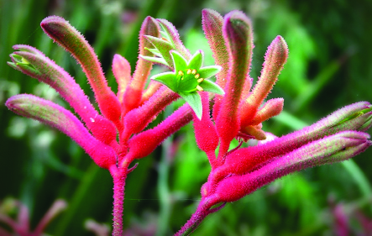  De Volder, Linda. Anigozathos flavidus. Kangaroo paw. 12 Aug 2007. Flickr. Web. 14 Feb 2016.  <https://www.flickr.com/photos/lindadevolder/1124094400>
Prickly Pear Cactus  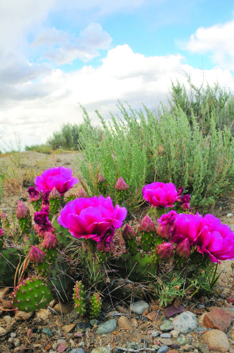  USFWS Mountain-Prairie. Prickly pear cactus (Opuntia polyacantha) Seedskadee National Wildlife Refuge. 22 June 2014. Flickr. Web. 14 Feb 2016.  <https://www.flickr.com/photos/usfwsmtnprairie/14535556695/> | The prickly pear cactus is good at surviving in areas with little water because it stores water in its pads, which are a modified stem. It then can use the water when there is a drought. Another way it conserves water is that it has spines instead of leaves. These spines also protect it from animals that may want to eat it. The prickly pear cactus grows low to the ground so it can better survive in windy places.
Barrel Cactus  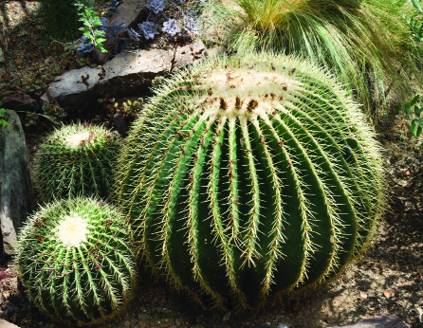  Intrepid00. “Golden Barrel Cactus.” Flickr. 9 August 2015.  <https://www.flickr.com/photos/intrepid00/20256146729/> | The barrel cactus gets its name from its barrel-shaped stem, which works as a water storage device for the plant. It has lots of spines that protect the plant from heat and animals, and help it not lose water in the dry environment. Animals are unable to eat the barrel cactus because of its thick spines, but its fruit can be eaten by various animals and birds. The animals and birds that eat the fruit help disperse, or move, the barrel cactus’ seeds. This helps the species continue surviving.
Big Sagebrush  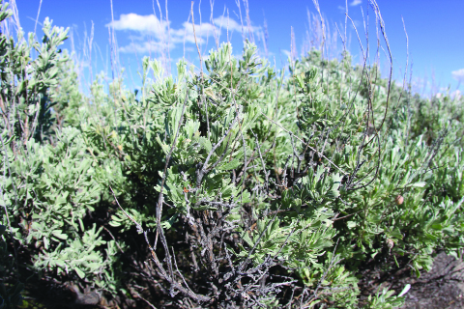  daveynin. Sagebrush Flats. 25 June 2010. Flickr. Web. 14 Feb 2016.  <https://www.flickr.com/photos/daveynin/4784153620/> | Big sagebrush grows two sets of leaves. In the spring when it is not as hot, it has big leaves to help it grow quickly. These leaves fall off in the summer when it becomes very hot, leaving the smaller leaves that grow on the plant year-round. These smaller leaves are covered with tiny hairs that give them a silky gray color. These hairs help protect the plant from drying out. Big sagebrush also has well-adapted roots for survival where there is little water. It has three sets of roots for absorbing all possible water. It has roots close to the surface for absorbing rainfall quickly. A second, deeper set of roots, absorbs water that soaks into the soil from winter snow melting. Thirdly, a taproot that goes 6 feet or more underground absorbs deep groundwater.
Aloe Vera  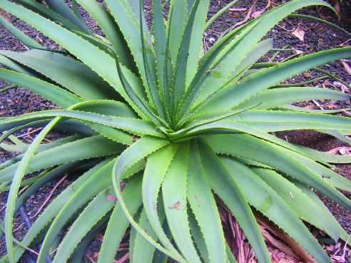  IES CANARIAS INSTITUTO. ALOE VERA 2. 8 Sept 2008. Flickr. Web. 14 Feb 2016.  <https://www.flickr.com/photos/iescanarias38010797/9144463048/> | The thick, fleshy leaves of aloe vera are great at holding water to sustain the plant, or keep it alive, during a drought. To help prevent water loss through the leaves, aloe vera has a waxy coating on the outside of its leaves.
Indian Ricegrass  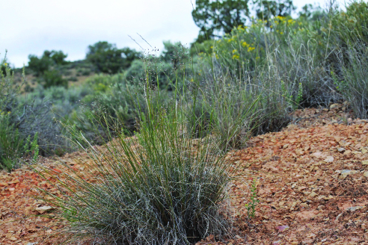  Zharkikh, Andrey. 2015.05.27_16.08.11_IMG_2399. 27 May 2015. Flickr. Web. 14 Feb 2016.  <https://www.flickr.com/photos/zharkikh/18284435112/> | Indian ricegrass is a native bunchgrass, which means it grows in bunches instead of spreading everywhere like the grass that is on a sports field. It looks delicate, but it can withstand the heat, cold, and ferocious winds. Its fibrous roots help it stay rooted in the ground even when it is blown by the strongest winds. Indian ricegrass is able to survive during a drought because it has thin leaves that lose little water. The seeds of Indian ricegrass were once used by Native Americans for grinding into flour to make bread.
Antarctic hair grass  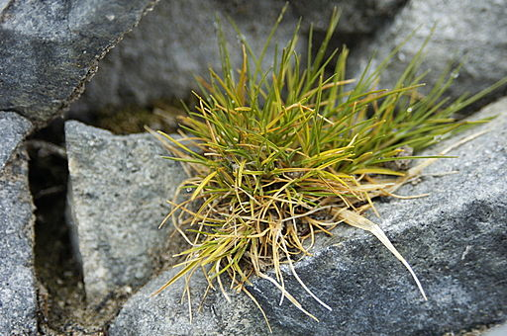  Lomvi2. “Deschampsia Antarctica.” Photograph. Wikimedia Commons. Web. 19 May 2010.  <https://commons.wikimedia.org/wiki/File:Deschampsia_antarctica.jpg> | Antarctic hair grass grows in dense mats very quickly during the summer. The Antarctic hair grass is able to reproduce even though it has a short growing season because it spreads its reproduction cycle over multiple years. It flowers in one summer, then goes dormant (like going to sleep) over the winter, and then the next year it continues to develop seeds from the previous year’s flowers.
Diamond Leaf Willow  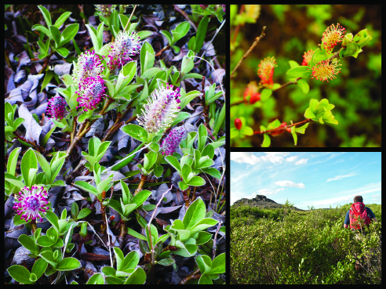  Bering Land Bridge National Preserve. Willows_2. Flickr. Web. 14 Feb 2016.  <https://www.flickr.com/photos/bering_land_bridge/16189204939/> | The diamond leaf willow grows low to the ground so that it doesn’t lose as much heat. It also has little hairs on its leaves to help it stay warm. Its twigs are soft and slender so that they bend easily in strong winds instead of breaking. When the diamond leaf willow is in bloom, it looks like a bumpy, fuzzy carpet covering the ground.
Bear Berry  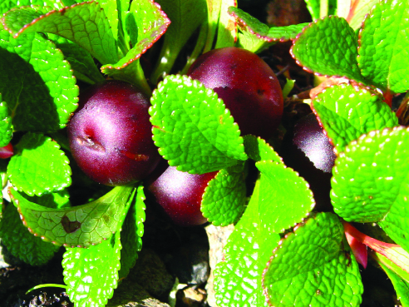  Hannawacker, Robb. Bear berries. 13 July 2009. Flickr. Web. 14 Feb 2016.  <https://www.flickr.com/photos/39422575@N02/12584857705/> | Bear berry grows low to the ground and often behind rocks where it can avoid strong, cold winds. It has leathery leaves that help it not lose water or heat. The plant is named “bear berry” because bears like to eat its red berries. When the bears eat the berries, it helps disperse the plants seeds.
Purple Saxifrage  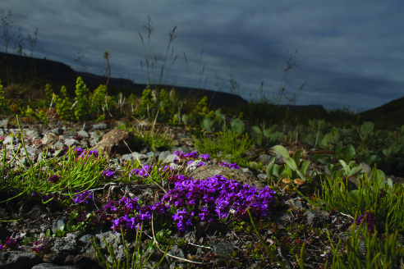  Gratwicke, Brian. Purple Saxifrage. 13 July 2013. Flickr. Web. 14 Feb 2016.  <https://www.flickr.com/photos/briangratwicke/9384585027/> | The purple saxifrage is called a “cushion plant” because it grows in a low, tight clump that looks like a seat cushion. Purple saxifrage can grow on rocky ground and has many branching roots. It is also one of the earliest plants to bloom in the spring. It sometimes flowers beside melting snow banks. Many tiny leaves cover the plant’s short stems and if you look closely, you may see tiny rigid hairs on the leaves. These tiny hairs help to capture the heat. The flowers grow above the cushion of small leaves and are bigger then the leaves.  Text adapted from: Giannetta, J. “ARCTIC PLANT LIFE.” June 2000, updated August 2011. Web. 14 Feb 2016.

Needs of the Organism Checklist
 | Animal #1:  What does this animal need to survive well? | Animal #2:  What does this animal need to survive well? | Plant #1:  What does this plant need to survive well?
Temperature or weather needs
Water needs
Types of animals it needs (as food)
Types of plants it needs (as food)
Shelter it needs (in plants or abiotic features)
 | Would these needs be met in my ecosystem? | Would these needs be met in my ecosystem? | Would these needs be met in my ecosystem?
Would the organism survive well, less well, or not at all in my ecosystem?

Scientists Do These Things Anchor Chart
(For Teacher Reference)

Scientists Do These Things anchor chart
Engaging in Argument  What’s needed for a scientific argument?  Preparing for the argument:  - Pose the question.  - Identify evidence that answers the question.  - Evaluate whether or not that evidence is sufficient to support the claim. “Is this good evidence?”  Making the argument:  - Make a claim.  I’m arguing that…  - Use the evidence and scientific reasoning to support the claim.  The evidence I have is…  This evidence shows...  - Explain why the evidence is sufficient and relevant.  This evidence is sufficient because… | Modeling  - A model has limitations because it is used to study one part of a system or object while not paying attention to other parts.  - A model can be a drawing or diagram, a physical replica, or a simulation. | Planning an Investigation:  - Pose a question that can be investigated with trials.  - Decide what can be changed (variables).  - Set up the procedure.  - Record observations.
Example:  Ecosystem and organism argument | Example: | Example:
Model Argument:
The Snowshoe Hare and the Tundra
Preparing for the argument
- Pose the question: Will the snowshoe hare survive well/ survive less well/ die in the ecosystem?
- Identify evidence:

Evidence about the ecosystem:  Evidence: The tundra is often snowy and cold.  Evidence: Food is scarce in the tundra. There are shrubs and grasses. | Evidence about the needs of the organism:  Evidence: The hare has thick fur to keep it warm.  Evidence: The hare turns white in the winter so it is camouflaged.  Evidence: The hare has flat teeth that can grind up any plant material.

- Evaluate the evidence: This is good evidence to make the claim that in a tundra the snowshoe hare will be able to survive well and grow and reproduce because it will get enough food and shelter.

Making the argument
- Make a claim: The snowshoe hare will survive well in the tundra because the characteristics of the habitat fully meet the hare’s needs.
- Use evidence and scientific reasoning to support the claim: Because the snowshoe hare has thick, white fur, it can stay warm and be camouflaged in the snowy tundra. Food is scarce in the tundra, but there are shrubs and grasses and the hare has flat teeth to grind up plants. So the snowshoe hare will survive well in the tundra because it can get its needs for shelter and food met.
- Evaluation of evidence: This is good evidence to make the claim that in a tundra the hare will be able to survive well and grow and reproduce because it will get enough food and shelter.

Final Argument:
Claim  Evidence with reasoning  Evaluation of evidence | The snowshoe hare will survive well in the tundra because the characteristics of the habitat fully meet the hare’s needs. The tundra is often snowy and cold, but the snowshoe hare has thick fur to keep it warm. The fur on the hare is white, which means it will be well camouflaged in the snow. So the tundra actually provides good shelter for the hare. The tundra has shrubs and grasses, and the hare has flat teeth that can grind up the plants. So the tundra provides the food that the hare needs. This is good evidence to make the claim that a snowshoe hare would survive well in the tundra because food and shelter are two very important parts of survival.

