MODULE LESSONS
Grade 1: Module 1: Unit 3: Lesson 2
Noticing and Describing: Looking at Models of a Magnificent Thing
Language Arts Curriculum

Ways We Work Together Anchor Chart
Collaboration  Looks Like ... | Collaboration  Sounds Like ...
- Taking turns  - Listening to another person  - Helping a teammate  - Doing some of the work  - Offering ideas | - Kind words  - Sometimes silence  - Helpful feedback
Magnificent Thing Model:
Student Pictures
(For teacher reference; see suggested materials)

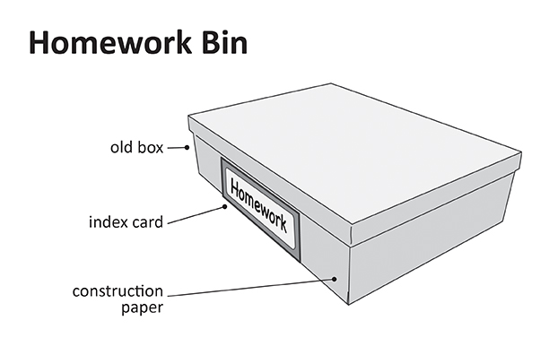
Magnificent Thing Model:
Student Pictures
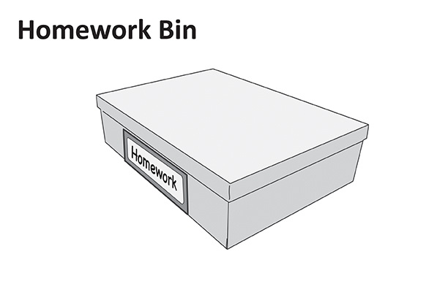
Magnificent Thing Model:
Student Pictures
(For teacher reference; see suggested materials)

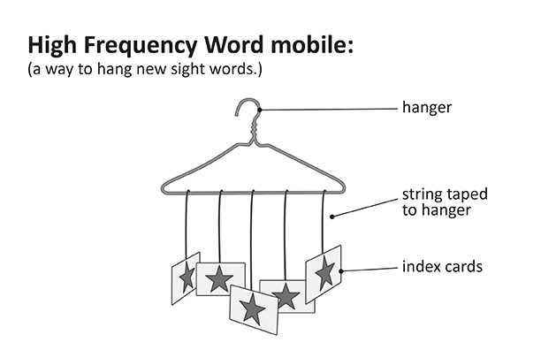
Magnificent Thing Model:
Student Pictures
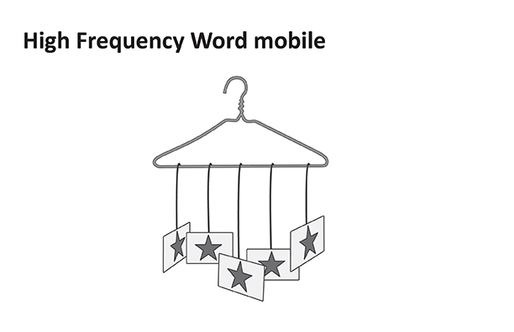
Magnificent Thing Model:
Student Pictures
(For teacher reference; see suggested materials)

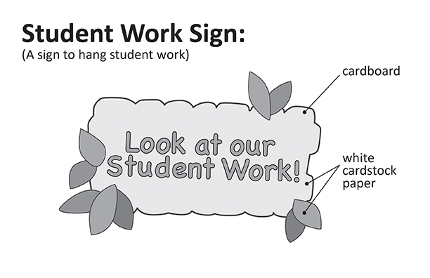
Magnificent Thing Model:
Student Pictures
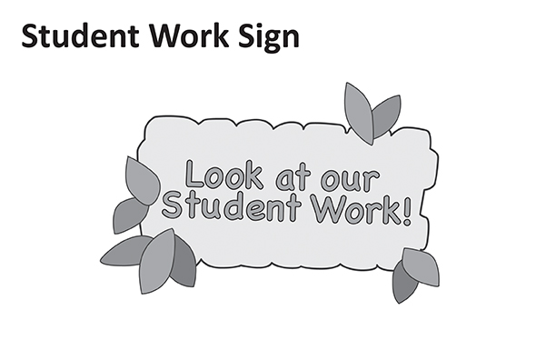
Magnificent Thing Model:
Student Pictures
(For teacher reference; see suggested materials)

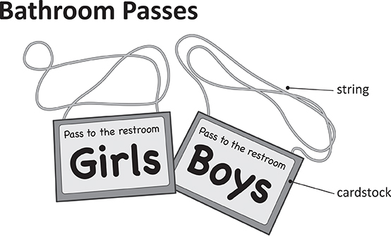
Magnificent Thing Model:
Student Pictures
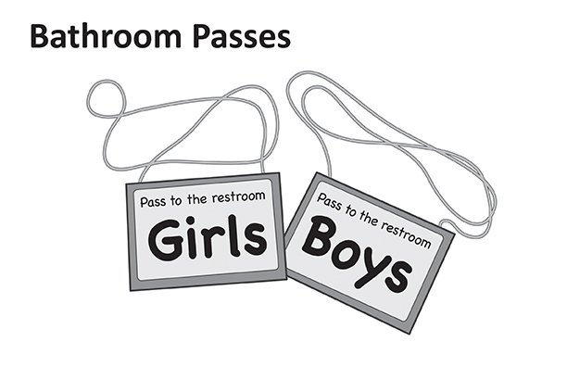
Magnificent Thing Model:
Student Pictures
(For teacher reference; see suggested materials)

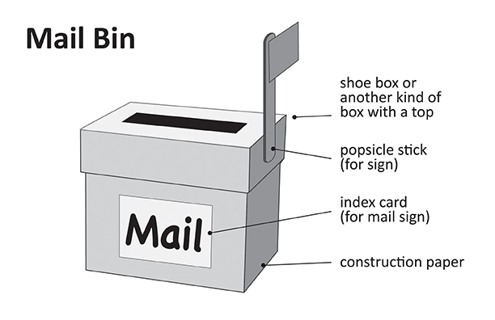
Magnificent Thing Model:
Student Pictures
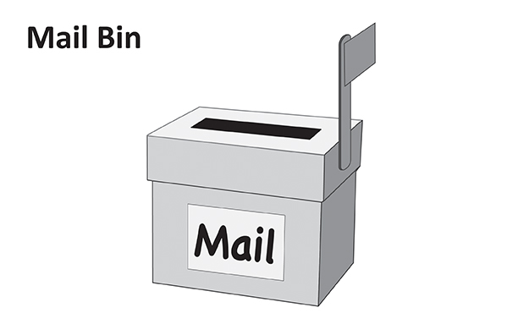
Magnificent Thing Model:
Student Pictures
(For teacher reference; see suggested materials)

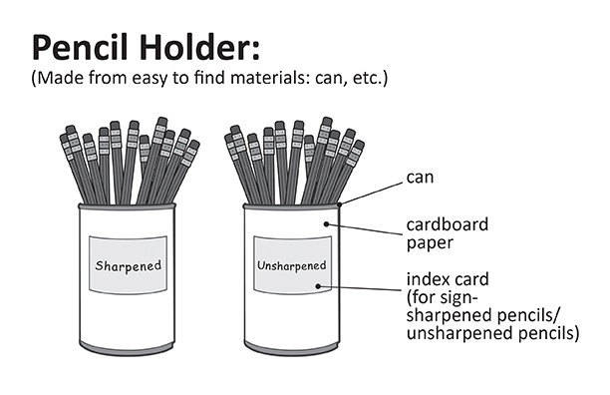
Magnificent Thing Model:
Student Pictures
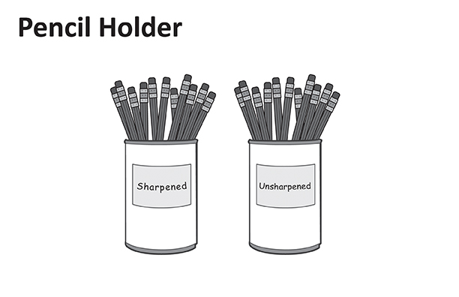
Classroom Magnificent Things
Anchor Chart
(For Teacher Reference)

Use pictures of the magnificent thing models in the left column. Add or replace pictures based on classroom decisions.

What we are making | Why we are making it
Teacher: Classwork Display Sign | Papers need to be displayed
Group 1: Mailbox | Need a place for important mail
Group 2: High-frequency sight word hanger | Sight words need an important spot in the classroom
Group 3: Pencil holder | Pencils need to be more organized
Group 4: Bathroom passes | Bathroom passes are missing
Group 5: Home bin | Homework needs to be more organized
Magnificent Thing Notebook
(Sample, for Teacher Reference)

Lesson 2 - Describe it! Page 1

My magnificent thing is a student work sign.

Tall   | Short  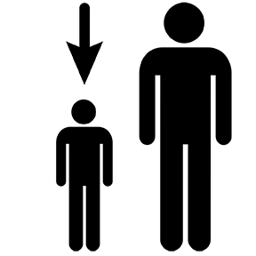 | Round   | Square   | Walls   | Corners  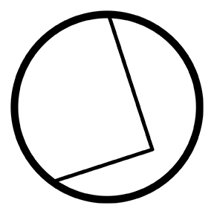
Flat   | Bumpy   | Striped   | Plain  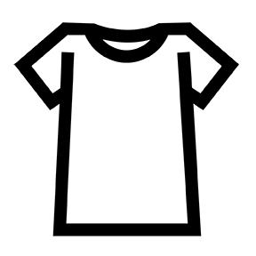 | Straight  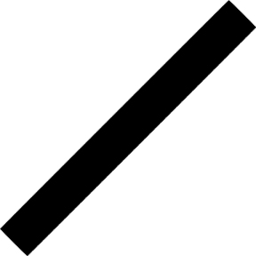 | Curved  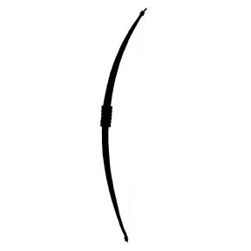

What size is it?
My sign is large. It is long.

What shape is it?
My sign is like a rectangle.

What color is it?
My sign has many colors. There are yellow letters and green leaves.

What parts does it have?
My sign has string and paper. It has letters and leaves.
Draw a sketch.

Responses will vary.
Magnificent Thing Notebook
Name: __________________________ Date: ______________

Lesson 2 - Describe it! Page 1

My magnificent thing is a ___________________________________________

Tall | Short | Round | Square | Walls | Corners
Flat | Bumpy | Striped | Plain | Straight | Curved

What size is it?
__________________________________________________________

What shape is it?
__________________________________________________________

What color is it?
__________________________________________________________

What parts does it have?
__________________________________________________________
Draw a sketch.

Magnificent Thing Notebook
(Sample, for Teacher Reference)

Lesson 3 - Plan it! Page 2

My magnificent thing is a class work display sign.

Scissors | Tape  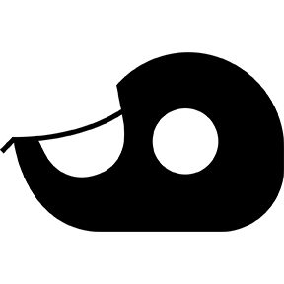 | Glue   | Stapler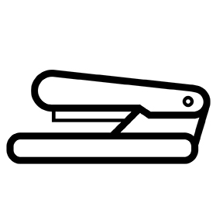

I will use
Scissors

to
cut the letters

I will use
hole puncher

to
poke holes for my string
Materials I Used

Paper  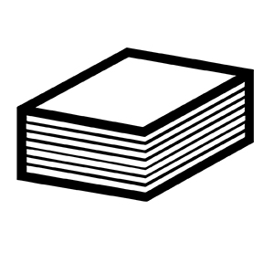 | String  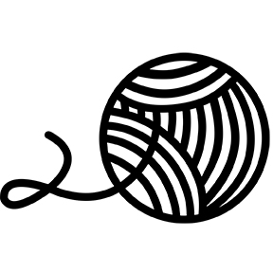 | Markers | Stencils

I will use
paper to make my letters. I also used markers to color leaves.

Responses will vary.
Magnificent Thing Notebook
Name: __________________________ Date: ______________
Lesson 3 - Plan it! Page 2

My magnificent thing is a _____________________________________

Scissors | Tape | Glue | Stapler

I will use
______________________________________________

to
______________________________________________

I will use
______________________________________________

to
______________________________________________
Materials I Used

Paper | String | Markers | Stencils

I will use
______________________________________________

Magnificent Thing Notebook
(Sample, for Teacher Reference)

Lesson 5 - Work on it! Page 3

My magnificent thing is a student work sign.

Today I worked on
cutting out the letters for the sign nice and neat. Also, I put the string on the top of the sign. I made the leaves with fabric instead of paper.

Today my magnificent thing looks like
Responses will vary.
Magnificent Thing Notebook
Name: __________________________ Date: ______________
Lesson 5 - Work on it! Page 3

My magnificent thing is a _____________________________________

Today I worked on

__________________________________________________________

__________________________________________________________

Today my magnificent thing looks like

Magnificent Thing Notebook
Name: __________________________ Date: ______________
(Sample, for Teacher Reference)

Lesson 6 - Revise it! Page 4

My magnificent thing is a student work sign.

Talk about each question with your group. Then circle yes or no.

Today I examined my magnificent thing to revise it. I discussed it with my group.

Does my magnificent thing work? | Yes or No
Does my magnificent thing look its best? | Yes or No
Will everyone know what my magnificent thing is? | Yes or No
Will everyone be able to use my magnificent thing? | Yes or No
Am I proud of the magnificent thing my group has created? | Yes or No

Here are one or two things we will change:

- I will make the string longer so that it can hang better on the board.
- I will remake two leaves because I rushed when I was cutting them before.
Magnificent Thing Notebook
Name: __________________________ Date: ______________
Lesson 6 - Revise it! Page 4

My magnificent thing is a _____________________________________

Talk about each question with your group. Then circle yes or no.

Today I examined my magnificent thing to revise it. I discussed it with my group.

Does my magnificent thing work? | Yes or No
Does my magnificent thing look its best? | Yes or No
Will everyone know what my magnificent thing is? | Yes or No
Will everyone be able to use my magnificent thing? | Yes or No
Am I proud of the magnificent thing my group has created? | Yes or No

Here are one or two things we will change:

- ________________________________________________________

________________________________________________________

- ________________________________________________________________

________________________________________________________
Magnificent Thing Notebook
(Sample, for Teacher Reference)

Lesson 7 - Finish it! Page 5

Today I finished my student work sign.

I finished my magnificent thing by
making the string longer. I also cut two new leaves to add onto my sign.

My finished magnificent thing looks like

Responses will vary.
Magnificent Thing Notebook
Name: __________________________ Date: ______________
Lesson 7 - Finish it! Page 5

Today I finished my __________________________________________

I finished my magnificent thing by

_________________________________________________________

__________________________________________________________

My finished magnificent thing looks like

Magnificent Thing Notebook
(Sample, for Teacher Reference)

Habits of Character Reflection
Page 6

Write about a habit of character you used that helped you make your magnificent thing.

- What habit of character did you use?
- Describe how you used that habit of character to help you make your magnificent thing.

I used initiative to get work done. I thought of a lot of ideas, and then I did them.
Magnificent Thing Notebook
Name: __________________________ Date: ______________
Habits of Character Reflection Page 6

Write about a habit of character you used that helped you make your magnificent thing.

- What habit of character did you use?
- Describe how you used that habit of character to help you make your magnificent thing.

Collaboration Anchor Charts
(For Teacher Reference)

Collaboration
I used collaboration today by …
- Listening to my classmates
- Sharing materials
- Etc.

Image Credits
Pages 3-14. All Magnificent Thing Model images created by Stacey Posnett for EL Education.

