Grade 3: Life Science Module 2: Unit 2
Lesson Sequence 2:
Environment and an Organism’s Traits
Life Science Module

Concepts Scientists Think About Anchor Chart
(For Teacher Reference)
Concepts Scientists Think About anchor chart
Patterns | Cause and Effect | Systems
A repeated event or object  Finding patterns help us see similarities and differences and make predictions. | Events have causes. Cause and effect relationships are identified, tested, and used in explanations.  Identify and test relationships in order to explain change.
Example: Variation in families happens in human families as well as in other animal families.
Example: All life cycles have the pattern of birth, growth, reproduction, and death.
Example: All offspring inherit traits from their parents.

Dog Pictures
Directions: Print out and display the images below. To print in color or display digitally, use the links provided.

Picture #1

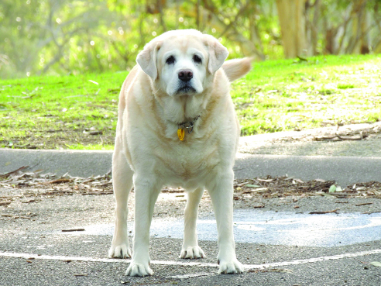

PsJeremy. “fat-dog1.” Photograph. Flickr. 7 June 2012. Web. 21 March 2016. <https://www.flickr.com/photos/psjeremy/7347447292/>

Dog Pictures
Picture #2

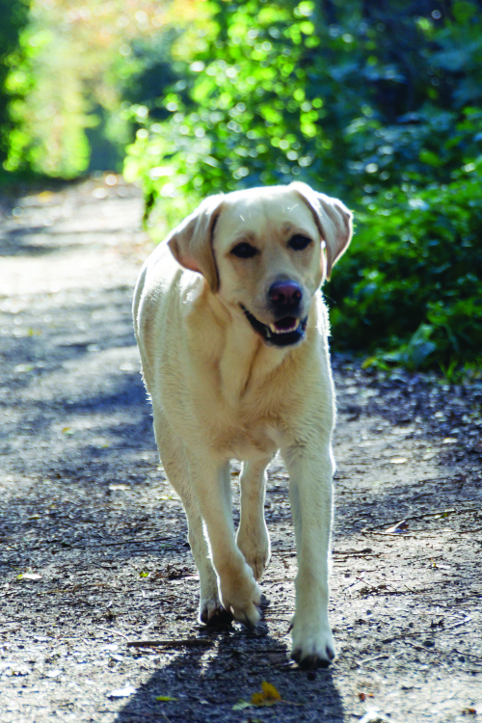

Eselsmann. “Random.” Flickr. 8 November 2014. https://www.flickr.com/photos/eselsmann/15782183836/

Dog Pictures
Picture #3

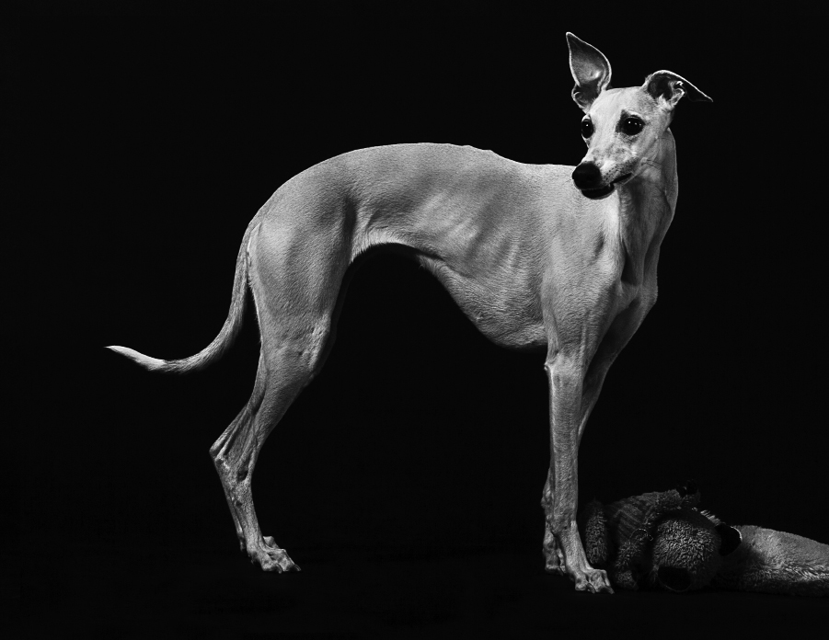

Huey, Trista. “Whippet.” Flickr. 2 December 2014. https://www.flickr.com/photos/132617695@N04/17018374477/

Planning a Frog Pond Anchor Chart
Planning a Frog Pond
Problem: Frogs are losing habitats

Task: Build a frog pond that meets the needs of a frog at all stages of its life.
Identify Needed Evidence: What do we need to know? What questions do we have?

Responses will vary. Be sure students identify components of the habitat.
Possibilities might include:
- Where frogs want to live
- What frogs like to sleep on
- The plants and other animals that share their habitat.
- What frogs eat
- Do frogs eat the same thing at all parts of their life?
- Where frogs get their food
- Is pond water normal water?
- What should the pond be built out of?
Collect Evidence: “How do we know our frog pond designs will positively affect the traits of our frogs and will meet the survival needs of frogs?”
Habitat Anchor Chart
Habitat anchor chart
Task: Create a habitat where all the needs of a frog are met throughout its life cycle

What are the parts of a frog habitat?
Food | Water | Shelter/Space
Air: This is a given—something that we already know. We have
clean air.
Hungry Bullfrog Simulation Student Directions
You are a bullfrog who lives in a pond.
You are hungry.
All day you look for food.

Take turns drawing a card to see how you interact with your environment.

For example, if you find food, your card will tell you to collect a token(s) and gain weight. If you use lots of energy hopping around, you may be told to return a token(s) to the bowl and your weight will go down. The tokens represent the weight that is gained when an animal eats food or is used when the animal moves around.

Directions:
Draw a card and read it out loud.
  - Follow the directions on the card to either collect tokens from the bowl or return tokens to the bowl.
  - Record the thing in the environment that caused your frog to gain weight or lose weight (like “snake,” “mayflies,” or “hiding under tree”). Use the chart provided in your student science notebook in the “Using Models” section.
  - After recording the relationship, discard the card into a separate pile.
  - Next player repeats Steps 1–4.
  - Continue taking turns until the time is up.

Optional Special Cards:
The player with the Long Tongue Inherited Trait card is allowed to collect two extra tokens each time he or she draws a card that allows him or her to eat.
Hungry Bullfrog Simulation Teacher Directions
(For Teacher Reference)

Overview:
The sack represents the frog. The tokens represent the food. Animals get energy from food, and they use that energy to survive by moving to find a mate or find food or shelter. Each card gives a scenario about how a frog interacts with its environment and explains how either the animal uses energy and loses food and has to take tokens out of the sack and/or gains tokens that represent energy from getting food from its environment. In the second round of play, one student inherits an extra-long tongue that allows him or her to eat extra food. This second round should be used to emphasize that traits are influenced by inheritance as well as the environment.

Focusing Question: Does the environment have an effect on a frog’s trait of weight?

Setup:
Place Hungry Bullfrog cards and tokens in the middle of the table.
Open up the Environment and an Organism’s Traits Entry of the student science notebook to record interactions from cards under the Using Models section.
Place 10 tokens in every sock before beginning.

Directions:
First student draws a card and reads it out loud.
First student puts tokens in the bowl or draws tokens out and puts them in the sack as directed by the card.
First student then records the cause and effect relationship on the card in the student science notebook in the Using Models section on the chart provided. The student writes the thing in the environment that caused the bullfrog to gain or lose weight (i.e., snake, mosquito, fallen tree).
After recording the relationship, discard the card into a separate pile.
Students take turns repeating Steps 1–4 until the time is up.

Optional Second Round:
Each student empties his or her frog and begins again.
At random, give one student from each group the Long Tongue Inherited Trait card and explain that this card allows that student to collect two extra tokens each time he or she draws a “frog eats” card.
Hungry Bullfrog Simulation Cards
You eat up a grasshopper that hopped onto the log.  (plus 1 token) | You eat up a grasshopper that hopped onto the log.  (plus 1 token)
You eat up a grasshopper that hopped onto the log.  (plus 1 token) | A group of mosquitos are hatching in the pond. You eat all day long.  (plus 4 tokens)
A small snake slithers by, and you catch it and eat it! What a big meal!  (plus 6 tokens) | You are well camouflaged in the lily pads. You eat many unsuspecting flies pollinating the lily flowers.  (plus 4 tokens)
A small fish swims by in the water. You catch it and eat it.  (plus 1 token) | A group of mayflies hatch from the water, and you eat all day long!  (plus 6 tokens)
You capture and eat a sphinx moth that lands on a nearby plant.  (plus 1 token) | You capture and eat a sphinx moth that lands on a nearby plant.  (plus 1 token)
You capture and eat a sphinx moth that lands on a nearby plant.  (plus 1 token) | You eat a cricket frog swimming by.  (plus 2 tokens)
A pond has many lily pads that give you places to hide. You spend the day eating.  (plus 6 tokens) | A tree falls into the water, providing lots of hiding places for you to catch food.  (plus 4 tokens)
You camouflage well in a patch of duckweed and snatch many unsuspecting insects from the air as they fly by.  (plus 5 tokens) | A beaver dam breaks, your pond drains, and you have to spend the day traveling to a nearby pond.  (minus 6 tokens)
A heron tries to eat you along the shore, but you swim away into deeper water where the heron can’t get you.  (minus 2 tokens) | It turns out to be a very cold day, so you hide in the mud and leaves to stay warm.  (minus 4 tokens)
You must evade a snapping turtle that is hunting you.  (minus 2 tokens) | A snake chases you.  (minus 2 tokens)
Lots of other frogs move into your pond and eat your food.  (minus 5 tokens) | A hawk is circling the pond all day. You spend the day hiding in cattails and are not able to eat.  (minus 5 tokens)
Kids with nets come and put you in a jar for half the day. No food.  (minus 3 tokens) | A painted turtle is hunting you, but you swim away.  (minus 2 tokens)

Long Tongue Inherited Trait Card (Optional)
Inherited Trait:  Long Tongue    Your long tongue allows you to take 2 extra tokens every time your bullfrog “eats.” | Inherited Trait:  Long Tongue  Your long tongue allows you to take 2 extra tokens every time your bullfrog “eats.”
Inherited Trait:  Long Tongue  Your long tongue allows you to take 2 extra tokens every time your bullfrog “eats.” | Inherited Trait:  Long Tongue  Your long tongue allows you to take 2 extra tokens every time your bullfrog “eats.”
Inherited Trait:  Long Tongue  Your long tongue allows you to take 2 extra tokens every time your bullfrog “eats.” | Inherited Trait:  Long Tongue  Your long tongue allows you to take 2 extra tokens every time your bullfrog “eats.”

Scientists Do These Things Anchor Chart
(For Teacher Reference)

Analyzing and Interpreting Data | Modeling | Constructing Explanation | Engaging in Argument
Organize data in tables and/or graphs.  Look at the table/graph to see patterns and relationships. | - A model can be a drawing or diagram, physical replica, or a simulation.  - A model has limitations because it is used to study one part of a system or object while not paying attention to other parts.  - A model can help make predictions. | - OBSERVE relationships  I notice...  I wonder...  This seems…  This connects to…  This relates to that…  - COLLECT evidence (Make a more focused observation)  Let’s look more closely…  And now I notice…  And now I wonder...  Let’s read more to find out... | - Preparing for the argument:  - Pose the question.  - Identify evidence that answers the question.  - Evaluate whether that evidence is good enough.  - Making the argument:  - Make a claim  I’m arguing that...  - Use the evidence and scientific reasoning to support the claim  The evidence I have is…  This evidence shows...

Analyzing and Interpreting Data | Modeling | Constructing Explanation | Engaging in Argument
 |  | - IDENTIFY what EVIDENCE supports the observed relationship  This evidence makes me think that…  X, Y, and Z have convinced me there is a relationship...  - Construct explanation (Now you’re ready to share your thinking)  - Make a CLAIM that answers the question (in speaking or writing).  There appears to be a (pattern, connection, relationship)...  - Describe EVIDENCE to support the claim  My evidence for the claim is…  - Provide scientific REASONING to connect evidence to claim  The evidence shows…  So… | - Explain why the evidence is good evidence  This is good evidence because...

Analyzing and Interpreting Data | Modeling | Constructing Explanation | Engaging in Argument
Example: Lily observations are organized on a table. Organizing the data helped us identify the pattern of variation among siblings. | Example: Life cycle model | Example:  Offspring look the way they do because they inherit traits from parents. | Example:  The bullfrog is affected by the environment.
 |  | Example: Bullfrog and water lily variation of traits helps organisms survive in specific environments.

Pond Slideshow
Directions: Create a digital slideshow or prepare photos to display in color in order to activate student thinking about the parts of the pond. Feel free to augment the slideshow with additional pictures, especially if you have pictures of a local pond.

Slide 1

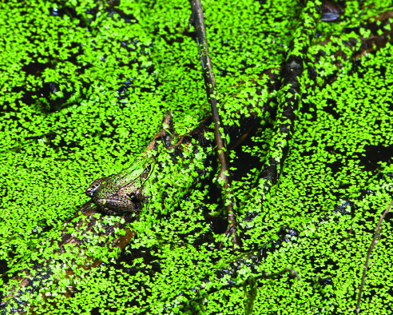

West, Liz. “Hiding in Plain Sight.” Flickr. 19 July 2014. <https://www.flickr.com/photos/calliope/14590870578/>

Caption: Duckweed is a small plant that grows in the water of ponds. But what is the environment that helps it grow best?
Pond Slideshow
Slide 2
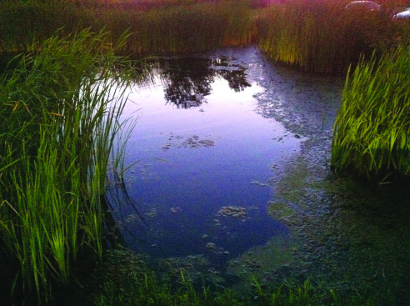

Rothhaas, Joshua. “Little Pond.” Photograph. Flickr. 27 Aug 2010. Web. 23 March 2016. https://www.flickr.com/photos/joshuarothhaas/4933082943/

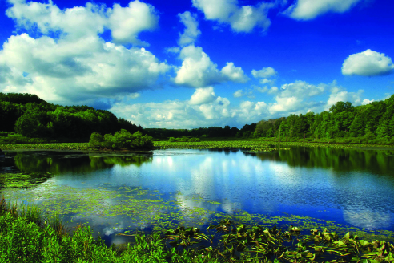

Tonelli, Nicholas A. “Erie National Wildlife Refuge (Revisited) (12).” Photograph. Flickr. 1 June 2013. Web. 23 March 2016. https://www.flickr.com/photos/nicholas_t/9056430996/

Caption: There are many parts to a pond. The water can be different temperatures, different depths, get different amounts of sunlight, and be full of other plants or empty. What difference do you see in the pond water here?
Pond Slideshow
Slide 3

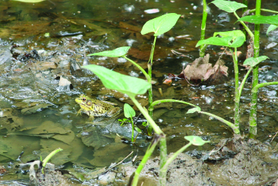

Cliff. “Northern Green Frog (Rana clamitans melanota).” Photograph. Flickr. 2 May 2009. Web.
23 March 2016. https://www.flickr.com/photos/nostri-imago/3564690699/

Caption: The edge of the pond has shallow water and sometimes lots of debris. Would duckweed grow here?
Pond Slideshow
Slide 4

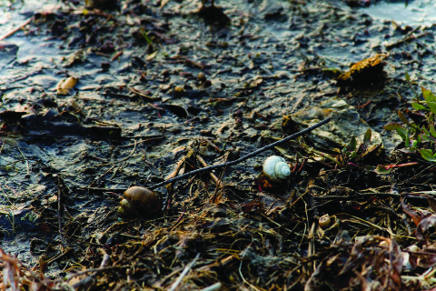

McMenemy, Sean. “Snails.” Photograph. Flickr. 6 April 2011. Web. 23 March 2016. https://www.flickr.com/photos/seanfx/5597317005/

Caption: The shore of the pond has very little water. Is it enough for duckweed to grow? How much water does duckweed really need?
Pond Slideshow
Slide 5

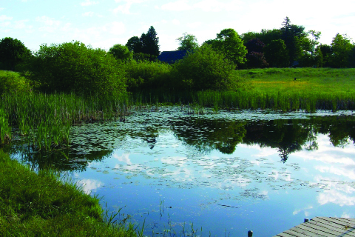

InAweofGod’sCreation. “Pond at Gilsland.” Photograph. Flickr. 4 June 2009. Web. 23 March 2016. https://www.flickr.com/photos/nhoulihan/3598110326/
Caption: In the middle of the pond, the water is usually deeper. Does duckweed like deeper water? Is deeper water cooler or warmer than shallow water?
Pond Slideshow
Slide 6

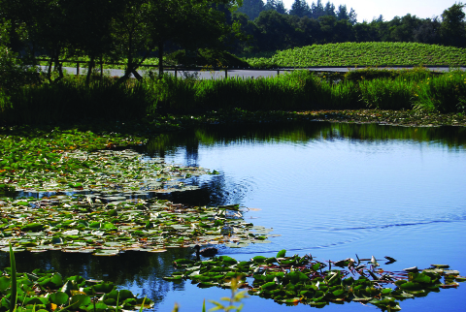

Kimpel, Kathy. “duck pond.” Photograph. Flickr. 13 June 2008. Web. 23 March 2016. https://www.flickr.com/photos/kkimpel/2581788174/

Caption: Sometimes ponds get different amounts of sunlight. The tall trees provide some shade, but the open water is sunny. How much sunlight might duckweed need?
Pond Slideshow
Slide 7

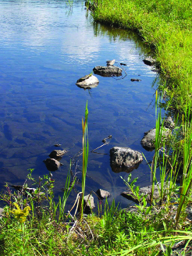  https://www.flickr.com/photos/andyarthur/4943126126/  Arthur, Andy.” Edge at Mallet Pond State Forest. Mallet Pond’s embankment is made up these large flat shale rocks, and lined with them to discourage erosion over its massive earthen dam.” Photograph. Flickr. 30 Aug 2010. Web. 23 March 2016. | 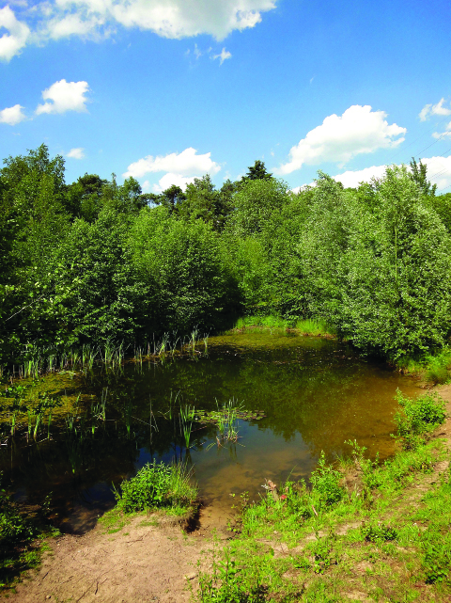  https://www.flickr.com/photos/dnet/5783925100/  Dronkert, E. “Poel aan de rand van het bos.” Photograph. Flickr. 30 May 2011. Web. 23 March 2016.
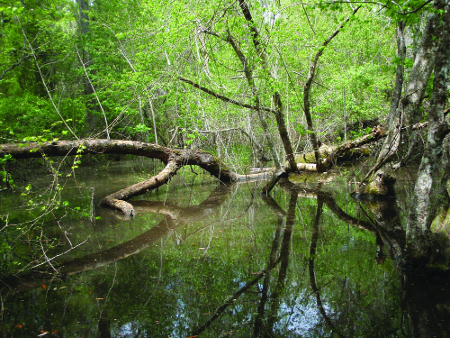

Quarterman, John S. “Logs in Pond.” Flickr. 10 April 2010. https://www.flickr.com/photos/98706376@N00/4517229405/

Caption: Ponds have lots of other things in them, too: dead logs, dead leaves, rocks, dirt. What might be the different non-living things that a pond has in it? Could they affect the growth of duckweed?
Pond Slideshow
Slide 8

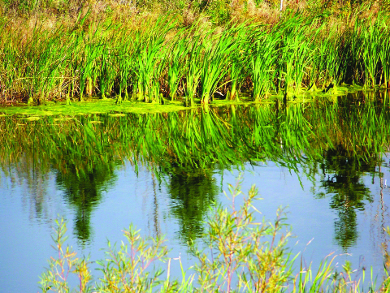

Art of Nature – Canada. “Pond Edge.” Photograph. Flickr. 17 Oct 2011. Web. 23 March 2016. https://www.flickr.com/photos/government-lists-canada/6261420020/

Caption: What difference do you see in the pond water here?

