MODULE LESSONS
Grade 1: Module 1: Unit 2: Lesson 8
Focused Read-aloud, Session 2:
What Work Does Initiative Help the Characters Do?
Language Arts Curriculum

Session 2, Feeling Words
Student Response Sheet
(Answers, for Teacher Reference. Answers are italicized.)

On page 24, how is Eraser feeling?
Circle one:
 |  |  |  | 
Circle the word that helped you know how she was feeling:
“Oh, no,” whispered Eraser. “Pen is in the ... the …”

On page 25, how is Box feeling?
Circle one:
Circle the word that helped you know how she was feeling:
“Can’t have ’em.” Box scowled.

Session 2, Feeling Words:
Student Response Sheet
Name: ___________________________ Date: _____________
On page 24, how is Eraser feeling?
Circle one:
Circle the word that helped you know how she was feeling:
“Oh, no,” whispered Eraser. “Pen is in the ... the …”

On page 25, how is Box feeling?
Circle one:
Circle the word that helped you know how she was feeling:
“Can’t have ’em.” Box scowled.

Words That Show Feelings Anchor Chart
(For Teacher Reference)
Feeling | Words that show feeling
 | Frowned
 | Scowled
 | Whispered
 | Exhausted

The Little Red Pen Initiative
(Answers, for Teacher Reference)

In this part of the text, how is Highlighter showing initiative? What work does initiative help him do? Use evidence to support your answer.

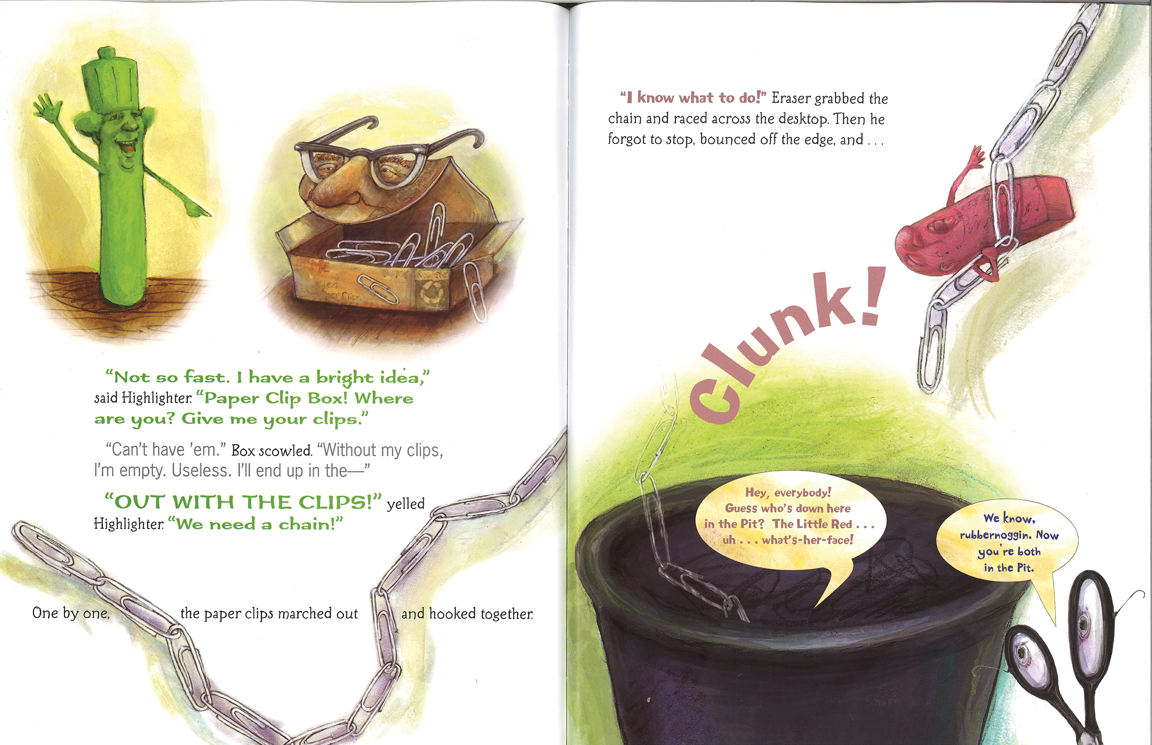

The Highlighter is showing initiative.
Highlighter showed initiative by thinking of a way to save Little Red Pen. Initiative helped to get Little Red Pen out of the trash.

This is one way he got the job done.
The Little Red Pen Initiative
Name: ___________________________ Date: ____________
In this part of the text, how is Highlighter showing initiative? What work does initiative help him do? Use evidence to support your answer.

The Highlighter is showing initiative.
______________________________________________
______________________________________________
______________________________________________
______________________________________________
______________________________________________

This is one way he got the job done.
Image Credits
Pages 5-6. From THE LITTLE RED PEN by Janet Stevens and Susan Stevens Crummel. Text copyright © 2011 by Janet Stevens and Susan Stevens Crummel. Illustrations copyright © 2011 by Janet Stevens. Reprinted by permission of Houghton Mifflin Harcourt Publishing Company. All rights reserved.

