MODULE LESSONS
Grade 1: Module 1: Unit 1: Lesson 8
Unit 1 Assessment: Focused Read-aloud and Writing about Tools
Language Arts Curriculum

Types of Tools, Picture Set 3
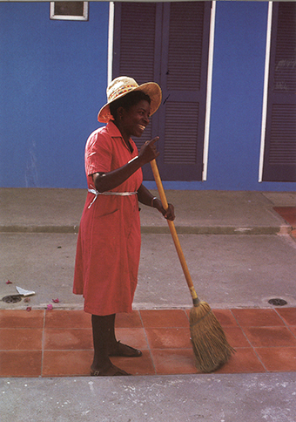

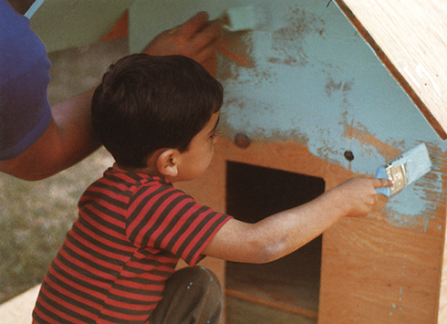
Types of Tools, Picture Set 3


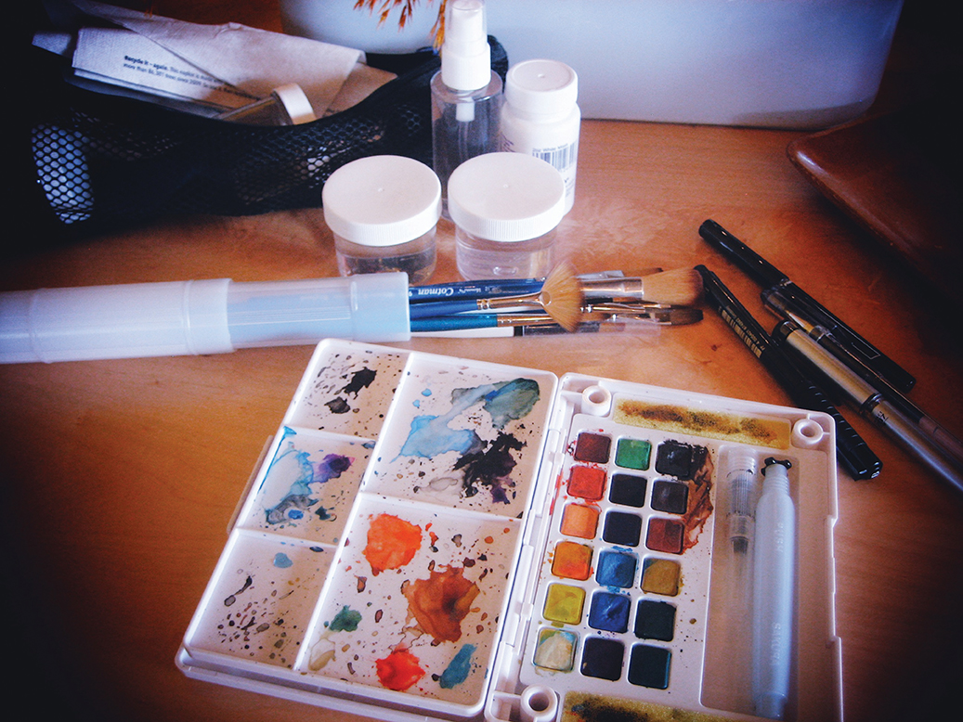
Image Credits
Page 2. Images from Tools, copyright (c) 1992 by Ann Morris. Photographs copyright (c) 1992 by Ken Heyman. Used by permission of HarperCollins Publishers.
Page 3. “Stock photo of ‘people, housework and housekeeping concept - close up of woman with legs vacuum cleaner cleaning carpet at home’.” Photograph. Shutterstock. Web. 16 June 2017.
Page 3. McMenemy, Sean. “My Water color kit open.” Photograph. Flickr. 1 March 2013. Web. 7 May 2017.

