MODULE LESSONS
Grade 1: Module 1: Unit 1: Lesson 5
Asking and Answering: Why Do We Need Tools?
Language Arts Curriculum

Mission Letter #2
Challenges: Complete!

Congratulations on completing all of the challenges. You are one step closer to achieving your mission.

Tools are going to help you create an object needed for your class, so it is a good thing you have started to learn about them.

You will now be given very important photographs and a book called Tools by Ann Morris. Listen to your teacher as the book is read aloud, and look at the pictures closely to discover more about tools. Find clues about what types of tools you can use to make things easier.

Remember, your mission is to create an object that is needed for our classroom. This book will give you many of the answers you need in order to continue with the mission.

Headquarters will check in on your progress to see if you are getting closer to achieving the mission.

Good luck
Types of Tools, Master Picture Set

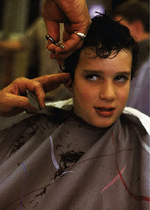
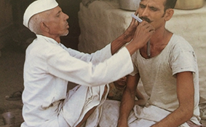
Types of Tools, Master Picture Set
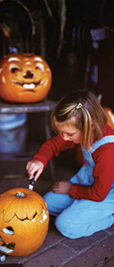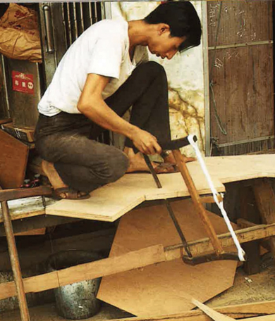
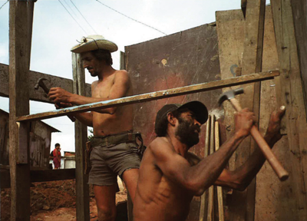
Types of Tools, Master Picture Set

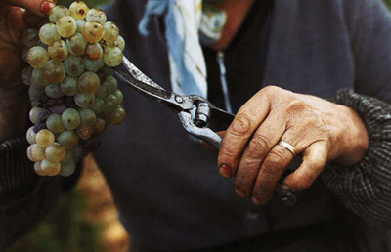

Types of Tools, Master Picture Set
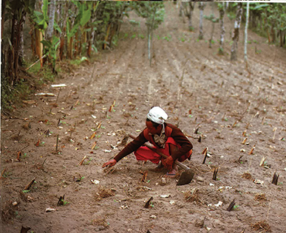
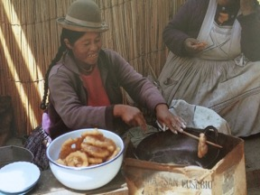
Types of Tools, Master Picture Set
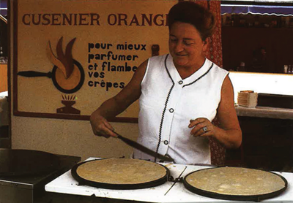
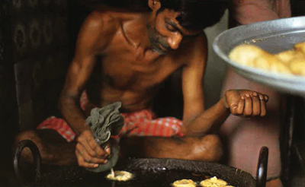
Types of Tools, Master Picture Set



Types of Tools, Master Picture Set
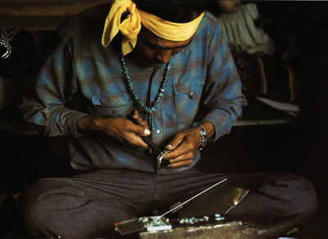
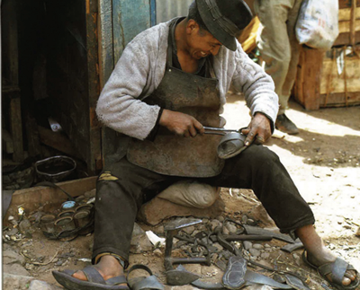
Types of Tools, Master Picture Set
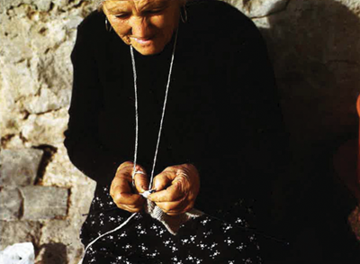
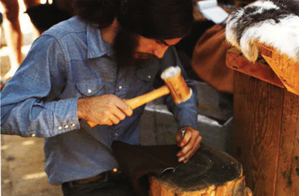
Types of Tools, Master Picture Set
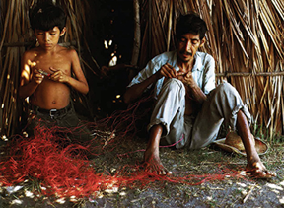
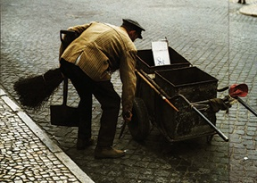
Types of Tools, Master Picture Set
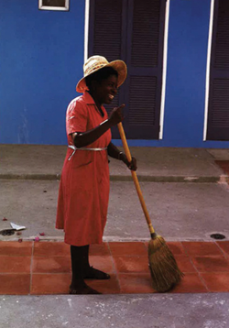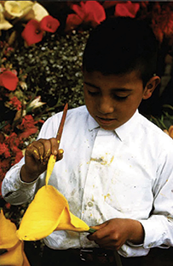
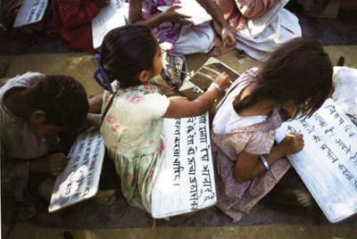
Types of Tools, Master Picture Set
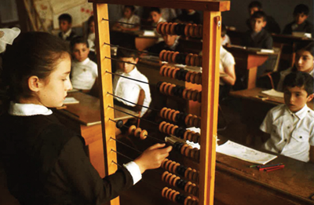
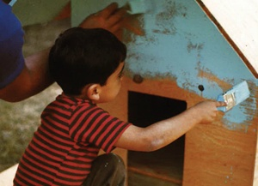
Types of Tools, Master Picture Set
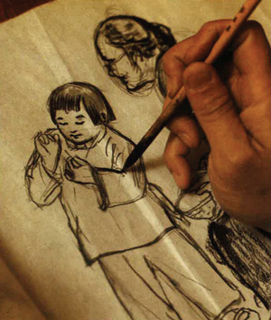
Classroom Discussion Norms
Anchor Chart
(For Teacher Reference)

Classroom Discussion Norms
Listen with care.
Look at the speaker.
Take turns speaking.
Stay on topic.

Questions about Tools Anchor Chart
(For Teacher Reference)

Note to Teachers: This anchor chart will be used in the remaining Unit 1 lessons.
Students’ questions may vary.

Tool Questions
Our Questions  about Tools | Our Answers

Image Credits
All images in the Types of Tools, Master Picture Set are from Tools, copyright (c) 1992 by Ann Morris. Photographs copyright (c) 1992 by Ken Heyman. Used by permission of HarperCollins Publishers.

