MODULE LESSONS
Grade 2: Module 2: Unit 2: Lesson 10
Close Reading: “Fossils and the Earth Long Ago” Part 1
Language Arts Curriculum

Fossils and the Earth Long Ago
Name: ________________________ Date: _______________

1 | Rock Layers  Look at the rock in the picture. This rock is called a sedimentary rock. These rocks are made from layers of mud and sand. The layers got pressed together. Slowly they became rock. It takes a long time to make sedimentary rock. Paleontologists look at fossils inside the layers of these rocks. This helps them learn about plants and animals from long ago. Fossils in the bottom layers are the oldest. Fossils in the top layers are not as old. Paleontologists found more plant fossils in the bottom layers. They found more animal fossils in the top layers. This means that plants were on Earth before animals. They also learned that the oldest plants did not have roots! They floated in water. | 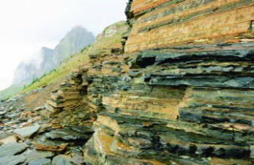
2 | Learning from Fossils  Fossils give clues about the past. Fossils give paleontologists information about plants and animals from long ago. They can study, or look closely at, a fossil of a tooth. A sharp tooth means the animals ate meat. A big tooth means the animal was big. They can also learn from fossil footprints. A big footprint means the animal was big. A small footprint means the animal was small. | 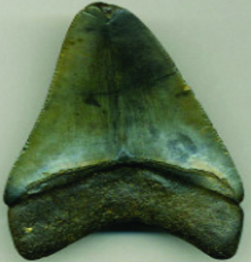
3 | Earth Long Ago  Fossils can tell us what Earth was like a long time ago. They tell us about how it has changed. Paleontologists may be on a mountain. They may find a fossil of a fish on the mountain. This was not a mountain a long time ago. It was underwater! They may go to a cold place. They may find a fossil of a plant that grows in warm places. This means the place was not cold a long time ago. It was warm. The earth has changed a lot! | 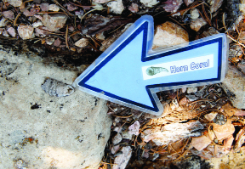

Written by EL Education for Instructional Purposes
490L
“Fossils and the Earth Long Ago”:
Selected Response Questions
Name: ________________________ Date: _______________

RI.2.1, RI.2.2, RI.2.4, RI.2.5, RI.2.6, W.2.8, L.2.4

Directions: Read each question. Choose the best answer.

- What is the meaning of sedimentary rock as it is used in paragraph 1? (RI.2.4, L.2.4a)
- rock made in a mountain
- rock made from layers of mud and sand
- rock made from layers of fossils

- What do paleontologists learn from studying fossils in sedimentary rock? (RI.2.1)
- They learn about mud and sand from the past.
- They learn about mountains from the past.
- They learn about plants and animals from the past.

- Which section in the article tells the reader about how paleontologists study fossils to learn about animals from long ago? (RI.2.5)
- Rock Layers
- Learning from Fossils
- Earth Long Ago

- Inform means “to give knowledge.” What might the word information mean? (L.2.4c)
- knowledge or facts about something
- gifts for someone
- how something is made

- What is the meaning of the word past as it is used in paragraph 2? (RI.2.4, L.2.4a)
- all of the time before now
- all of the plants and animals
- all of the rocks in the earth

- What is the meaning of the word study as it is used in paragraph 2? (RI.2.4, L.2.4a)
- to look closely
- to prepare
- to find fossils

- What might paleontologists learn when they find a fossil of a fish on top of a mountain? (RI.2.1)
- that the place was once under water
- that the fish got lost
- that fossils are hard to get

- What is the main idea of paragraph 3? (RI.2.2)
- The earth has changed.
- Fossils have changed.
- Mountains have fossils.

- Why did the author write “Fossils and the Earth Long Ago”? (RI.2.6)
- to explain what we learn from studying fossils
- to explain what fossils might look like
- to explain how to find fossils

According to the article, what can we learn from studying fossils? Below, show one thing we can learn from studying fossils. Draw a picture and write a sentence about what we can learn from studying fossils. (RI.2.1, W.2.8)

“Fossils and the Earth Long Ago”:
Selected Response Questions
(Answers, for Teacher Reference)

RI.2.1, RI.2.2, RI.2.4, RI.2.5, RI.2.6, W.2.8, L.2.4
Directions: Read each question. Choose the best answer.

- What is the meaning of sedimentary rock as it is used in paragraph 1? (RI.2.4, L.2.4a)
- rock made in a mountain
- rock made from layers of mud and sand
- rock made from layers of fossils

- What do paleontologists learn from studying fossils in sedimentary rock? (RI.2.1)
- They learn about mud and sand from the past.
- They learn about mountains from the past.
- They learn about plants and animals from the past.

- Which section in the article tells the reader about how paleontologists study fossils to learn about animals from long ago? (RI.2.5)
- Rock Layers
- Learning from Fossils
- Earth Long Ago

- Inform means “to give knowledge.” What might the word information mean? (L.2.4c)
- knowledge or facts about something
- gifts for someone
- how something is made

- What is the meaning of the word past as it is used in paragraph 2? (RI.2.4, L.2.4a)
- all of the time before now
- all of the plants and animals
- all of the rocks in the earth

- What is the meaning of the word study as it is used in paragraph 2? (RI.2.4, L.2.4a)
- to look closely
- to prepare
- to find fossils

- What might paleontologists learn when they find a fossil of a fish on top of a mountain? (RI.2.1)
- that the place was once under water
- that the fish got lost
- that fossils are hard to get

- What is the main idea of paragraph 3? (RI.2.2)
- The earth has changed.
- Fossils have changed.
- Mountains have fossils.

- Why did the author write “Fossils and the Earth Long Ago”? (RI.2.6)
- to explain what we learn from studying fossils
- to explain what fossils might look like
- to explain how to find fossils

According to the article, what can we learn from studying fossils? Below, show one thing we can learn from studying fossils. Draw a picture and write a sentence about what we can learn from studying fossils. (RI.2.1, W.2.8)

Sketches will vary.
Sample sentence: We can learn if animals were big or small.
Pictures of Fossils and
Pictures of Animals from Long Ago

Note to Teachers: Cut these pictures apart ahead of time and attach them to the Matching Fossils to their Animals graphic organizer.
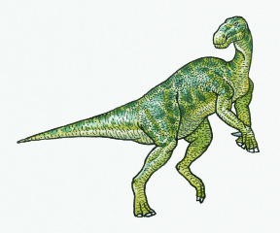 | 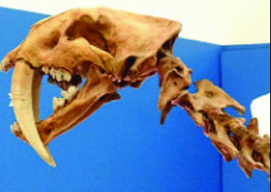
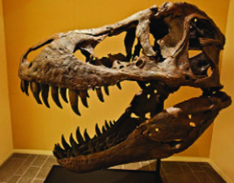 | 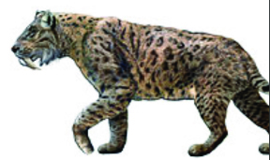
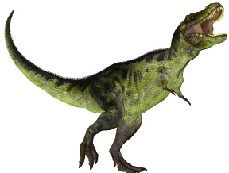 | 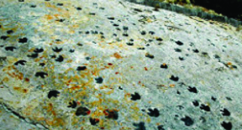
Matching Fossils to Their Animals
Graphic Organizer
Fossil | Animal It May Have Come from
Matching Fossils to Their Animals
Graphic Organizer
(Answers, for Teacher Reference)

Fossil | Animal It May Have Come from
Matching Fossils to Their Animals
Activity Anchor Chart
- Pick up one fossil picture.
- Look closely for clues in the picture.
- Use a clue to think about which animal the fossil came from.
- Put the picture of the fossil and the picture of the animal next to each other.
Image Credits
Page 2. Winti, Edna. “[untitled].” Photograph. Flickr. 17 Aug 2013.
Page 2. St. John, James. “Carcharodon megalodon fossil shark tooth (upper Cenozoic; Eastern Seaboard of America)” Photograph. Flickr. 23 Sept 2014.
Page 2. Grand Canyon National Park. “Grand Canyon National Park- Fossils in Kaibab Limestone_0369.” Photograph. Flickr. 18 July 2012.
Pages 8 and 10. Kindersley, Dorling. “Illustration of Iguanodon ornithopod dinosaur.” Watercolor painting. Getty Images.
Pages 8 and 10. St. John, James. “Smilodon fatalis (saber-toothed tiger) (Upper Pleistocene; California, USA) 2.” Photograph. Flickr. 11 June 2014.
Pages 8 and 10. Dantheman9758. “Restoration of S. fatalis with spotted coat.” Artwork. English Wikipedia. 22 February 2008.
Pages 8 and 10. Jurvetson, Steve. “The biggest and most complete male T-Rex ever found.” Photograph. Flickr. 08 January 2014.
Pages 8 and 10. Santos, Sofia. “Illustration of a Tyrannosaurus (dinosaur species) isolated on a white background.” Illustration. Shutterstock.
Pages 8 and 10. St. John, James. “Dinosaur footprints (Dakota Sandstone, Lower Cretaceous; Dinosaur Ridge, Colorado, USA) 2. Photograph. Flickr. 16 December 2012.

