MODULE LESSONS
Grade 2: Module 2: Unit 2: Lesson 8
Launching Close Reading:
“Other Types of Fossils”
Language Arts Curriculum

Interactive Word Wall Cards
Note to Teachers: Cut these cards apart to use during the Opening.

paleontologist
fossils
clues
excavate
Interactive Word Wall Cards
fossilization
decay
preserved
petrified
surrounding
Arrow Cards
Note to Teachers: Copy and cut sets of these cards out to use during the Opening.


Directions for the Interactive Word Wall
(For Teacher Reference)

- Sit in a circle with your group and put the word cards and arrow cards face-up in the middle of the circle.

- Take turns choosing one word to connect (join together) with another word using an arrow card.

- Explain your connection (why the words belong together) to the group.

- Continue taking turns until you have connected every word to some other word. It is okay to move words or connect more than one word with another.
“Other Types of Fossils”
Name: ________________________ Date: _______________
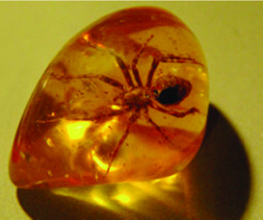

This is a spider stuck in sap. It is a fossil.

1. | Some fossils come from animals that got stuck and preserved. Preserved means their bodies were saved—sometimes even the hair and skin! They were saved because they were covered with something.
2. | Sticky Sap  Some fossils come from animals that got covered in sap. Sap comes out of trees. It is runny and sticky. An insect could land in the sap and get stuck. Its body could get covered. The sap could harden with the insect inside. It could become a fossil.
3. | Chilly Ice  Some fossils are animals that got covered in ice. Long ago, some parts of the earth got very cold. Some animals froze to death. Their bodies could get covered with snow and ice. They could become fossils.
4. | Tricky Tar  Some fossils are animals that got covered in tar. Oil mixed with sand makes tar. Tar is thick and sticky. Animals could walk into the tar. They could get trapped. A trapped animal would die. It could get covered in the tar. It could become a fossil.

Written by EL Education for Instructional Purposes. 390L
Close Readers Do These Things Anchor Chart
RL.2.1, RL.2.4, RL.2.10, RI.2.1, RI.2.4, RI.2.10, L.2.4

Close Readers Do These Things:

- Look closely at the pictures.
- Reread important parts of the text.
- Act out important parts of the text.
- Listen carefully to the words.
- Talk with classmates about the text.
- Draw and write about the text.
- Answer questions about the words and pictures using details from the text.
- Use strategies to figure out the meaning of unknown words:
  - Context: Read the sentence around the word.
  - Word parts: Look for root words, prefixes, and suffixes.
- Read small chunks of text slowly and think about the gist (what the text is mostly about).
“Other Types of Fossils”:
Selected Response Questions
Name: ________________________ Date: _______________
RI.2.1, RI.2.2, RI.2.4, RI.2.5, RI.2.6, L.2.4a

Directions: Read each question. Choose the best answer.

- Reread Paragraph 1 to find the meaning of the word preserved. Circle the answer that tells the meaning of the word preserved. (RI.2.4, L.2.4a)
- when something is stuck
- when something is saved
- when something is covered

- Reread Paragraph 2. What can happen to insects that land in sap? (RI.2.1)
- They can get stuck.
- They can get very hot.
- They can get eaten.

- Where does sap come from? (RI.2.1)
- cold weather
- oil and sand
- trees

- What is the main idea of the section “Sticky Sap”? (RI.2.2)
- Fossils can be preserved in ice.
- Fossils can be preserved in sap.
- Fossils can be preserved in trees.

- Which section in the article gives information about fossils found in snow? (RI.2.5)
- Sticky Sap
- Chilly Ice
- Trapped in Tar

- What is tar made of? (R.I.2.1)
- ice and snow mixed together
- sap and water mixed together
- sand and oil mixed together

- What is the meaning of the word trapped as it is used in Paragraph 4? (RI.2.4, L.2.4a)
- stuck
- hungry
- scared

- Why did the author write “Other Types of Fossils”? (RI.2.6)
- to explain how different types of fossils are made
- to explain how different types of fossils are destroyed
- to explain how paleontologists learn about fossils

- What information is learned about the photo from the caption? (RI.2.5)
- It is a fossil of a spider stuck in sap.
- It is a fossil of a spider stuck in ice.
- It is a fossil of a spider stuck in tar.
“Other Types of Fossils”:
Selected Response Questions
(Answers, for Teacher Reference)

RI.2.1, RI.2.2, RI.2.4, RI.2.5, RI.2.6, L.2.4a

Directions: Read each question. Choose the best answer.

- Reread Paragraph 1 to find the meaning of the word preserved. Circle the answer that tells the meaning of the word preserved. (RI.2.4, L.2.4a)

- when something is stuck
- when something is saved
- when something is covered

- Reread Paragraph 2. What can happen to insects that land in sap? (RI.2.1)

- They can get stuck.
- They can get very hot.
- They can get eaten.

- Where does sap come from? (RI.2.1)

- cold weather
- oil and Sand
- trees

- What is the main idea of the section “Sticky Sap”? (RI.2.2)

- Fossils can be preserved in ice.
- Fossils can be preserved in sap.
- Fossils can be preserved in trees.

- Which section in the article gives information about fossils found in snow? (RI.2.5)

- Sticky Sap
- Chilly Ice
- Trapped in Tar

- What is tar made of? (R.I.2.1)

- ice and snow mixed together
- sap and water mixed together
- sand and oil mixed together

- What is the meaning of the word trapped as it is used in Paragraph 4? (RI.2.4, L.2.4a)

- stuck
- hungry
- scared

- Why did the author write “Other Types of Fossils”? (RI.2.6)

- to explain how different types of fossils are made
- to explain how different types of fossils are destroyed
- to explain how paleontologists learn about fossils

- What information is learned about the photo from the caption? (RI.2.5)

- It is a fossil of a spider stuck in sap.
- It is a fossil of a spider stuck in ice.
- It is a fossil of a spider stuck in tar.
Sorting Different Types of Fossils Graphic Organizer
Sort the fossil pictures into fossils stuck in sap, fossils stuck in tar, or body fossils.
Use what you have learned from “Other Types of Fossils” to help you sort.

Fossils Preserved in Sap | Fossils Preserved in Tar | Body Fossils

Different Types of Fossils Pictures
Note to Teachers: Cut these pictures apart ahead of time and attach them to the Sorting Different Types of Fossils graphic organizer.

 | 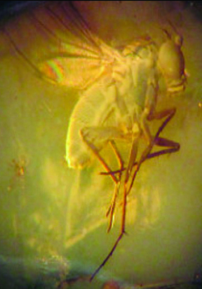
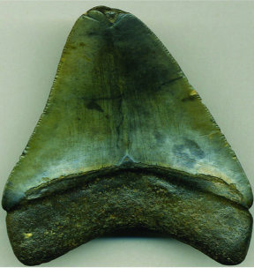 | 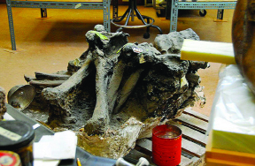
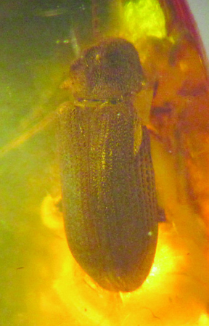 | 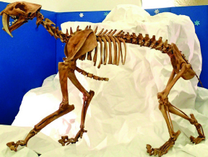
Sorting Protocol Anchor Chart
- Partner A chooses a picture and shares his or her thinking about how to sort the card.

- Partner B responds to Partner A.

- Partners A and B decide where the picture should go and place it in a category.

- Start again. Take turns.

Sentence starters to use:

- “I think ______.”
- “I agree with you because ______.”
- “I respectfully disagree with you because ______.”
Sorting Different Types of Fossils Graphic Organizer
(Answers, for Teacher Reference)

Sort the fossil pictures into fossils stuck in sap, fossils stuck in tar, or body fossils. Use what you have learned from “Other Types of Fossils” to help you sort.

Fossils Preserved in Sap | Fossils Preserved in Tar | Body Fossils
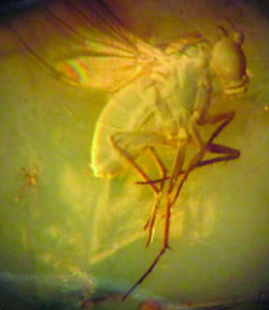  a fly | bones from  LaBrea Tar Pit | 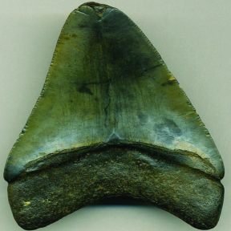  a shark’s tooth
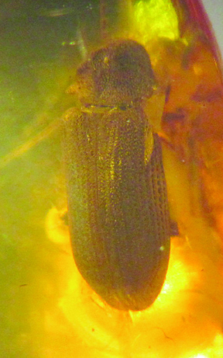  a beetle |  | 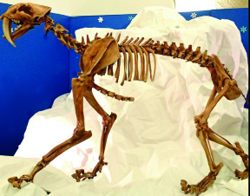  saber-toothed tiger

Museum Display Label Model
A Shark’s Tooth

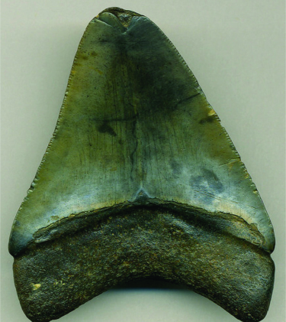

This is a picture of a shark’s tooth. The tooth got buried in the ocean millions of years ago. It was covered by layers and layers of mud and sand. The pressure from all the layers turned the sand into rock. Minerals and the layers helped the tooth become a fossil. The shark’s tooth was preserved, so you can see what it looked like long ago.
Criteria for a Museum Display Label Anchor Chart
- States what is in the picture
- Includes two or three facts about that type of fossil and how it was formed
- Uses words from the Fossil Word Wall, like fossil and preserved
Image Credits
Page 6. Walraven, Floortje. “Amber- free texture.” Photograph. Flickr. 27 June 2008.
Pages 13 and 15. St. John, James. “Fly in amber (Amber Formation, Middle Eocene; Yantarnyi, Samland Peninsula along the Baltic Sea, far-western Russia) 2.” Photograph. Flickr. 11 April 2012.
Pages 13 and 15. St. John, James. “Carcharodon megalodon fossil shark tooth (upper Cenozoic; Eastern Seaboard of America)” Photograph. Flickr. 23 Sept 2014.
Pages 13 and 15. Trebz. “DSC_3101.” Photograph. Flickr. 13 Feb 2009.
Pages 13 and 15. St. John, James. “Beetle in amber (Amber Formation, Middle Eocene; Yantarnyi, Samland Peninsula along the Baltic Sea, far-western Russia).” Photograph. Flickr. 11 April 2012.
Pages 13, 15-16. St. John, James. “Smilodon fatalis saber-toothed tiger (Upper Pleistocene; California, USA) 1.” Photograph. Flickr. 11 June 2014.

