Performance Task Overview
 Summary of Task
Plastic Pollution Documentary Clip
Throughout the module, students have read texts, watched videos, and conducted research into the problem of plastic pollution and the possible solutions. Students will now share their learning with an audience beyond their classroom by creating a brief documentary clip. Creating this clip is important because plastic pollution presents an urgent and real problem, and the ability to think through solutions, act on them, and share progress with others will be crucial in addressing it. In Unit 3, students have worked with groups to write a documentary script and create a storyboard to plan their documentary clips. For the performance task, students work in their triads to film and edit their documentary clips with the purpose of sharing their message with their peers and a larger audience.
Format
Digital video clip
Standards Addressed through This Task
The performance tasks at the end of every module are neither formative nor summative assessments. They are not formative because they come at the end of the module, concluding students’ learning about the module topic and the literacy skills they have built over eight or nine weeks. They are also not summative because they are heavily scaffolded to help students create high-quality work, and so are not a strong measure of what students can do independently. For these reasons, we do not recommend analyzing performance tasks through the same lens used to analyze assessments. Look at students’ performance tasks according to the quality of the authenticity, complexity, and craftsmanship of their work. Below are possible questions to keep in mind when considering these attributes:
- Authenticity: Does the student demonstrate interest and investment in their chosen action plan and video? Does the student provide appropriate explanations of how their action plans and efforts will address plastic pollution? Do students address the intended audience appropriately and engagingly? Do students apply their understanding of the elements of a quality documentary (interviews, music, visuals, reenactments, narration, close-ups, and statistics)?
- Complexity: Does the student demonstrate a deep knowledge of the topic of plastic pollution? Has the student effectively communicated the details that explain the problem of plastic pollution as well as how their action plan addresses the problem?
- Craftsmanship: Do the images in the video help to emphasize the points rather than distract from them? Is the student’s script writing accurate and thoughtfully crafted? Do students speak clearly and adapt their speech appropriately for the context of a documentary? Has the student successfully incorporated peer feedback on the content and presentation?
The following standards are addressed, but not assessed:
- W.7.1: Write arguments to support claims with clear reasons and relevant evidence.
- W.7.3: Write narratives to develop real or imagined experiences or events using effective technique, relevant descriptive details, and well-structured event sequences.
- W.7.6: Use technology, including the Internet, to produce and publish writing and link to and cite sources as well as to interact and collaborate with others, including linking to and citing sources.
- SL.7.4: Present claims and findings, emphasizing salient points in a focused, coherent manner with pertinent descriptions, facts, details, and examples; use appropriate eye contact, adequate volume, and clear pronunciation.
- SL.7.5: Include multimedia components and visual displays in presentations to clarify claims and findings and emphasize salient points.
- SL.7.6: Adapt speech to a variety of contexts and tasks, demonstrating command of formal English when indicated or appropriate. (See grade 7 Language standards 1 and 3 for specific expectations.)
- L.7.1: Demonstrate command of the conventions of standard English grammar and usage when writing or speaking.
Student-Friendly Writing Invitation/Task Description
Throughout the module, you have read about the problem of plastic pollution affecting our world and explored the different possible solutions. You have turned these possible solutions into an action plan alongside your peers, in the form of a documentary script and storyboard. You will now share this action plan and your learning by making a short documentary clip to share with the world.
For your performance task, you will work in a group of three to create a 3- to 5-minute documentary clip on plastic pollution. The purpose of this clip is to teach others about the plastic pollution problem and what can be done about it. This video clip will be based on the plan you developed, which includes your script, storyboard, and a description of your action plan and its effects.
 Key Criteria for Success (Aligned with CCSS ELA)
Below are key criteria students need to address when completing this task. Specific lessons during the module build in opportunities for students to understand the criteria, offer additional criteria, and work with support to construct a criteria list by which their work will be critiqued and formally assessed. Although the script and storyboard are not considered part of the performance task, the criteria for both have been included as they are essential elements needed to create the documentary clip.
The script should include
- a narrative lead introduction;
- an argument about why we need to solve the problem of plastic pollution, which is based on a claim supported by evidence and reasoning;
- an explanation of the triad’s action plan and its results; and
- a conclusion that follows from and offers a reflection on the possible impact of the action plan.
The storyboard should include
- images (either hand-drawn or clip art) to represent
- each scene in the script
- the actors
- the camera angles
- the techniques
- captions telling what is happening and who is in the scene.
The documentary clip should include
- several of the documentary film techniques the class identified (interviews, music, visuals, re-enactments, narration, close-ups, statistics), which help to emphasize the points rather than distract from them;
- appropriate eye contact, adequate volume, and clear pronunciation;
- speech that is appropriately adapted for the context of a documentary;
- content that demonstrates interest and investment in their chosen action plan as well as a deep knowledge of the topic of plastic pollution; and
- sufficient details that explain the problem of plastic pollution as well as explanations of how the action plan and efforts will address plastic pollution.
Options for Students
- Extension: Allow students who know how to film and edit to do so independently without group discussion.
- Extension: Allow students who know how to edit film to become class experts and support others with this work.
Options for Teachers
To build authentic engagement and pride in their high-quality work, organize a Plastic Pollution Documentary Film Clip Screening and consider inviting environmental agencies in the community. Students may piece together all the clips into a feature film, plan an introduction presentation, and invite questions and comments from the audience at the end of the screening. Students may be in charge of invitations, planning the venue, and/or creating a snack bar and bake sale to benefit plastic pollution reduction.
Students may choose to
- present their documentary clips to other classes and schools or the wider community;
- create a website, uploading their clips to reach a wider audience; or
- create a longer video of their documentary clips edited together to share with other classes, schools, or libraries.
Performance Task Anchor Chart
W.7.1, W.7.2, W.7.3, W.7.6, SL.7.4, SL.7.5, SL.7.6, L.7.1, L.7.2, L.7.3
(Example for Teacher Reference)
For your performance task, you will work in a group of three to create a 3- to 5-minute documentary clip on plastic pollution, how best to solve it, and your action plan for attempting the solution. The purpose of this clip is to teach others about the plastic pollution problem and what can be done about it. This video clip will be based on the plans you developed, which will include your script, storyboard, and a description of your action plan and its effects.
Your script should include
- a narrative lead introduction;
- your argument about why we need to solve the problem of plastic pollution, which is based on a claim supported by evidence and reasoning;
- an explanation of your triad’s action plan and its results;
- a conclusion that follows from and offers a reflection on the possible impact of your action plan; and
- several of the documentary film techniques your class identified (interviews, music, visuals, re-enactments, narration, close-ups, and statistics).
Your storyboard should include the following:
- Images (either hand-drawn or clip art) to represent
  - each scene in your script
  - the actors
  - the camera angles
  - the techniques
- Captions telling what is happening and who is in the scene
To celebrate this powerful learning and make a difference in the world, host a film screening at your school or in your community (possibly at the public library, local community center, or another public space).
Performance Task Directions
W.7.1, W.7.2, W.7.3, W.7.6, SL.7.4, SL.7.5, SL.7.6, L.7.1, L.7.2, L.7.3
Name: Date:
For your performance task, you will work in a group of three to create a 3- to 5-minute documentary clip on plastic pollution, how best to solve it, and your action plan for attempting the solution. The purpose of this clip is to teach others about the plastic pollution problem and what can be done about it. This video clip will be based on the plans you developed, which will include your script, storyboard, and a description of your action plan and its effects.
Your script should include
- a narrative lead introduction;
- your argument about why we need to solve the problem of plastic pollution, which is based on a claim supported by evidence and reasoning;
- an explanation of your triad’s action plan and its results;
- a conclusion that follows from and offers a reflection on the possible impact of your action plan; and
- several of the documentary film techniques your class identified (interviews, music, visuals, re-enactments, narration, close-ups, and statistics).
Your storyboard should include the following:
- Images (either hand-drawn or clip art) to represent
  - each scene in your script
  - the actors
  - the camera angles
  - the techniques
- Captions telling what is happening and who is in the scene
To celebrate this powerful learning and make a difference in the world, host a film screening at your school or in your community (possibly at the public library, local community center, or another public space).
Model Documentary Storyboard
SL.7.5
Name: Date:
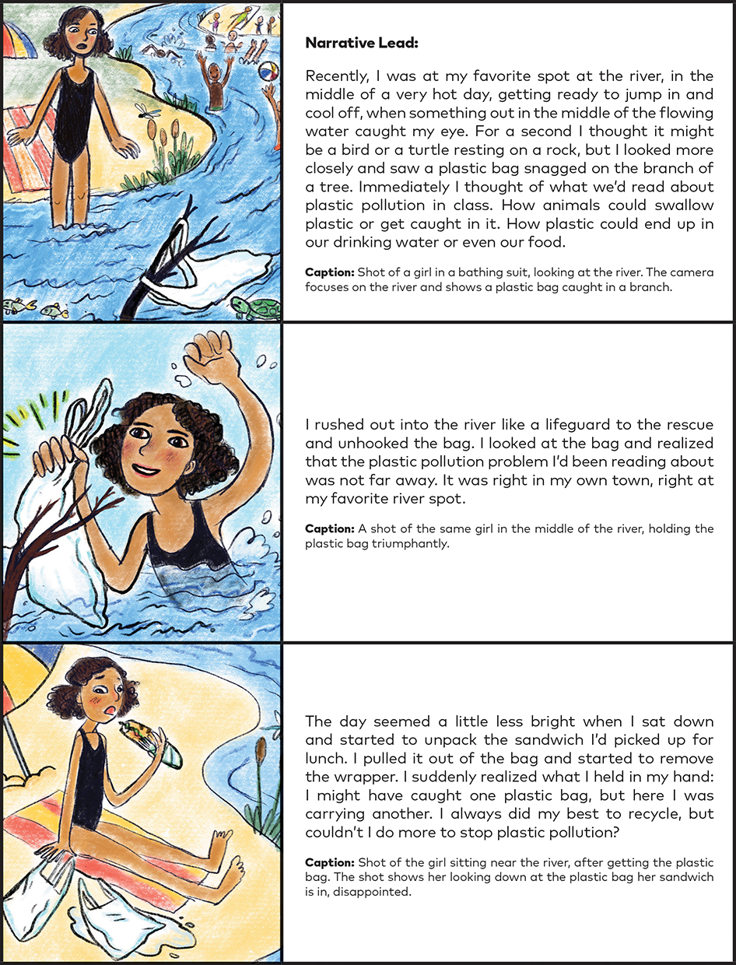
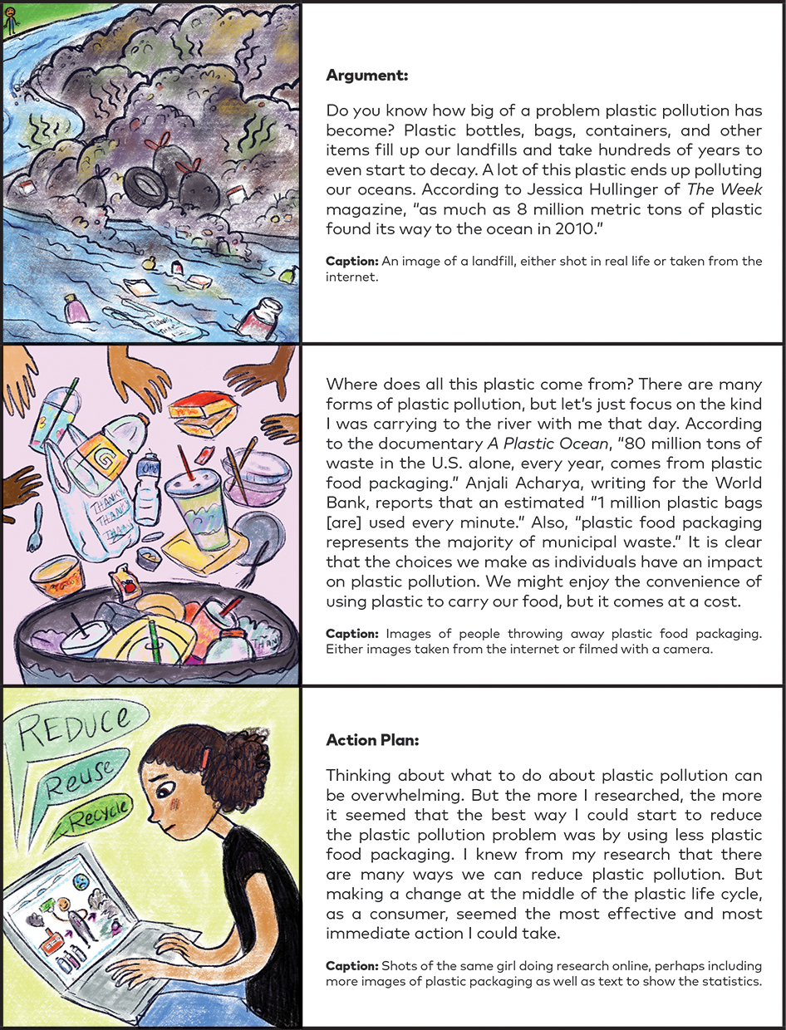
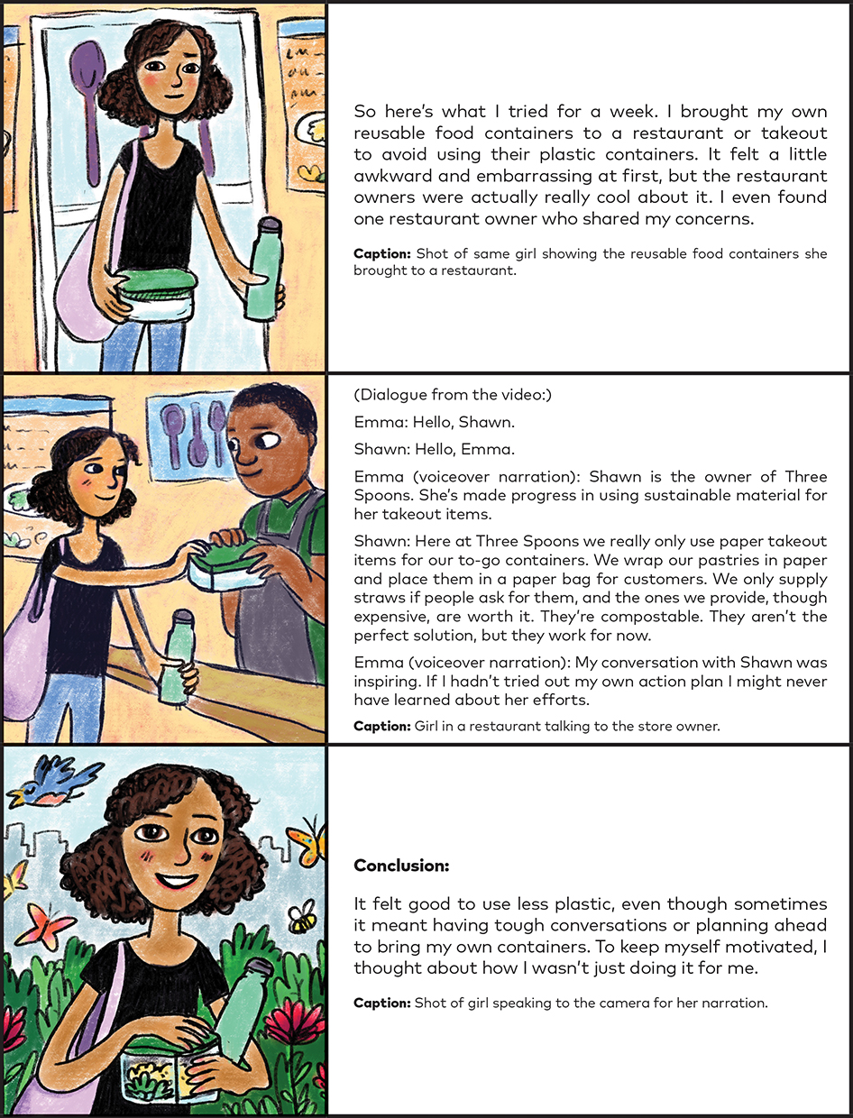
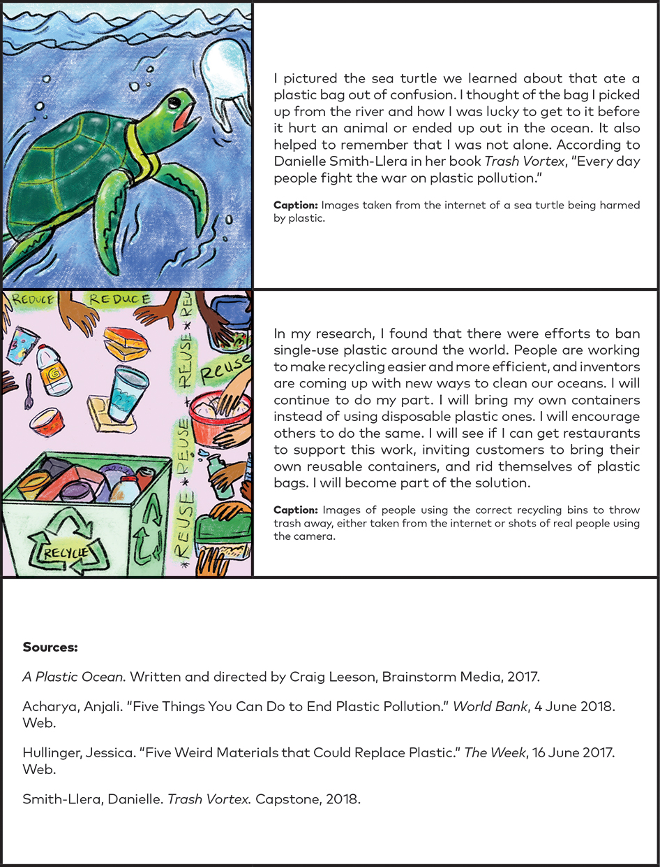
Scribe Concepts for EL Education.

