MODULE LESSONS
Grade 1: Module 2: Unit 1
The Sun, Moon, and Stars — Assessment
Language Arts Curriculum
Unit 1 Assessment: Reading and Answering Questions about Kitten’s First Full Moon
(For Teacher Reference)
This formative assessment centers on CCSS ELA RL.1.2, RL.1.3, RL.1.7, W.1.8, SL.1.2, and L.1.6. Students listen to and answer questions about the basic story elements and storyline of Kitten’s First Full Moon. Students use words and pictures to demonstrate understanding of character, setting, and the major events from the story, including events that occur in the beginning, middle, and end of the story. The assessment follows a similar sequence of reading, speaking and listening, and writing as in previous lessons, but involves less teacher support in order to measure students’ independent progress toward the above standards. The assessment is completed over the course of two lessons.

CCSS Assessed:
- RL.1.2: Retell stories, including key details, and demonstrate understanding of their central message or lesson.
- RL.1.3: Describe characters, settings, and major events in a story, using key details.
- RL.1.7: Use illustrations and details in a story to describe its characters, setting, or events.
- W.1.8: With guidance and support from adults, recall information from experiences or gather information from provided sources to answer a question.
- SL.1.2: Ask and answer questions about key details in a text read aloud or information presented orally or through other media.
- L.1.6: Use words and phrases acquired through conversations, reading and being read to, and responding to texts, including using frequently occurring conjunctions to signal simple relationships (e.g., because).

Assessment Directions:
This assessment is administered in Unit 1, Lessons 14–15.

Unit 1 Assessment, Part I: Lesson 14

- Before conducting the assessment, post a blank version of page 1 of the Student Response Sheet on chart paper and prepare the Kitten’s First Full Moon chart by displaying the pictures from pages 4, 8, 12, 16, 22, and 28.
- Display Kitten’s First Full Moon and read the text aloud slowly, fluently, with expression, and without interruption.
- Distribute prepared clipboards with the Unit 1 Assessment Response Sheets and pencils.
- Direct students’ attention to Part I of the response sheet and read the prompt aloud:
— “Who is the main character?” and “Where does the story take place?”
- Invite students to complete Part I. Remind them that they should use pictures and words to show their thinking.
- Circulate and support students by reviewing the prompts as needed, asking them to orally articulate their answers before writing, directing them to the Story Elements board, and reminding them to use the High-Frequency Word Wall as a resource as they write.
- Display the Kitten’s First Full Moon chart.
- Tell students they will use the Kitten’s First Full Moon chart to help them complete Part II on the response sheet.
- Invite students to point to Part II on the response sheet and read aloud the prompt:
— “Based on the pictures on the Kitten’s First Full Moon chart, which word would you use to describe how Kitten is acting? Circle one.”
- Read the seven word choices aloud and review their definitions as necessary.
- Invite students to circle the word they think best describes how Kitten is acting in the pictures displayed on the Kitten’s First Full Moon chart.
- Direct students’ attention to the blank lines in Part II.
- Offer the sentence frame:
— “I think Kitten is acting ______ because I see _____.”
- Tell students to use the word they chose to describe Kitten to fill in the first blank. Tell students they should explain what, from the pictures, helped them pick those words and write that in the second blank.
- As students write, circulate to support them, reminding them of the sentence frame.
- Collect student response sheets and clipboards and remind students they will complete the remaining parts of the response sheet during the next lesson.

Unit 1 Assessment, Part II: Lesson 15
- On Day 2, post a blank version of pages 2 and 3 of the Student Response Sheet on chart paper. Remind students what they accomplished in the previous lesson (listened to the text, identified the main character and setting) and what they will complete today (listen to the text again and identify three major events).
- Display Kitten’s First Full Moon and read it aloud slowly, fluently, and with expression, stopping at the following pages, reading aloud the applicable prompt, and giving students time to turn and talk to an elbow partner:
A. Page 6: “What happened in the beginning of the story?” (Kitten wanted a bowl of milk.)
B. Page 16: “What are one or two things that happened in the middle of the story?” (Kitten ran through a field. Kitten climbed a tree.)
C. Page 22: “What are one or two more things that happened in the middle of the story?” (Kitten saw the bowl of milk in the lake. Kitten jumped into the lake.)
D. Page 29: “What happened at the end of the story?” (Kitten went back home. Kitten saw a bowl of milk on the porch, and she drank from it.)
- Distribute clipboards with the Unit 1 Assessment Response Sheets and pencils.
- Direct students’ attention to Part III of the response sheet. Remind them that they should use pictures and words to show their thinking.
- Invite students to point to the first box and write and draw their answers to the prompt:
— “What happened in the beginning of the story?”
- Repeat Step 5 with the second and third boxes.
Circulate and support students by reviewing the prompts as necessary and directing them to the Story Elements board.
- Direct students’ attention to Part IV of the response sheet and read the prompt aloud:
— “Why couldn’t Kitten get the first bowl of milk she saw?”
- Invite students to use words and pictures to show their answer, using the box and lines in Part IV.
- Circulate and support students by reviewing the prompt as necessary and directing them to the Story Elements board.
- Collect students’ responses sheets.
Unit 1 Assessment: Reading and Answering Questions about Kitten’s First Full Moon
(For Teacher Reference)
RL.1.2, RL.1.3, RL.1.7, W.1.8, SL.1.2, L.1.6

Day 1: Now that you have listened to Kitten’s First Full Moon by Kevin Henkes, use your response sheet to capture the responses to the following questions and prompts:
- Who is the main character? How would you describe the main character?
- Where does the story take place?
- Looking at the pictures on the Kitten’s First Full Moon chart, which word would you use to describe how Kitten is acting? Circle one.
- What evidence from the pictures helps you know which word describes Kitten? Complete the sentence frame to show that.

Day 2: Now that you have listened to Kitten’s First Full Moon by Kevin Henkes, use your response sheet to capture the responses to the following questions:
- What happened in the beginning of the story?
- What are one or two things that happened in the middle of the story?
- What happened at the end of the story?
- Why couldn’t Kitten get the first bowl of milk she saw?

Story Elements Board: Kitten’s First Full Moon
(Example, for Teacher Reference)
RL.1.2, RL.1.3, RL.1.7, W.1.8, SL.1.2, L.1.6

Kitten’s First Full Moon

Main Character:  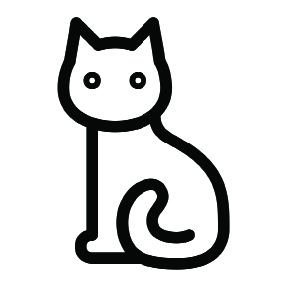  Kitten |  | Setting:  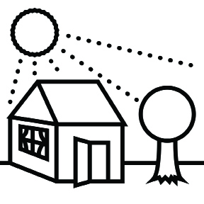  Outside
Beginning:  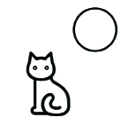 | Middle:  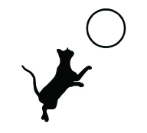 |  | End:  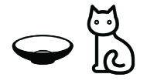
Unit 1 Assessment: Student Response Sheet
(Sample Proficient Response)

Page 1

RL.1.2, RL.1.3, RL.1.7, W.1.8, SL.1.2, L.1.6

Part I: Use words and pictures to answer these questions.

Who is the main character?  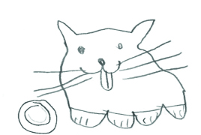 | What is the setting?  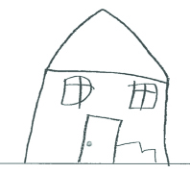

Part II: Based on the pictures on the Kitten’s First Full Moon chart, which word would you use to describe how Kitten is acting? Circle one.

(Response indicated with underlining.)

brave scared curious smart silly happy adventurous

I think Kitten is acting scared because I see ___kitten up high in the tree.
Unit 1 Assessment: Student Response Sheet
(Sample Proficient Response)

Part III: Use words and pictures to show what happened in the story.

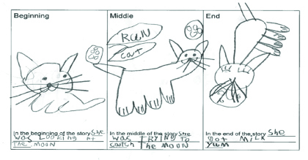

Unit 1 Assessment: Student Response Sheet
(Sample Proficient Response)

Part IV: Use words and pictures to show your answer.

Why couldn’t Kitten get the first bowl of milk she saw?

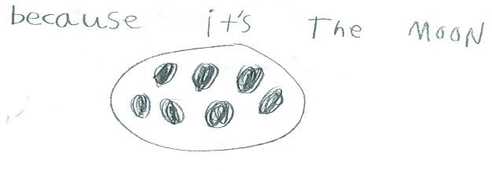
Unit 1 Assessment Criteria List
(For Teacher Reference)
RL.1.2, RL.1.3, RL.1.7, W.1.8, L.1.6

Beginning: Student meets one or no criteria.
Developing: Student meets two or three criteria. (This may mean that students are Proficient in one standard and Beginning in another.)
Proficient: Student meets all criteria.
Advanced: Student meets/exceeds all criteria.
Criteria | Meets | Notes
Student correctly identifies and draws/labels main character. (RL.1.3, W.1.8)
Student correctly identifies and draws/labels setting, including time and place. (RL.1.3, W.1.8)
Student correctly describes and draws/labels three major events that occur in the story. (RL.1.3, W.1.8)
Student identifies a word that describes Kitten and cites evidence from illustrations to support his or her answer. (RL.1.7, W.1.8)
Student completes storyboard independently. (RL.1.2, W.1.8)
Student responses show understanding of the central idea of the text. (The bowl of milk Kitten sees is actually the moon.) (RL.1.2, W.1.8)
Student work shows evidence of words and phrases acquired through being read to and responding to texts. (L.1.6)

Sample Completed Rubric
(For Teacher Reference)
RL.1.2, RL.1.3, RL.1.7, W.1.8, L.1.6

Beginning: Student meets one or no criteria.
Developing: Student meets two or three criteria. (This may mean that students are Proficient in one standard and Beginning in another.)
Proficient: Student meets all criteria.
Advanced: Student meets/exceeds all criteria.
Criteria | Meets | Notes
Student correctly identifies and draws/labels main character. (RL.1.3, W.1.8) | ✓
Student correctly identifies and draws/labels setting, including time and place. (RL.1.3, W.1.8) | ✓
Student correctly describes and draws/labels three major events that occur in the story. (RL.1.3, W.1.8) | ✓
Student identifies a word that describes Kitten and cites evidence from illustrations to support his or her answer. (RL.1.7, W.1.8) | ✓
Student completes storyboard independently. (RL.1.2, W.1.8) | ✓
Student responses show understanding of the central idea of the text. (The bowl of milk Kitten sees is actually the moon.) (RL.1.2, W.1.8) | ✓
Student work shows evidence of words and phrases acquired through being read to and responding to texts. (L.1.6) | ✓ | Student completed all sections of graphic organizer independently and used resources around the room to label pictures and complete sentences.

Unit 1 Assessment: Student Response Sheet
Name: __________________________________________________________ Date: ___________________
Page 1
RL.1.2, RL.1.3, RL.1.7, W.1.8, SL.1.2, L.1.6

Part I: Use words and pictures to answer these questions.

Who is the main character? | What is the setting?

Part II: Based on the pictures on the Kitten’s First Full Moon chart, which word would you use to describe how Kitten is acting? Circle one.

brave scared curious smart silly happy adventurous

I think Kitten is acting ______________ because I see ____________________________________

_______________________________________.
Unit 1 Assessment: Student Response Sheet
Name: __________________________________________________________ Date: ___________________
Part III: Use words and pictures to show what happened in the story.

Beginning | Middle | End
In the beginning  _______________________  _______________________  _______________________. | In the middle  _______________________  _______________________  _______________________. | In the end  _______________________  _______________________  _______________________.

Unit 1 Assessment: Student Response Sheet
Name: _______________________________________ Date: _____________
Part IV: Use words and pictures to show your answer.

Why couldn’t Kitten get the first bowl of milk she saw?

