MODULE LESSONS
Kindergarten: Module 3
Trees Are Alive —
Performance Task
Language Arts Curriculum
Summary of Task
Informational Collage: Tree Experts
In this performance task, students create an informational collage to demonstrate their expertise about a tree, its needs, and the animals for which it provides food. The collage contains three distinct parts: the tree collage; an informational writing piece that describes the tree and its needs, and shares information about one animal that depends on the tree for food; and an accurately colored animal puppet that represents the animal from students’ writing. Students use notes from their small group research to inform their writing as well as the tree collage. They also use peer feedback to revise their writing and collage, and they practice presenting their informational tree collage in preparation for sharing it with visitors at the end of module celebration. Note: It is recommended that the teacher type students’ writing into a paragraph and affix it to the final collage before the celebration. Teachers may wish to make enlarged copies of collage templates for students for this task. This task addresses CCSS ELA W.K.2, W.K.5, W.K.8, and the NGSS Standard K.LS1.1.
Format
Informational Collage: Tree Experts
The informational collage includes: tree collage, informative writing piece, and animal puppet.

The informative writing piece tasks students with writing about a researched tree, its needs, and one animal that depends on it for food.

It includes information gathered during the small group research in Unit 3.

The writing is compiled in a booklet that includes illustrations on each page, which is later typed into a paragraph and affixed to the tree collage.

The task is scaffolded through the use of whole group and small group research, oral processing, shared writing, practiced collage, teacher modeling, and teacher guidance.
Standards Addressed through This Task

CCSS:
- W.K.2: Use a combination of drawing, dictating, and writing to compose informative/explanatory texts in which they name what they are writing about and supply some information about the topic.
- W.K.5: With guidance and support from adults, respond to questions and suggestions from peers and add details to strengthen writing as needed.
- W.K.8: With guidance and support from adults, recall information from experiences or gather information from provided sources to answer a question.

NGSS:
- K.LS1.1
Student-Friendly Task Invitation/Task Description
Create an informational collage to teach your classmates, friends, and family about your tree.

Collage and write about your researched tree.

Your collage should include:
- The tree trunk
- The bark
- The branches
- The leaves
Your Performance Task Writing booklet should include:
- A focus statement that tells which tree it is
- A detail sentence describing the tree
- A detail sentence that states one thing the tree needs in order to live
- A detail sentence that tells about one animal that depends on the tree for food

You will accurately color an animal puppet to represent the animal from your writing booklet.

You will share your informational collage with family and friends at the Celebration of Learning!

 Key Criteria for Success (Aligned with CCSS ELA)
Below are key criteria students need to address when completing this task. Specific lessons during the module build in opportunities for students to understand the criteria.

Students’ collage should include:
- Trunk, bark, branches, and leaves
- An animal puppet based on their Performance Task Writing booklet
- Accurate colors for the tree and animal

Students’ writing should include:
- A focus statement that tells the name of the tree
- A detail sentence that describes the tree
- A detail sentence that names one thing that the tree needs in order to live
- A detail sentence that names one animal that depends on the tree for food
Options for Students
- If students have prior experience with collage, consider providing different materials to collage with (e.g., tissue paper, wrapping paper, or mixed media).
- Students could create a tree fact page at the back of their writing booklet using researched facts from the tree texts. (Example: If a student’s researched tree was the coast redwood, he or she could include the fact that coast redwoods are the tallest trees in the world.)
- Students could work with a partner to assist as they plan and work on their writing, but the final piece will be an individual’s product.
- Students’ writing could be various lengths. Students may have their sentences dictated, write using labels, or write a sentence or multiple sentences.
- Differentiate support for students who may be in different places with inventive spelling.
- Students could present their informative writing to another class as practice for presenting to their classroom visitors.
Options for Teachers
- Teachers may wish to make enlarged copies of collage templates for students for this task.
- Model collage with different illustrators who use it in their illustrations (e.g., Eric Carle, Leo Lionni, Lois Elhert, Faith Ringgold).
- Students may present their projects to their own class, to other classes in the school, or to parents or other adults.
- Students’ writing could be captured through oral dictation.
- Consider videotaping students sharing their informational collages to share with family members who are unable to attend the Celebration of Learning.
Central Text and Informational Texts

Tree texts (written by EL Education)
- “Paper Birch”
- “Live Oak”
- “Quaking Aspen”
- “Weeping Willow”
- “Coast Redwood”
Performance Task Writing Booklet - Page 1
(Example, for Teacher Reference)
W.K.2, W.K.8
Focus Statement

Drawing of a sugar maple tree

This is the sugar maple tree.
Performance Task Writing Booklet - Page 2
(Example, for Teacher Reference)

Detail Sentence 1

Drawing of sugar maple with details on the leaves, branches, bark, etc

It has lots of green, yellow, and orange leaves.
Performance Task Writing Booklet - Page 3
(Example, for Teacher Reference)
Detail Sentence 2

Drawing of a half shaded in sun

It needs some sun.
Performance Task Writing Booklet - Page 4
(Example, for Teacher Reference)
Detail Sentence 3

Drawing of a deer eating leaves

Deer depend on the tree for food.
Performance Task Writing Booklet - Page 1
Name: _________________________ Date: _______________
W.K.2, W.K.8
Focus Statement

Performance Task Writing Booklet - Page 2
Name: _________________________ Date: _______________
Detail Sentence 1

Performance Task Writing Booklet - Page 3
Name: _________________________ Date: _______________
Detail Sentence 2

Performance Task Writing Booklet - Page 4
Name: _________________________ Date: _______________
Detail Sentence 3

Collage Templates
Note: Teachers should make a copy of a tree collage template and corresponding animal puppet template for students according to their research group. Teachers may wish to enlarge templates for student use when copying.
Tree Collage Template 1

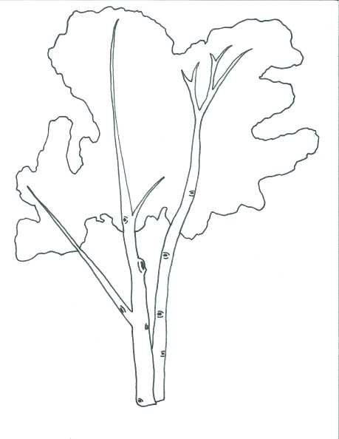
Tree Collage Template 2

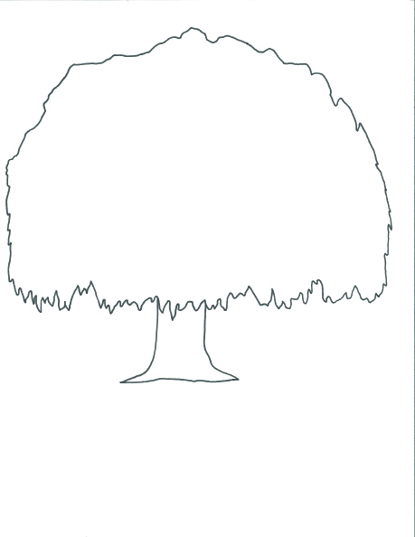
Tree Collage Template 3

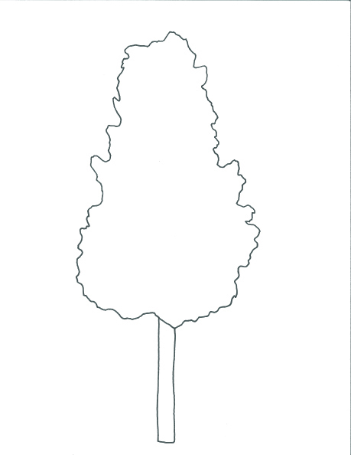
Tree Collage Template 4

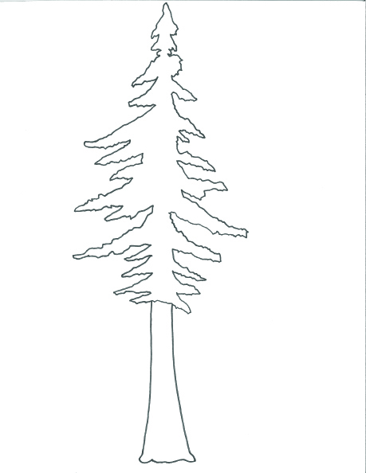
Tree Collage Template 5

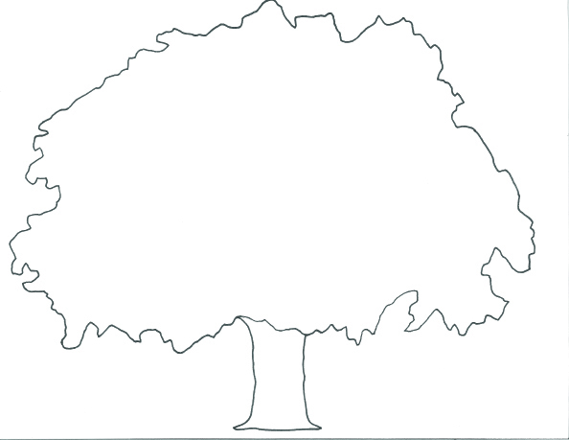
Animal Puppet Templates
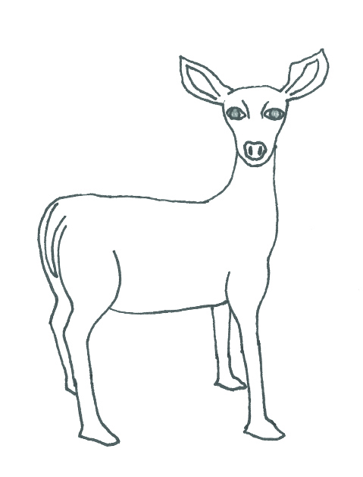
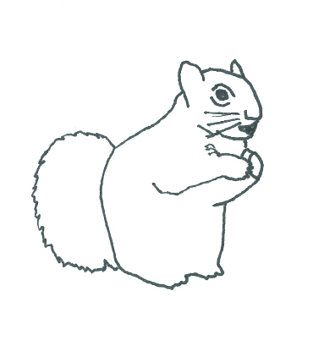
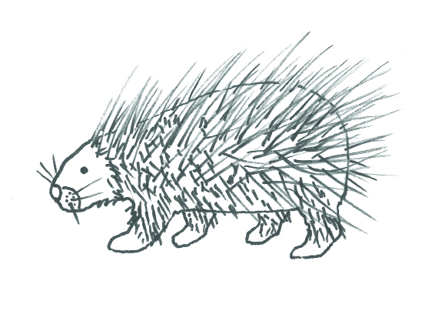
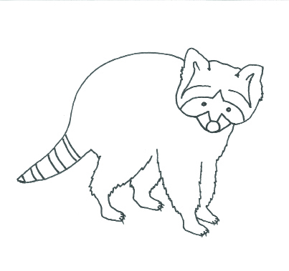
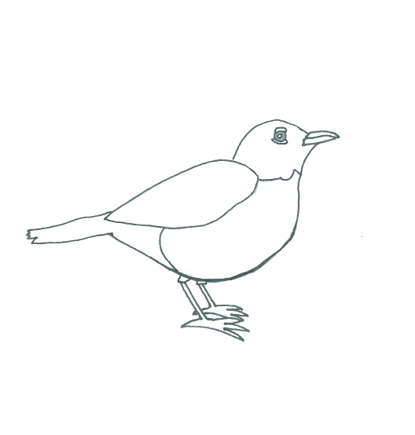

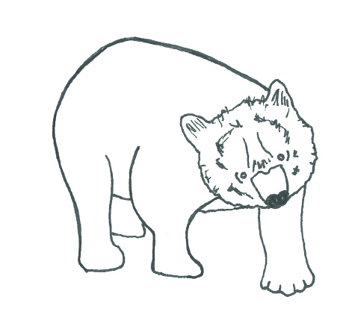

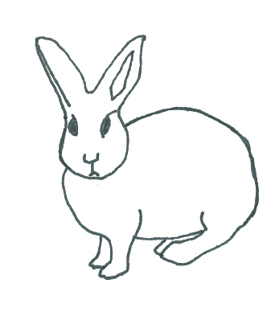
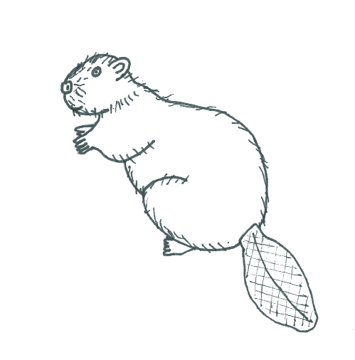
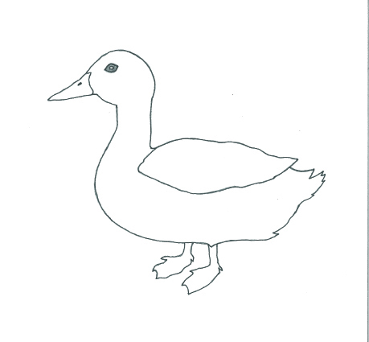

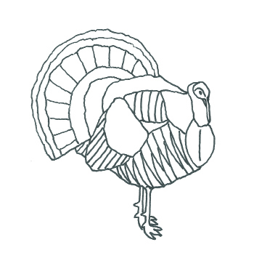

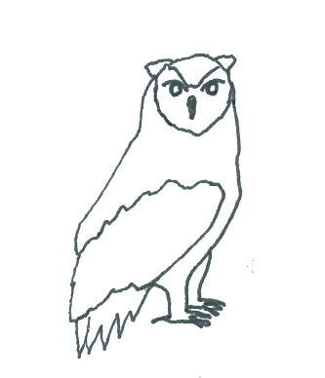
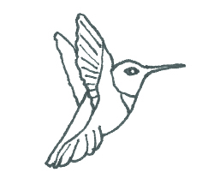
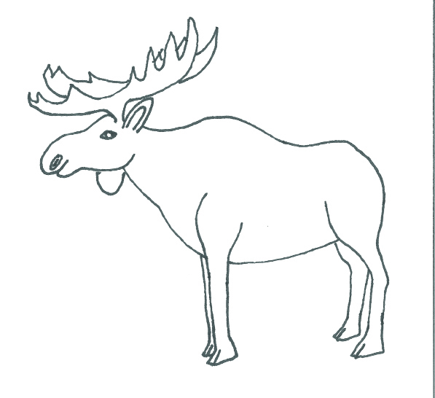

Informational/Explanatory Writing Checklist
W.K.2, W.K.5, W.K.8
This checklist focuses on W.K.2 but also includes language standards that can be taught, reviewed, or monitored along with informational writing tasks. Use this checklist to track students’ progress as they complete the performance task.

Module 3 Informational/Explanatory Writing Checklist
STUDENT INITIALS
Uses a combination of drawing, dictating, and writing to:
Name what he or she is writing about
Supply some information about the topic (using evidence from sources)
Show a solid understanding of content
With guidance and support from adults, respond to questions and suggestions from peers and add details to strengthen writing as needed
CONVENTIONS
L.K.1a
Print many upper- and lowercase letters
L.K.2c
Write a letter or letters for most consonant and short-vowel sounds (phonemes)
L.K.2d
Spell simple words phonetically, drawing on knowledge of sound-letter relationships
L.K.6
Use words and phrases acquired through conversations, reading and being read to, and responding to texts

Image Credits
Pages 16-27. Templates by Anna Loring for EL Education.

