Performance Task Overview
 Summary of Task
Hidden Figures in Space Science Picture Book
Throughout the module, students will have studied the contributions and celebrated the accomplishments of key “hidden figures” in space science, beginning with the titular hidden figures the West Computers at NACA, who serve as the focus of the module’s anchor text—and culminating with other under-recognized hidden figures in space science. In this performance task, students (working in triads) will create and contribute three pages of a class picture book devoted to the stories of hidden figures. Each triad, or crew, will be responsible for three pages of content centered on the focus figure of their research. These individual stories will be compiled into an anthology-style picture book geared toward an elementary-age audience.
Students will use models of narrative nonfiction picture books to determine the key criteria for this genre and incorporate those characteristics into their own pages. To create the content of the text, students will conduct independent research into the individual of their choosing to locate particularly remarkable accomplishments worthy of being shared. Then, students will collaborate within their crew to compose the text for their three-page contribution to the class picture book. Illustrations (hand-drawn sketches or images found online) will accompany each section of text. This performance task intends to uplift the mostly unknown stories of these other hidden figures and distill information about them into simpler language that can be easily shared with younger students so that they, too, may learn about these important figures in space science.
Format
A children’s picture book created from contributions by each crew, whose work will focus on just one of many hidden figures in space science. Students will share duties as authors, illustrators, and editors, designing three pages of content for their class book. Each triad will be responsible for highlighting their individual’s accomplishments in narrative nonfiction text with accompanying illustrations.
Standards Addressed through This Task
The performance tasks at the end of every module are neither formative nor summative assessments. They are not formative since they come at the end of the module, concluding students’ learning about the module topic and the literacy skills they have built over eight or nine weeks. However, they are also not summative because they are heavily scaffolded to help students create high-quality work, and so are not a strong measure of what students can do independently. For these reasons, we do not recommend analyzing performance tasks with the same lens used to analyze assessments. Consider looking at students’ performance tasks through the lens of the attributes of high-quality student work (authenticity, complexity, and craftsmanship).
Below are possible questions to keep in mind when considering these attributes:
- Authenticity: Were the students careful to conduct accurate research from credible sources and to paraphrase their findings responsibly? Did students internalize the roles of author, illustrator, and editor, understanding the connection between their work and the tasks of those who work in these occupations? Does student work reflect an understanding of the need to lift up the stories of those who have historically gone unrecognized?
- Complexity: Did the students carefully consider what accomplishments are most important to share with their audience? Do the text and illustrations reveal an understanding of the abilities and interests of an elementary-age audience? Do students use thoughtful, precise, and appropriate vocabulary and grammatical structures to convey their ideas?
- Craftsmanship: Is the text carefully crafted to appeal to a younger audience? Are the characteristics of narrative nonfiction present in the writing? Is the text edited for conventions and aesthetics and presented in a professional manner? Are the illustrations carefully drawn or culled from online sources to accurately and meaningfully reflect the events described in the text? Did the students draw from the criteria for an effective children’s picture book to create a book worthy of publication in the school library? During class presentations, did the students appropriately adjust their language (i.e., their wording, volume, and intonation) to share their work with a larger audience?
The following standards are addressed, but not assessed:
- RI.6.1: Cite textual evidence to support analysis of what the text says explicitly as well as inferences drawn from the text.
- W.6.3: Write narratives to develop real or imagined experiences or events using effective technique, relevant descriptive details, and well-structured event sequences.
- W.6.4: Produce clear and coherent writing in which the development, organization, and style are appropriate to task, purpose, and audience. (Grade-specific expectations for writing types are defined in standards 1–3 above.)
- W.6.5: With some guidance and support from peers and adults, develop and strengthen writing as needed by planning, revising, editing, rewriting, or trying a new approach. (Editing for conventions should demonstrate command of Language standards 1–3 up to and including grade 6.)
- W.6.7: Conduct short research projects to answer a question, drawing on several sources and refocusing the inquiry when appropriate.
- W.6.10: Write routinely over extended time frames (time for research, reflection, and revision) and shorter time frames (a single sitting or a day or two) for a range of discipline-specific tasks, purposes, and audiences.
- SL.6.1: Engage effectively in a range of collaborative discussions (one-on-one, in groups, and teacher-led) with diverse partners on grade 6 topics, texts, and issues, building on others’ ideas and expressing their own clearly.
- SL.6.3: Delineate a speaker’s argument and specific claims, distinguishing claims that are supported by reasons and evidence from claims that are not.
- SL.6.4: Present claims and findings, sequencing ideas logically and using pertinent descriptions, facts, and details to accentuate main ideas or themes; use appropriate eye contact, adequate volume, and clear pronunciation.
- SL.6.5: Include multimedia components (e.g., graphics, images, music, sound) and visual displays in presentations to clarify information.
- SL.6.6: Adapt speech to a variety of contexts and tasks, demonstrating command of formal English when indicated or appropriate. (See grade 6 Language standards 1 and 3 for specific expectations.)
- L.6.3: Use knowledge of language and its conventions when writing, speaking, reading, or listening.
- L.6.6: Acquire and use accurately grade-appropriate general academic and domain-specific words and phrases; gather vocabulary knowledge when considering a word or phrase important to comprehension or expression.
Student-Friendly Writing Invitation/Task Description
Houston, we have a problem. A problem with individuals not getting the credit they deserve for their remarkable accomplishments. Throughout this module, you have discovered that despite the contributions of many, sometimes only a few key individuals get recognition for incredible achievements, such as landing humans on the moon. For this performance task, you will research other stars of space science who have been underrepresented, just as Margot Lee Shetterly did in Hidden Figures. In small crews of three, you and your peers will write and illustrate one section of a children’s picture book, focusing your section on just one of many “hidden figures” in the field of space science. Your story should reflect the factual information you discover during your research but be written to appeal to a young audience. Compile your section with those written by your fellow crewmates to make one stellar picture book to be shared with elementary Earthlings.
Mission Objectives
- In crews of three, choose a focus figure, and conduct research on this individual’s remarkable contributions to space science.
- Determine which accomplishments should be highlighted, keeping in mind that each crew will be responsible for three pages of content.
- Collaborate on the completion of the narrative nonfiction picture book, sharing duties as authors, illustrators, and editors with the rest of your crew.
- Present your crew’s pages of the picture book to the class, explaining why these particular achievements were highlighted.
- Compile your story into a class anthology to be shared with the school community.
 Key Criteria for Success (Aligned with CCSS ELA)
Below are key criteria students need to address when completing this task. Specific lessons during the module build in opportunities for students to understand the criteria, offer additional criteria, and work with their teacher to construct a criteria list by which their work will be critiqued and formally assessed.
Your contribution to the picture book will include the following:
- research conducted on an unsung focus figure in the field of space science chosen from the provided list of options,
- the story of this individual’s remarkable accomplishments described in a text that incorporates the characteristics of effective narrative nonfiction writing,
- relevant and thoughtful illustrations (hand-drawn or computer-generated) to accompany the text, and
- a presentation of your crew’s contribution to the class book.
Options for Students
- Expand learning outside of space science. Research hidden figures in other fields, such as music or math, and come up with other creative ways to share their stories.
- Look for the hidden figures within your school community. Whose efforts at school often go unnoticed? Custodians? Secretaries? Honor them in a public way that highlights their contributions.
- Reflect on your learning across the four modules. Consider places where the learning in the different modules overlapped. What themes emerged in more than one module? What connections can you make between this performance task and others, such as the audio museum in Module 3? Engage in a reflective class discussion about the lessons that resonated most during this school year.
Options for Teachers
- Module 4 Unit 3 lessons take into account widely varying technological resources in classrooms. Explore options carefully, and choose what is best for aiding students in creating their texts and illustrations. Maintain the focus on uncovering the contributions of hidden figures rather than on comparing artistic talents amongst students. Direct students to online sources for free, high-quality images if they are hesitant about their ability to create original drawings.
- The picture book could also be created using an online resource. This may aid the collaborative process, allowing students to work from home, and may make it easier to keep track of materials.
- Donate the completed picture book to the school library to extend learning to the rest of the school community.
- Arrange to have the sixth-grade students partner with students in a lower grade for a shared reading experience of the completed picture book.
- Besides presenting their final product to their classmates, consider inviting parents or other adults in the school community to share in the celebration of their completed picture books.
- Leverage local resources by inviting an actual author, illustrator, or editor into the classroom to speak with the students about the tasks and responsibilities associated with their profession.
Performance Task Anchor Chart
RI.6.1, W.6.3, W.6.4, W.6.5, W.6.7, W.6.10, SL.6.1, SL.6.4, SL.6.5, SL.6.6, L.6.3, L.6.6
Hidden Figures in Space Science Picture Book
Task
Create a picture book intended for an elementary-age audience that highlights the remarkable contributions of those who have gone unrecognized in the field of space science. Students will work in triads, or “crews,” and each crew will be responsible for three pages of an anthology featuring a number of hidden figures who deserve to have their achievements celebrated.
Your contribution to the children’s picture book will include
- research conducted on an unsung focus figure in the field of space science chosen from the provided list of options,
- the story of this individual’s remarkable accomplishments described in a text that incorporates the characteristics of effective narrative nonfiction writing,
- relevant and thoughtful illustrations (hand-drawn or computer-generated) to accompany the text, and
- a presentation of your crew’s contribution to the class book.
Purpose
Our study of history is most accurate when we celebrate the contributions of all involved. By uncovering the stories of hidden figures and sharing them with a wider audience in the form of a picture book, we contribute to a better world in which everyone gets the recognition they deserve.
Performance Task: Picture Book Directions
W.6.3, W.6.4, L.6.3, L.6.6
Name: Date:
Houston, we have a problem. A problem with individuals not getting the credit they deserve for their remarkable accomplishments. Throughout this module, you have discovered that despite the contributions of many, sometimes only a few key individuals get recognition for incredible achievements, such as landing humans on the moon. For this performance task, you will research other stars of space science who have been underrepresented, just as Margot Lee Shetterly did in Hidden Figures. In small crews of three, you and your peers will write and illustrate one section of a children’s picture book, focusing your section on just one of many “hidden figures” in the field of space science. Your story should reflect the factual information you discover during your research but be written to appeal to a young audience. Then you will compile your section with those written by your fellow crewmates to make one stellar picture book to be shared with elementary Earthlings.
Mission Objectives
- In crews of three, choose a focus figure, and conduct research on this individual’s remarkable contributions to space science.
- Determine which accomplishments should be highlighted, keeping in mind that each crew will be responsible for three pages of content.
- Collaborate on the completion of the narrative nonfiction picture book, sharing duties as authors, illustrators, and editors with the rest of your crew.
- Present your crew’s pages of the picture book to the class, explaining why these particular achievements were highlighted.
- Compile your story into a class anthology to be shared with the school community.
Your contribution to the picture book will include
- research conducted on an unsung focus figure in the field of space science chosen from the provided list of options,
- the story of this individual’s remarkable accomplishments described in a text that incorporates the characteristics of effective narrative nonfiction writing,
- relevant and thoughtful illustrations (hand-drawn or computer-generated) to accompany the text, and
- a presentation of your crew’s contribution to the class book.
Performance Task: Focus Figure Options
Name: Date:

Directions: Choose one individual from the list provided to be the focus of your research for the Performance Task: Hidden Figures in Space Science Picture Book.

- Aglaonice: (c. 1st or 2nd century): The first female Greek astronomer, she learned to predict lunar eclipses, which gained her a reputation as a sorceress.
- Bell Burnell, Jocelyn: (1943– ) The 1974 the Nobel Prize for Physics was awarded to British astrophysicist Bell Burnell’s male colleagues for discovering pulsars, though it was she who discovered the weird, fast-spinning stellar bodies first.
- Cannon, Annie Jump: (1863–1941) Cannon’s stellar classification system, developed in the early twentieth century, is still in use today as the instrument for organizing and classifying stars.
- Cobb, Jerrie: (1931–2019) Cobb was an aviatrix and a member of the First Lady Astronaut Trainees, an elite group of women pilots who underwent astronaut testing but never got the chance to go into space due to gender discrimination.
- Cochran, Jacqueline: (1906–1980) An American pilot and the first woman to break the sound barrier, Cochran then went on to sponsor the Mercury 13 program, an effort to test the ability of women to be astronauts.
- Collins, Eilleen: (1956– ) After retiring as a Colonel in the US Air Force, Collins went on to become the female pilot and first female commander of a Space Shuttle.
- Easley, Annie: (1933–2011) Easley started as a computer at NACA, just like the other hidden figures. In her thirty-year career at NASA, she worked on many projects, most notably the Centaur rocket which landed Apollo 11 on the moon and is still being used today to send spacecraft to Mars.
- Ghez, Andrea: (1965– ) Astronomer and black hole hunter, Ghez helped prove the existence of the black hole at the center of our Milky Way galaxy.
- Hamilton, Margaret: (1936– ) An American computer scientist, Hamilton coined the term software engineer. She helped write the computer code for the command and lunar modules used on the Apollo missions.
- Herschell, Caroline: (1750–1848) Herschel discovered eight comets and became the first woman to be awarded the gold medal of the Royal Astronomical Society.
- Howard, Ayanna: (1972– ) Working at NASA’s Jet Propulsion Laboratory as a roboticist, Howard developed the next generation of Mars rover.
- Jemison, Mae: (1956– ) In 1991, Jemison became the first African American woman in space as a research scientist on the shuttle Endeavor.
- Mitchell, Maria: (1818–1889) Mitchell was the first female astronomer in the United States and the first American scientist to discover a comet.
- Mukai, Chiaki: (1952– ) A doctor and an astronaut, Mukai was the first Japanese woman in space.
- Ocampo, Adriana: (1955– ) Ocampo works for NASA as a Program Executive. She leads the Juno mission to Jupiter, the New Horizons mission to Pluto, and an asteroid sample return mission.
- Ochoa, Ellen: (1958– ) As the first female Hispanic astronaut, Ochoa has flown on four shuttle missions, working as a mission specialist, payload commander, and flight engineer.
- Porco, Carolyn: (1953– ) An imaging scientist, Porco led several missions to map the outer solar system and has regularly consulted on major motion pictures, such as Contact.
- Ride, Sally: (1951–2012) Ride was selected as a candidate for NASA’s astronaut program in the same year she received her Ph.D. in astrophysics. She became the first American female in space.
- Roman, Nancy: (1925–2018) Known as the “Mother of Hubble,” Roman led the drive to get the Hubble Space Telescope launched. She also served as the first chief of astronomy at NASA.
- Shoemaker, Carolyn: (1929– ) Shoemaker is an American astronomer who, until 2002, held the record for discovering the most comets.
- Smith, Eunice Gray: (1923–2006) During her forty-year career at NASA, Smith contributed to research on aircraft antiskid braking systems, the use of photographic evidence for aeronautic research, aircraft tire behavior during high-speed operations, and more.
- Tartar, Jill: (1944– ) As the former director of the Center for SETI Research, Tartar led the institute’s search for extra-terrestrial Intelligence. She earned the Lifetime Achievement Award from Women in Aerospace and was named one of the fifty most important women in science by Discover magazine.
- Tereskova, Valentina: (1937– ) In 1963, at age twenty-six, Tereskova became the first woman in space and the only woman to have ever been on a solo space mission.
- Tucker, Virginia: (1910–1985) Tucker was one of the first five women hired by the Langley Memorial Aeronautical Laboratory as a computer. As the first Head Computer, she recruited hundreds more women computers to NASA.
- Whitson, Peggy: (1960– ) Dr. Whitson completed two six-month tours of duty aboard the International Space Station before serving as Chief of the Astronaut Corps, for which she prepared other astronauts for their missions aboard the ISS.
- Williams, Sunita: (1965– ) Williams holds the records for most spacewalks by a woman (seven), and the longest total amount of time spent on spacewalks (50 hours, 40 minutes). She also was the first person to run a marathon in space!
Model Performance Task: Wang Zhenyi
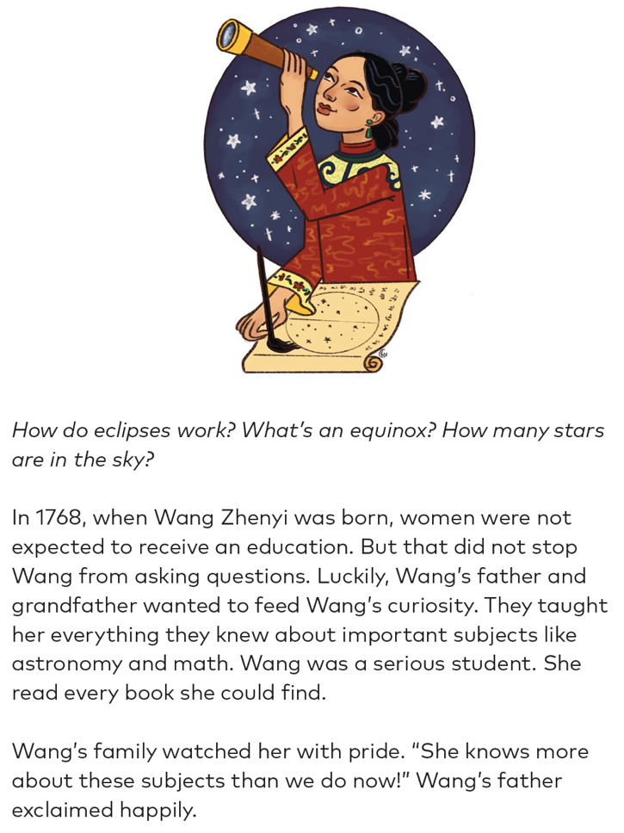 | 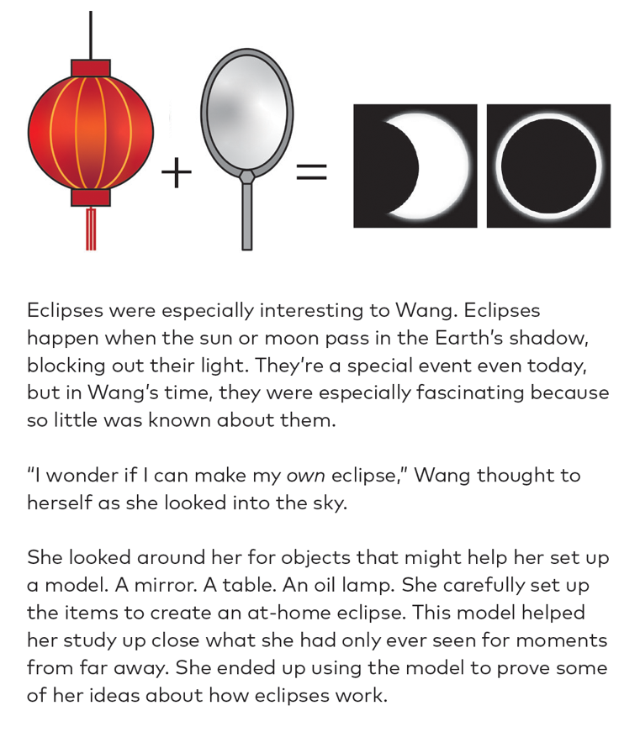

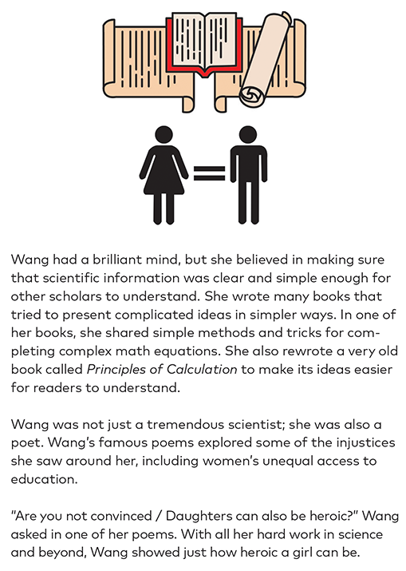 | 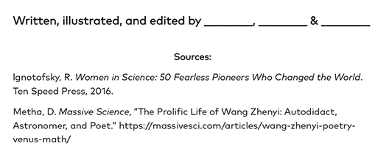

Scribe Concepts for EL Education.

Model Performance Task: Mae Jemison
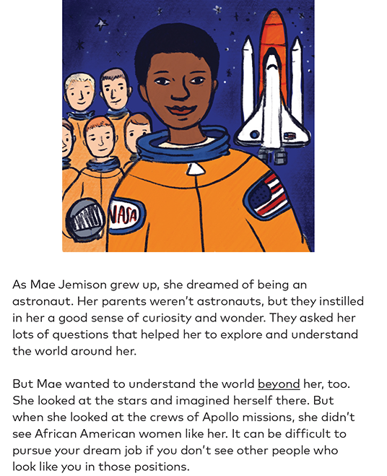 | 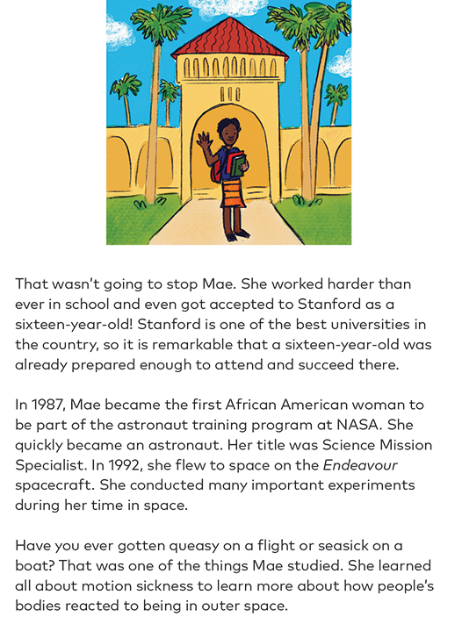

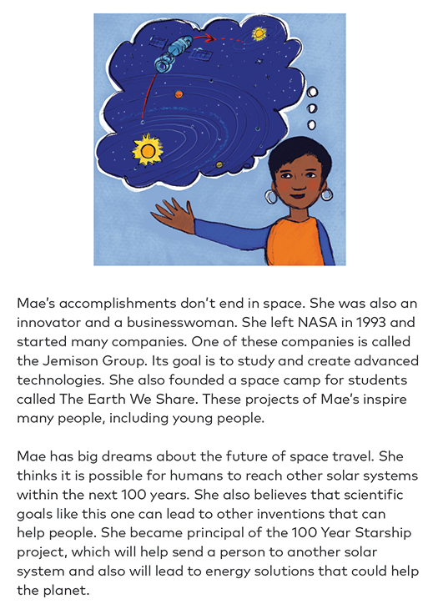 | 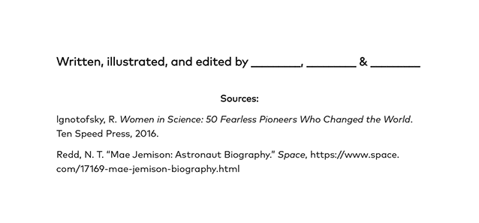
Scribe Concepts for EL Education.
Performance Task Presentation Checklist
SL.6.4
Name: Date:
Directions: Rehearse the presentation of your Performance Task: Hidden Figures in Space Science Picture Book, checking to ensure that all of the following criteria are included in your presentation. Check off whether the criterion needs improvement (Still in Liftoff) or if it has been successfully incorporated into the presentation (Mission Accomplished!).
Put the initials of the crewmate next to the task(s) for which they are responsible, in the Designated Crewmate column. Each crewmate should be responsible for at least one of the four main parts of the presentation: introduction, reason 1, reason 2, or conclusion. Note: All crewmates should initial the final criterion on the list!
 | Designated Crewmate | Still in Liftoff | Mission Accomplished!
Introduction
Begin with an interesting hook to engage your audience.
Provide any necessary background on the focus figure or the time period the audience needs to understand the topic.
Statement
State your claim. Include the focus figure’s name and remarkable accomplishments.
Reason 1
State the first reason that supports your claim.
Include evidence and reasoning that connect back to the reason.
Share them in a way that makes your argument clear and easy to follow.
Reason 2
State the second reason that supports your claim. Include evidence and reasoning that connect back to the reason.
Share them in a way that makes your argument clear and easy to follow.
Restatement
Restate your claim, reminding the audience of your two main reasons.
Conclusion
Conclude your presentation with a statement that reveals additional thinking or reflection on this topic.
Presentation Skills
Demonstrate appropriate eye contact, adequate volume, and clear pronunciation.

