Performance Task Overview
 Summary of Task
Roundtable Presentations of Food Choices
This performance task gives students the opportunity to present their findings and claims about food choices. Throughout Unit 1 of this module, students learn new information about where food in America comes from and analyze arguments about food. In Unit 2 of this module, students explore two topics—GMOs and a topic of their choice (pesticides, food deserts, high-fructose corn syrup, or organic foods)—and use their research findings to write an expository essay about their topic. Throughout Unit 3, students begin to formulate their opinions on what food choices they think people in their community could make in order to eat more healthily and sustainably. Students write an argumentative essay, making a recommendation for how people should take informed action about their food choices. For the performance task, each student creates an infographic, along with a 3-minute oral presentation of the argument they made in their essay. Students share their infographics in a roundtable presentation with an authentic audience of classmates, teachers, families, and community members.
Format
Students create an infographic in order to visually represent their claims. Additionally, students create prompt cards for a 3-minute speech to accompany their visual. Students present their arguments in roundtables in which each student is continually presenting his or her claims to a rotating audience of observers who will take notes on what they learned and any questions or feedback they have.
Standards Addressed through This Task
The performance tasks at the end of every module are neither formative nor summative assessments. They are not formative since they come at the end of the module, concluding students’ learning about the module topic and the literacy skills they have built over eight or nine weeks. However, they are also not summative because they are heavily scaffolded to help students create high-quality work, and so they are not a strong measure of what students can do independently. For these reasons, we do not recommend analyzing performance tasks with the same lens used to analyze assessments. Consider looking at students’ performance tasks through the lens of the attributes of high-quality student work (authenticity, complexity, craftsmanship). Below are possible questions to keep in mind when considering these attributes:
- Authenticity: Does the student demonstrate interest and investment in their food choice and the claims they are making? Does the student provide appropriate explanations of the evidence that helped them come to their opinion and reasoning for why community members should follow this food choice? Does the student address the intended audience appropriately and engagingly?
- Complexity: Does the student demonstrate deep knowledge of food choices and sustainability? Has the student effectively communicated an argument for a specific food choice through his or her infographic? Does the argument indicate that the student thought carefully about the topic and considered all points of view?
- Craftsmanship: Do the visual elements in the infographic presentation help to portray the argument and ideas? Are the ideas organized logically, with shapes and arrows, on the infographic? Is there a headline with a recommendation for the audience? Did the student include two points from their argument essay, reasoning, evidence, and a counterclaim? Did the student include key words and notes, rather than full sentences, to express ideas? Is the infographic simple and uncluttered—easy to understand with a quick glance? Are the infographic and speech carefully written and thoughtfully crafted? Do students speak carefully, with attention to purpose and audience? Has the student successfully incorporated peer feedback on the content and presentation?
The following standards are addressed, but not assessed:
- SL.8.4: Present claims and findings, emphasizing salient points in a focused, coherent manner with relevant evidence, sound valid reasoning, and well-chosen details; use appropriate eye contact, adequate volume, and clear pronunciation.
- SL.8.5: Integrate multimedia and visual displays into presentations to clarify information, strengthen claims and evidence, and add interest.
- SL.8.6: Adapt speech to a variety of contexts and tasks, demonstrating command of formal English when indicated or appropriate. (See grade 8 Language standards 1 and 3 for specific expectations.)
- L.8.6: Acquire and use accurately grade-appropriate general academic and domain-specific words and phrases; gather vocabulary knowledge when considering a word or phrase important to comprehension or expression.
Student-Friendly Writing Invitation/Task Description
How do we make the right choices about what to eat? There are so many options and so much information, including conflicting information, about what Americans should do to make healthy food choices. It can be complex and confusing to decide just what to eat, and we need your help! Throughout this module, you researched and learned about how food is grown and processed, and how that impacts our health, nutrition, and our environment. Based on your findings, you wrote an argumentative essay about one recommendation for your community to consider when making healthy and sustainable food choices.
For this performance task, you will create an infographic and speaking points to present that argument to your community. You will present your infographic to an audience in a roundtable setting, explaining your argument to inform them about how to make healthy and sustainable food choices and why it is important to do so. You are the expert, and it is your turn to help your community make informed and healthy choices about what they eat!
Your infographic will include
- a clear recommendation for healthy and sustainable food choices;
- two reasons why your audience should consider your recommendation;
- two quotes or paraphrases from research texts that support each reason;
- a counterclaim that addresses the opposition to your claim/recommendation; and
- illustrations, images, or graphics that help convey your ideas.
This infographic can then be shared on social media, through email, on a website, or on bulletins in a school or local supermarket to help others learn about making healthy food choices.
Your presentation will include
- a 3-minute speech outlining the key points of your argument;
- domain-specific vocabulary to show your understanding of the topic;
- an infographic to visually represent your argument; and
- appropriate eye contact, adequate volume, and clear pronunciation when presenting your claims.
 Key Criteria for Success (Aligned with CCSS ELA)
Below are key criteria students need to address when completing this task. Specific lessons during the module build in opportunities for students to understand the criteria, offer additional criteria, and work with support to generate a list of criteria that will be used to critique and formally assess their work.
Your presentation will include:
Infographic (Created in Lesson 12)
- Illustrations, images, or graphics that help convey ideas
- Ideas organized in shapes and arrows
- Not full sentences—key words and notes
- Simple, uncluttered
- Easy to understand with a quick glance
- Headline—recommendation for the audience
- The two points from the argument essay
- Reasoning
- Evidence
- Counterclaim
Prompt Cards (Created in Lesson 13)
- Not full sentences—key words and notes
- Reflect the words being spoken at the time
- Give more information than just the key points of the essay—they also introduce themselves and thank the audience at the end
- Provide claims, points, evidence, reasoning, counterclaims
- Reflect the order of the argument essay
- Cue the speaker to know when to point to specific visuals
Presentation (Presented in Lesson 14)
- Speak slowly and clearly, articulating each word carefully.
- Speak at an appropriate volume for everyone to hear.
- Use more formal language rather than the kind of language we might use in a discussion.
- Make eye contact with the audience.
- Face the audience as much as possible.
- Point occasionally to relevant images or quotes on the visual.
Options for Students
Extension (digital): Students could provide an audio recording of their argument in the form of a podcast. They could create a video of their presentation, which shows the visual component while recording the audio component. They could also compile their digital copies of their presentations and create a class website to house their arguments.
Students could work in groups to create a group presentation and infographic if they have all chosen the same food choice.
Students could create original artwork for their presentations to accompany their speeches. This could be done as homework or in collaboration with a school visual arts teacher.
Options for Teachers
If technology is not available for students to create infographics digitally, students could create handwritten and illustrated visuals for their infographic.
If time permits, provide additional in-class time for students to work on their presentations and to peer-review one another’s work to ensure quality and consistency among presentations.
If unable to organize an event for community members, students may present their arguments to their own class, to other classes in the school, or to parents or other adults.
Performance Task Anchor Chart
SL.8.4, SL.8.5, SL.8.6, L.8.6
How do we make the right choices about what to eat? There are so many options and so much information, including conflicting information, about what Americans should do to make healthy food choices. It can be complex and confusing to decide just what to eat, and we need your help! Throughout this module, you researched and learned about how food is grown and processed, and how that impacts our health, nutrition, and environment. Based on your findings, you wrote an argumentative essay about one recommendation for your community to consider when making healthy and sustainable food choices.
For this performance task, you will create an infographic and speaking points to present that argument to your community. You will present your infographic to an audience in a roundtable setting, explaining your argument to inform them about how to make healthy and sustainable food choices, and why it is important to do so. You are the expert, and it is your turn to help your community make smart, informed, and healthy choices about what we eat!
Your infographic will include
- a clear recommendation for healthy and sustainable food choices;
- two reasons why your audience should consider your recommendation;
- two quotes or paraphrases from research texts that support each reason;
- a counterclaim that addresses the opposition to your claim/recommendation; and
- illustrations, images, or graphics that help convey your ideas.
This infographic can then be shared on social media, through email, on a website, or on bulletins in a school or local supermarket to help others learn about making healthy food choices.
Your presentation will include
- a 3-minute speech outlining the key points of your argument;
- domain-specific vocabulary to show your understanding of the topic;
- an infographic to visually represent your argument about an important food choice; and
- appropriate eye contact, adequate volume, and clear pronunciation when presenting your claims.
Performance Task Criteria Anchor Chart
W.8.6, SL.8.4, SL.8.5
(For Teacher Reference)
Infographic (Lesson 13)
- Illustrations, images, or graphics that help convey ideas
- Ideas organized in shapes and arrows
- Not full sentences—key words and notes
- Simple, uncluttered
- Easy to understand with a quick glance
- Headline (recommendation for the audience to follow)
- The two points from the argument essay
- Reasoning
- Evidence
- Counterclaim
Prompt Cards (Lesson 14)
- Not full sentences—key words and notes
- Reflect the words being spoken at the time
- Give more information than just the key points of the essay—include an introduction, and thank the audience at the end
- Provide claims, points, evidence, reasoning, counterclaims
- Reflect the order of the argument essay
- Cue the speaker to know when to point to specific visuals
Presentation (Lesson 15)
- Speak slowly and clearly, articulating each word carefully
- Speak at an appropriate volume for everyone to hear
- Use more formal language rather than the kind of language we might use in a discussion
- Make eye contact with the audience
- Face the audience as much as possible
- Point occasionally to relevant images or quotes on the visual
Performance Task: Model Infographic
Name: Date:
Directions: Analyze the model infographic below to generate criteria for an effective infographic. Use this model to help you create your own infographic.
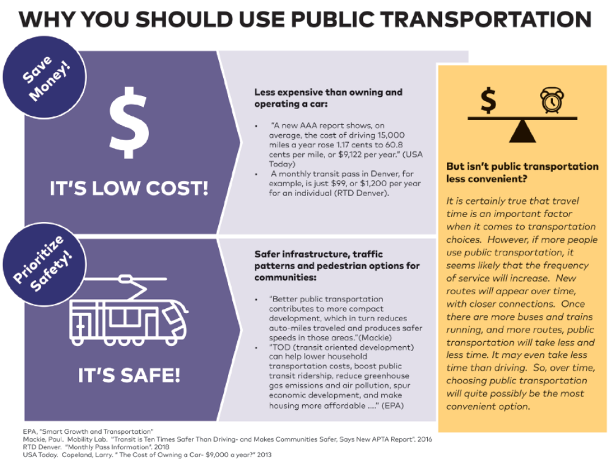

Scribe Concepts for EL Education.
Performance Task: Model Prompt Cards
Prompt Card 1
- Welcome, and thank you for coming.
- Introduce myself.
- What I will do in this presentation:
  - answer question: what is the best mode of transportation for members
of our community?
- Why is this important?
  - to improve the quality of life of individuals and the community
- Most important consideration:
  - public transportation
Prompt Card 2
- Point 1: Its low cost:
  - less expensive than owning a car
  - transit pass costs less than car costs
  - Companies offer employee discounts for public transportation.
  - less money spent on transportation = more money for other things
Visual of money and bubble that says, “Save money!”
Prompt Card 3
- Point 2: It’s safe:
  - safe infrastructure
  - People travel fewer miles to access public transportation.
  - safer speeds = fewer car accidents
Visual of city bus and bubble that says “Prioritize safety!”
Prompt Card 4
- Counterclaim: It isn’t convenient:
  - People are busy and need to get to places quickly.
  - there are places that don’t have adequate transit = waste time
  - but, more use creates new routes = less time
  - can take less time than driving
- Thank you.
- Any questions?
Visual of scale of dollar sign and clock

Performance Task: Guest Exit Ticket
Thank you for coming to our Roundtable Presentations. We would appreciate your feedback to help us with presentations in the future. We would appreciate it if you could please answer the following questions without using any student names.
What was a highlight for you?

What did you learn today?

What did you think we did well in our presentations?

Do you have any suggestions for how we might be able to improve next time?

