Performance Task Overview
 Summary of Task
Solution Symposium
The performance task is a student-hosted Solution Symposium during which students present the problem and design-solution that they researched in Unit 2 and about which they wrote a problem-solution essay in Unit 3. To prepare for the Solution Symposium, students create a flip-down visual representations of their essay content and post these visuals for the Solution Symposium event.
During the symposium, guests (i.e., other students, parents, members of the local community) will circulate around with a presentation prompts card: an index card with two questions to ask the presenters. These Presentation Prompts ask, (1) how was design thinking used to solve this problem and (2) how were habits of character used to solve this problem? Presenters answer questions, and guests record a new insight on a sticky note next to the presenters’ work.
Each student’s participation in the Solution Symposium includes five steps, repeated multiple times throughout the event, as new visitors arrive at the student’s station.
- Step 1: The student-presenter describes the problem they researched to guest(s) visiting their station. The solution to this problem is, at this point, concealed from the guest’s view.
- Step 2: The presenter invites guest to brainstorm one or two possible solutions to the problem.
- Step 3: The presenter uses a flip-down visual to reveal the solution, as illustrated through an illustration or diagram. The presenter explains the solution they researched, referring to the accompanying visual as needed.
- Step 4: The guest uses the presentation prompts card to ask two follow-up questions of the presenter: (1) how was design thinking used to solve this problem and (2) how were habits of character used to solve this problem? The presenter answers the questions.
- Step 5: The presentation concludes, and the guest uses a sticky note to record one insight or piece of learning gained during the presentation. The guest leaves the sticky note with the presenter.
Format
Short, interactive presentations, with a visual component. Students’ presentations are held simultaneously and repeated as new visiting guests arrive at each student’s station.
Standards Addressed through This Task
The performance tasks at the end of every module are neither formative nor summative assessments. They are not formative since they come at the end of the module, concluding students’ learning about the module topic, the habits of character, and the literacy skills they have built over 8 or 9 weeks. However, they are also not summative because they are heavily scaffolded to help students create high-quality work and so are not a strong measure of what students can do independently. For these reasons, we do not recommend analyzing performance tasks with the same lens used to analyze assessments.
Although the Solution Symposium addresses standards important for student success (listed below), consider looking instead at students’ performance tasks through the lens of the attributes of high-quality student work (authenticity, complexity, and craftsmanship). Below are possible questions to keep in mind when considering these attributes:
- Authenticity: Does the student demonstrate interest and investment in their chosen problem and design-solution? Does the student provide appropriate answers to the guests’ presentation prompts? Is the student able to meaningfully respond to any spontaneous, clarifying, or follow-up questions? Do students address the real-life impact of the design-solution they researched?
- Complexity: Does the student demonstrate deep knowledge of their researched problem and design-solution? Has the student effectively synthesized the content of their essays into a short-presentation format? Do students include relevant details in their responses to guests’ questions? Do they maximize opportunities to engage with the guests visiting their station?
- Craftsmanship: Do the student’s visuals artfully and meticulously represent their research problem and design-solution? Is any accompanying text accurate and thoughtfully crafted? Do students speak carefully, with attention to purpose and audience?
The following standards are addressed, but not assessed:
- RI.6.7: Integrate information presented in different media or formats (e.g., visually, quantitatively) as well as in words to develop a coherent understanding of a topic or issue.
- RI.6.10: By the end of the year, read and comprehend literary nonfiction in the grades 6-8 text complexity band proficiently, with scaffolding as needed at the high end of the range.
- W.6.7: Conduct short research projects to answer a question, drawing on several sources and refocusing the inquiry when appropriate.
- W.6.8: Gather relevant information from multiple print and digital sources; assess the credibility of each source; and quote or paraphrase the data and conclusions of others while avoiding plagiarism and providing basic bibliographic information for sources.
- SL.6.1: Engage effectively in a range of collaborative discussions (one-on-one, in groups, and teacher-led) with diverse partners on grade 6 topics, texts, and issues, building on others’ ideas and expressing their own clearly.
- SL.6.2: Interpret information presented in diverse media and formats (e.g., visually, quantitatively, orally) and explain how it contributes to a topic, text, or issue under study.
- SL.6.4: Present claims and findings, sequencing ideas logically and using pertinent descriptions, facts, and details to accentuate main ideas or themes; use appropriate eye contact, adequate volume, and clear pronunciation.
- SL.6.5: Include multimedia components (e.g., graphics, images, music, sound) and visual displays in presentations to clarify information.
- SL.6.6: Adapt speech to a variety of contexts and tasks, demonstrating command of formal English when indicated or appropriate. (See grade 6 Language standards 1 and 3 for specific expectations.)
Student-Friendly Writing Invitation/Task Description
You uncovered a critical problem. You researched a design-solution. Now, you’ll share your learning with others during a Solution Symposium!
What Is a Solution Symposium?
sym-po-si-um: a formal meeting or conference, where experts discuss a particular subject
The subject of our symposium is “critical problems and their design-solutions” and the experts are. . .you! Each of you will create a visual representation on paper of the problem and design-solution that you researched for your essays. You will hang the visuals on the wall, and, during the symposium, you will stand next to them. That will be your “station.” Guests will visit your station and you will present your problem and solution, using your visuals to help you explain. When you are the visitor at a station, you will use a note-catcher to record the key details from your peers’ presentations.
Preparing for the Symposium
You’ll use the information you gathered and wrote about for your problem-solution essay to prepare for the Solution Symposium. You might also have to do some additional research to gather images or other graphics for your presentation materials.
Flip-Down Visual
The flip-down visual will contain two sections: one for the problem and one for the solution. You’ll create each section using illustrations, diagrams, collages, or something else. And you will write some text to explain them, too.
Be creative when designing your visuals. You may choose to draw your problem and its solution, or you may be more comfortable using a computer program to create a diagram or making a collage of images you find online. Your visuals are meant to help guests better understand the problems and solutions you describe, but how you do that is up to you. Use your imagination!
Memorize your explanations of the problem and solution or put them on notecards to use during the symposium.
Think about other ways to make your presentation engaging for guests who visit your station. For example, depending on the problem and solution you researched, you may wish to have something physical (like a model) that guests can touch or hold.
Practice incorporating your flip-down visual into your presentation, making sure that your audience cannot see the solution until you have described the problem and given them a chance to brainstorm possible solutions.
Presentation Prompt Preparation Notes
Prepare your responses to these two questions, and either memorize them or put them on notecards to use during the symposium. Your guests will ask you two questions, after you present your problem and solution flip-down visual:
- How was design thinking used to solve this problem?
- How were habits of character used to solve this problem?
During the Symposium
Symposiums make presentations look a little different than you might be used to. Instead of presenting one at a time to the class, many of you will present at the same time to different people! You will also be giving the same presentation several times in a row to new guests. The guests who attend the symposium might be your classmates, other students, friends or family members, or other people in our community. Guests will walk from station to station to learn more about the problems and solutions you have researched. Whenever someone new comes to your station, you will follow a series of steps:
- First, you welcome your guests, introduce yourself, and describe the problem you researched. The top of your visual should cover the solution underneath.
- You ask the guests to guess one or two possible solutions to the problem. You discuss their ideas with them.
- Then, you flip down the top layer (the problem) of the visual to reveal the bottom layer (the solution). You explain the solution to the guest.
- Next, the guest will ask you two questions: (1) how was design thinking used to solve this problem and (2) how were habits of character used to solve this problem? These questions are called presentation prompts, and each guest will have them written down on a card. You answer these questions, one at a time.
- The guest uses a sticky note to write down one thing they learned from your presentation. Thank your guests as they leave the sticky note with you and move on to the next station. You get ready for your next guest, and the process starts again!
Our Solution Symposium is a great way to celebrate all the learning you have done during this module!
 Key Criteria for Success (Aligned with CCSS ELA)
Below are key criteria students need to address when completing this task. Specific lessons during the module build in opportunities for students to understand the criteria, offer additional criteria, and work with support to construct a criteria list by which their work will be critiqued and formally assessed.
Your participation in the Solution Symposium will include the following:
- Relevant informational text to describe the problem you researched.
- A clear explanation of the design-solution you researched.
- Artful visuals (e.g., illustrations, diagrams) that depict the problem and the solution.
- Carefully organized visuals to guide guests through your presentation.
  - This includes a flip-down visual that hides the solution while you present the problem.
- Thoughtful answers to questions about how design thinking and habits of character were used to solve your problem.
- The ability to repeat your presentation as new guests arrive at your station, improving or adapting as needed.
Options for Students
Be creative when designing your visuals. You may choose to draw your problem and its solution, or you may be more comfortable using a computer program to create a diagram or making a collage of images you find online. Your visuals are meant to help guests better understand the problems and solutions you describe, but how you do that is up to you. Use your imagination!
Think about other ways to make your presentation engaging for guests who visit your station. For example, depending on the problem and solution you researched, you may wish to have something physical (like a model) that guests can touch or hold.
Options for Teachers
Guest visitors to the symposium can include classmates, students in other classes, parents or other family members, and/or members of the local community. This will vary depending on accessibility and/or school and community attitudes and expectations.
Consider splitting the Solution Symposium into two parts. First, randomly assign students to Group A or Group B. During the first half of the symposium, students in Group A are the presenters, standing with their visuals and sharing their work, while students in Group B are guests, circulating with presentation prompt cards, asking questions, giving sticky-note feedback, and taking notes on their note-catchers. Halfway through the time allotted for the presentation task, Group A and B switch roles.
Consider ways to help students adapt the visual display of their information to best reflect the content of their essays. For example, if students researched problems whose initial solutions were inadequate or incomplete, students may wish to include visuals that show some of these steps. This might require a flip-down visual that contains multiple components underneath.
If there is concern that presenters may answer their questions too quickly or briefly, consider including a third question on the presentation prompt cards. This question could, for example, invite presenters to reflect on their learning or describe their interest in the problem and solution they choose. Alternatively, leave a blank space on the presentation prompts card underneath the two questions, and encourage guests to write their own third question to students. Note that this iteration of the task poses an increased challenge for presenters, as it will require presenters to respond spontaneously to questions for which they have not prepared answers.
Performance Task Anchor Chart
RI.6.7, RI.6.10, W.6.2, W.6.7, W.6.8, SL.6.1, SL.6.2, SL.6.4, SL.6.5, SL.6.6
(For Teacher Reference)
You uncovered a critical problem. You researched a design-solution. Now, share your learning with others!
We, as a class, are going to host a Solution Symposium! Now, you might be wondering, What is a “symposium”? Here’s the definition:
sym-po-si-um: a formal meeting or conference, where experts discuss a particular subject
The subject of our symposium is “critical problems and their design-solutions” and the experts are . . . you! Each of you will create a visual representation on paper of the problem and design-solution that you researched for your essays. You will hang the visuals on the wall and, during the symposium, you will stand next to them. Guests will visit your station and you will present your problem and solution, using your visuals to help you explain.
Symposiums make presentations look a little different than you might be used to. Instead of presenting one at a time to the class, many of you will present at the same time to different people. Guests will walk from station to station to learn more about the problems and solutions you have researched.
Your participation in the Solution Symposium will include the following elements:
- Relevant text information to describe the problem you researched.
- A clear explanation of the design-solution you researched.
- An artful flip-down visual that depicts the problem and the solution.
- Carefully organized text and visuals to guide guests through your presentation.
- Thoughtful responses about how design thinking and habits of character were used to solve your problem.
- The ability to repeat your presentation as new guests arrive at your station, improving or adapting as needed.
Performance Task: Solution Symposium
RI.6.7, RI.6.10, W.6.7, W.6.8, SL.6.1, SL.6.2, SL.6.4, SL.6.5, SL.6.6
Name: Date:
You uncovered a critical problem. You researched a design-solution. Now, you’ll share your learning with others during a Solution Symposium!
What is a Solution Symposium?
sym-po-si-um: a formal meeting or conference, where experts discuss a particular subject
The subject of our symposium is “critical problems and their design-solutions,” and the experts are . . . you! Each of you will create a visual representation on paper of the problem and design-solution that you researched for your essays. Guests will visit your “station” and you will present your problem and solution, using your visuals to help you explain. When you are the visitor at a station, you will use a note-catcher to record the key details from your peers’ presentations.
Before the Symposium
Use the information you gathered for your Problem-Solution essay to prepare for the Solution Symposium. You might have to conduct additional research to gather images or other graphics for your presentation materials.
Flip-Down Visual
The flip-down visual will contain two sections: one for the problem and one for the solution. You will create each section using visuals, such as illustrations, diagrams, collages, as well as text.
Memorize your explanations of the problem and solution or put them on notecards to use during the symposium.
Practice incorporating your flip-down visual into your presentation, making sure that your audience cannot see the solution until you have described the problem and given them a chance to brainstorm possible solutions.
Presentation Prompts
Guests will be given two specific questions to ask after your presentation. Prepare and rehearse your responses.
- How was design thinking used to solve this problem?
- How were habits of character used to solve this problem?
During the Symposium
Guests will walk from station to station, interacting with each presenter. Whenever someone new comes to your station, follow these steps:
- First, welcome your guests, introduce yourself, and describe the problem you researched. The top of your visual should cover the solution underneath.
- Ask the guests to guess one or two possible solutions to the problem.
- Flip down the top layer (the problem) of the visual to reveal the bottom layer (the solution). Explain the solution to the guest.
- Listen respectfully as the guest asks the presentation prompts: (1) How was design thinking used to solve this problem? and (2) How were habits of character used to solve this problem? Answer the questions one at a time.
- Offer each guest a sticky note on which to record their favorite insight they learned from your presentation. Thank your guests as they leave the sticky note with you and move on to the next station. Get ready for your next guest, and the process starts again!
Your participation in the Solution Symposium will include the following elements:
- Relevant text information to describe the problem you researched.
- A clear explanation of the design-solution you researched.
- An artful flip-down visual that depicts the problem and the solution.
- Carefully organized text and visuals to guide guests through your presentation.
- Thoughtful responses about how design thinking and habits of character were used to solve your problem.
- The ability to repeat your presentation as new guests arrive at your station, improving or adapting as needed.
Model Performance Task
Urbain J. Kinet. “Cable crossing (Tuin) of the Trisuli River; between Pokhara and Kathmandu, Nepal.” Photograph. n.d. Urbain J. Kinet Collection, Department of Geography at the University of California, Berkeley. Flickr. Web. No known copyright restrictions.

Doug Letterman. “Suspension bridge.” Photograph. Flickr. 14 Nov. 2010. Web. Used under CC BY 2.0.
Rheins. “Suspension Bridge near Yuewang Pavilion - 2012.02.” Photograph. Wikimedia. 9 Feb. 2012. Web. Used under CC BY 3.0.

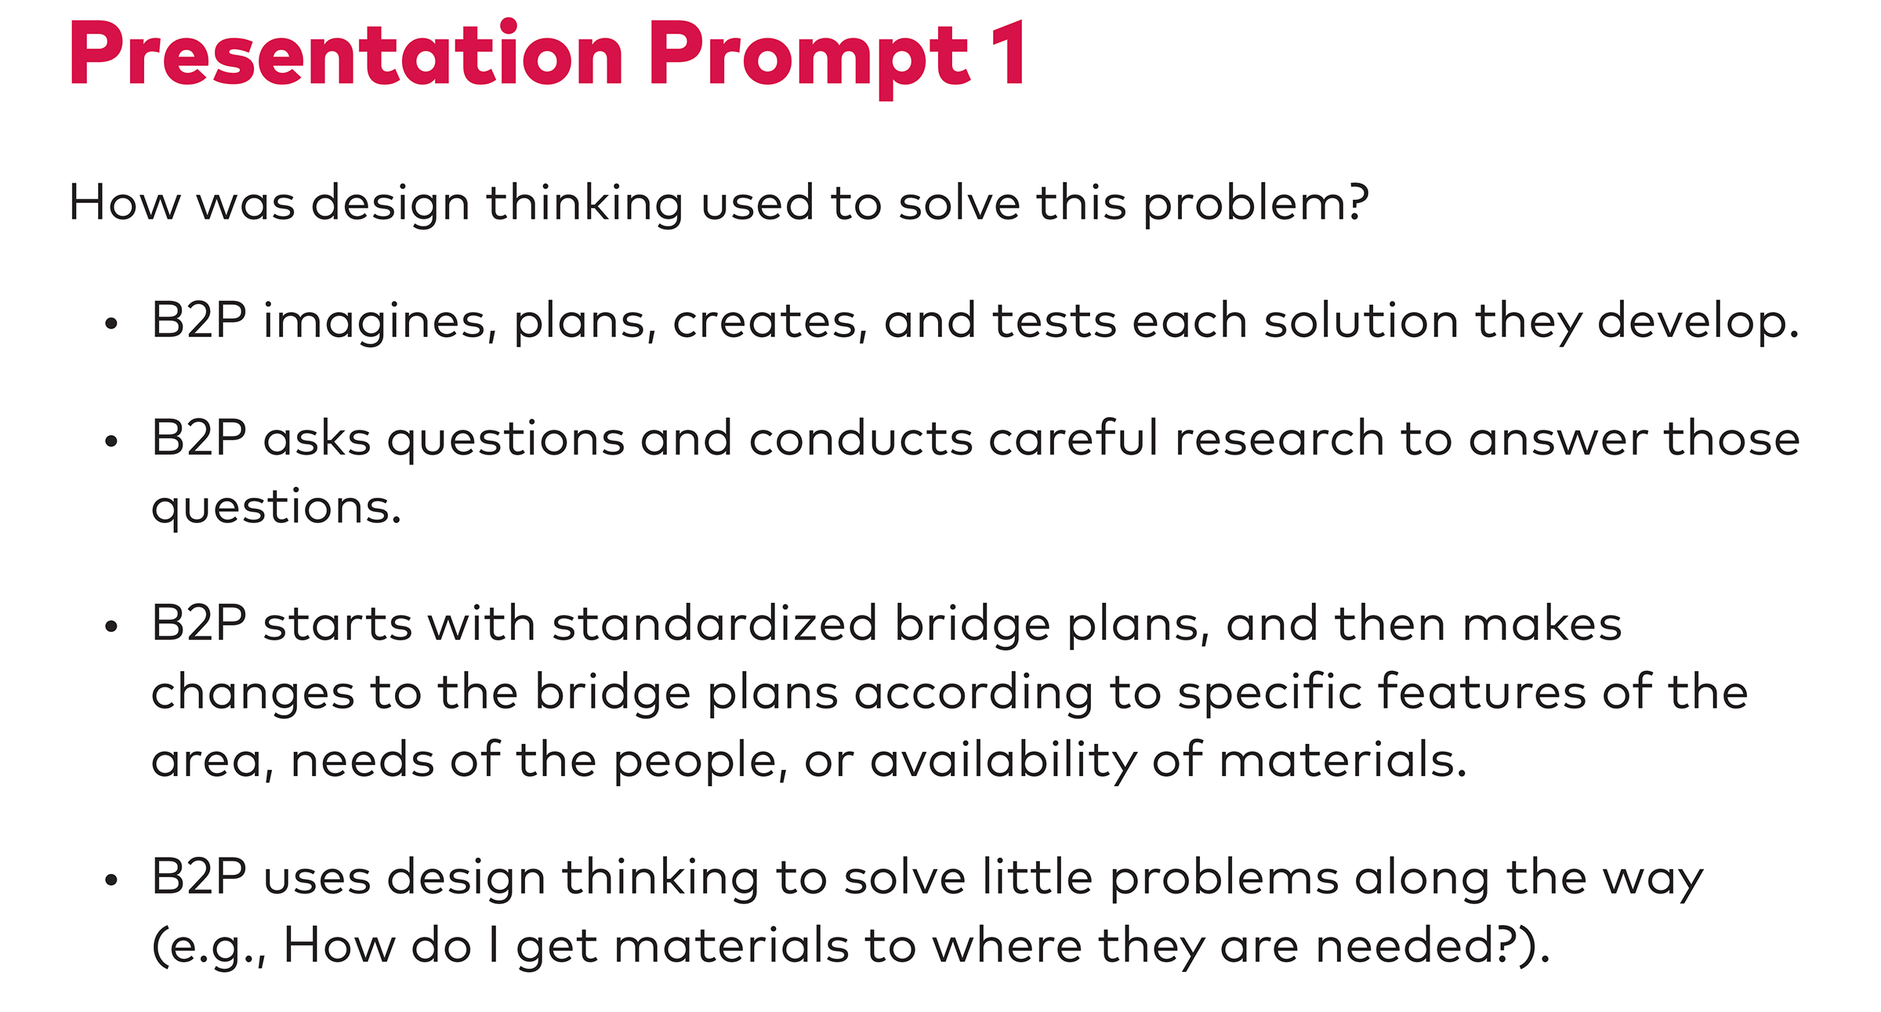

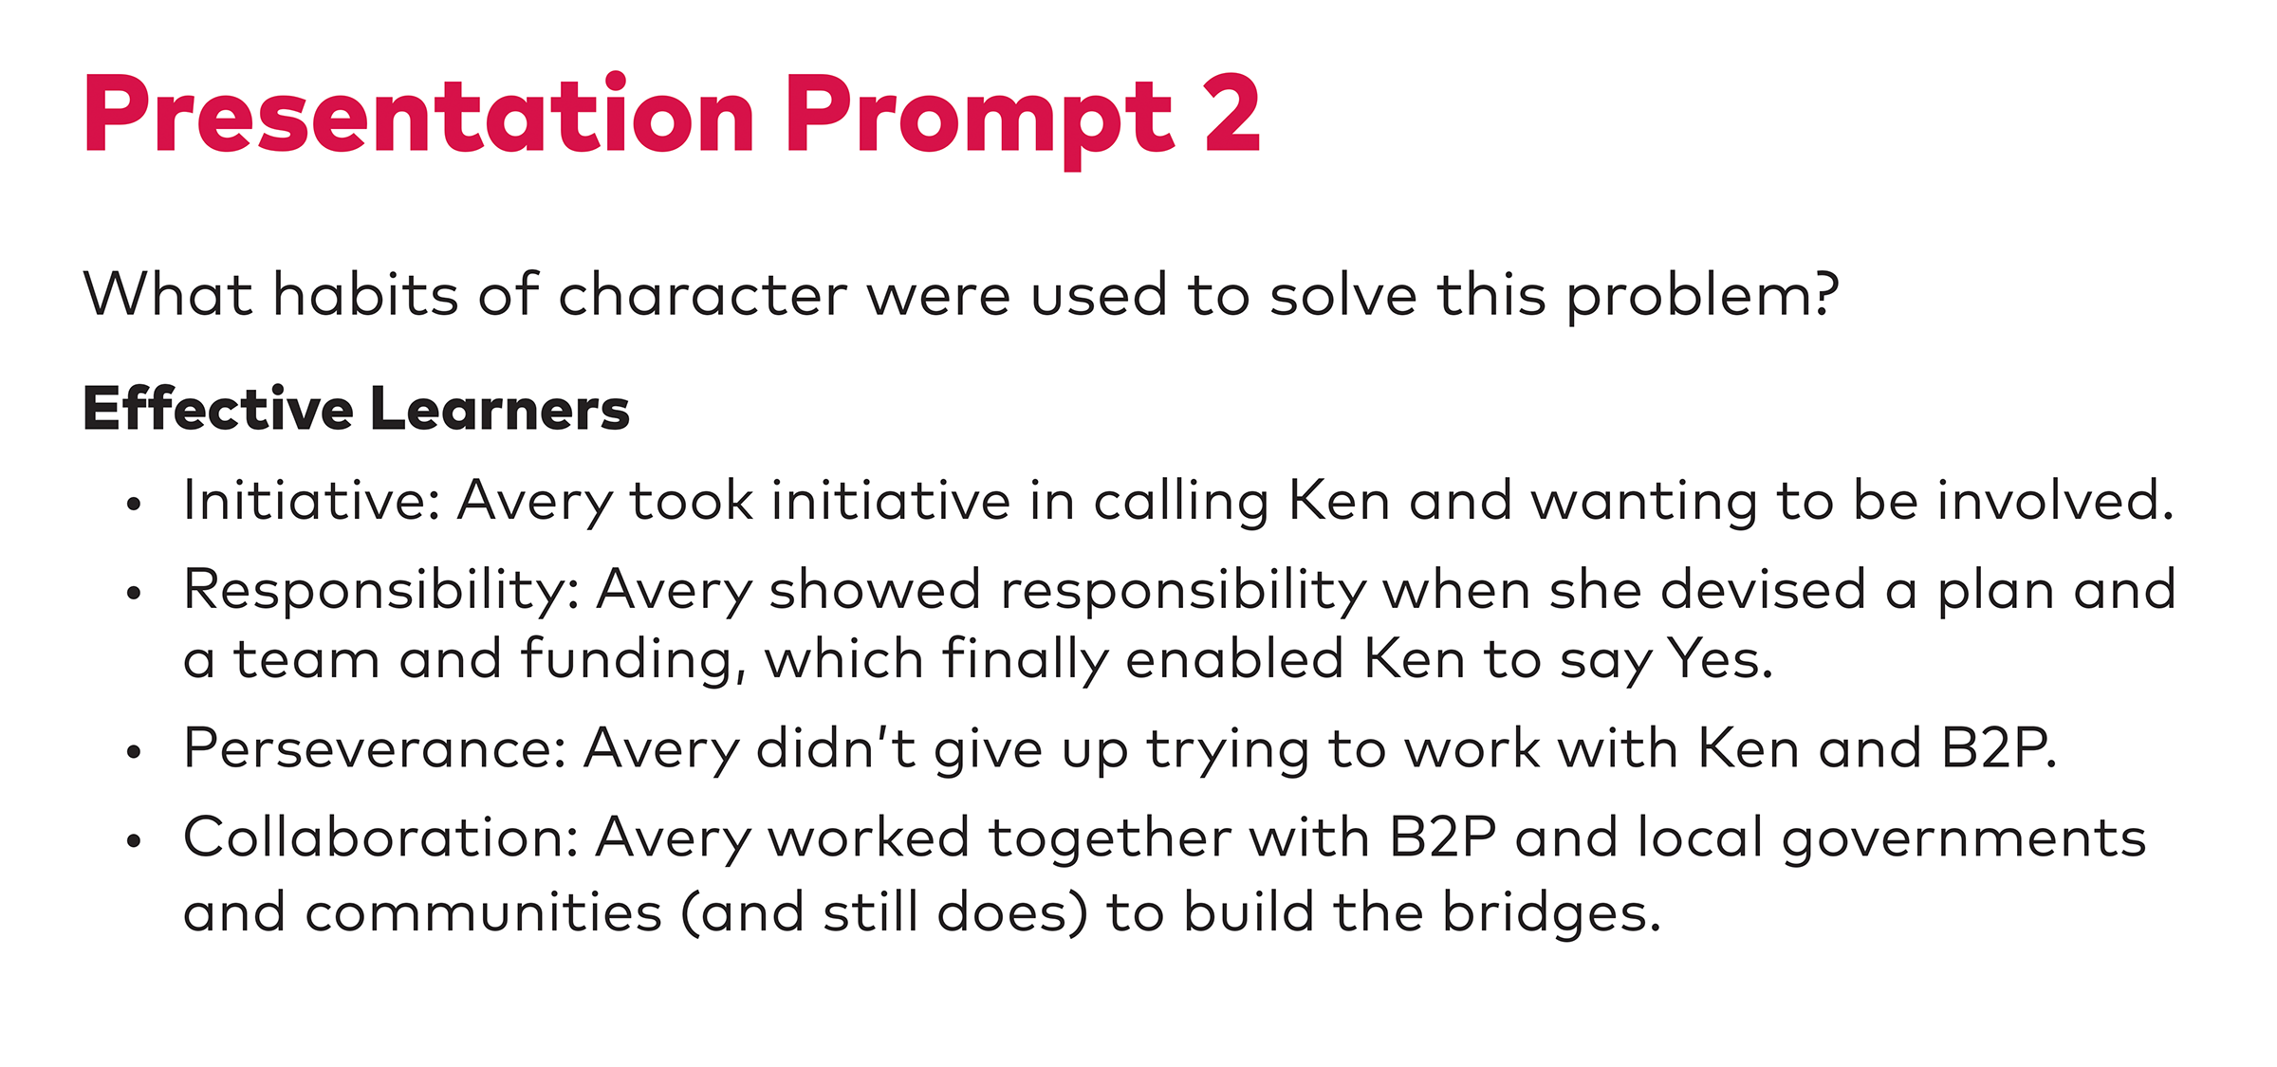

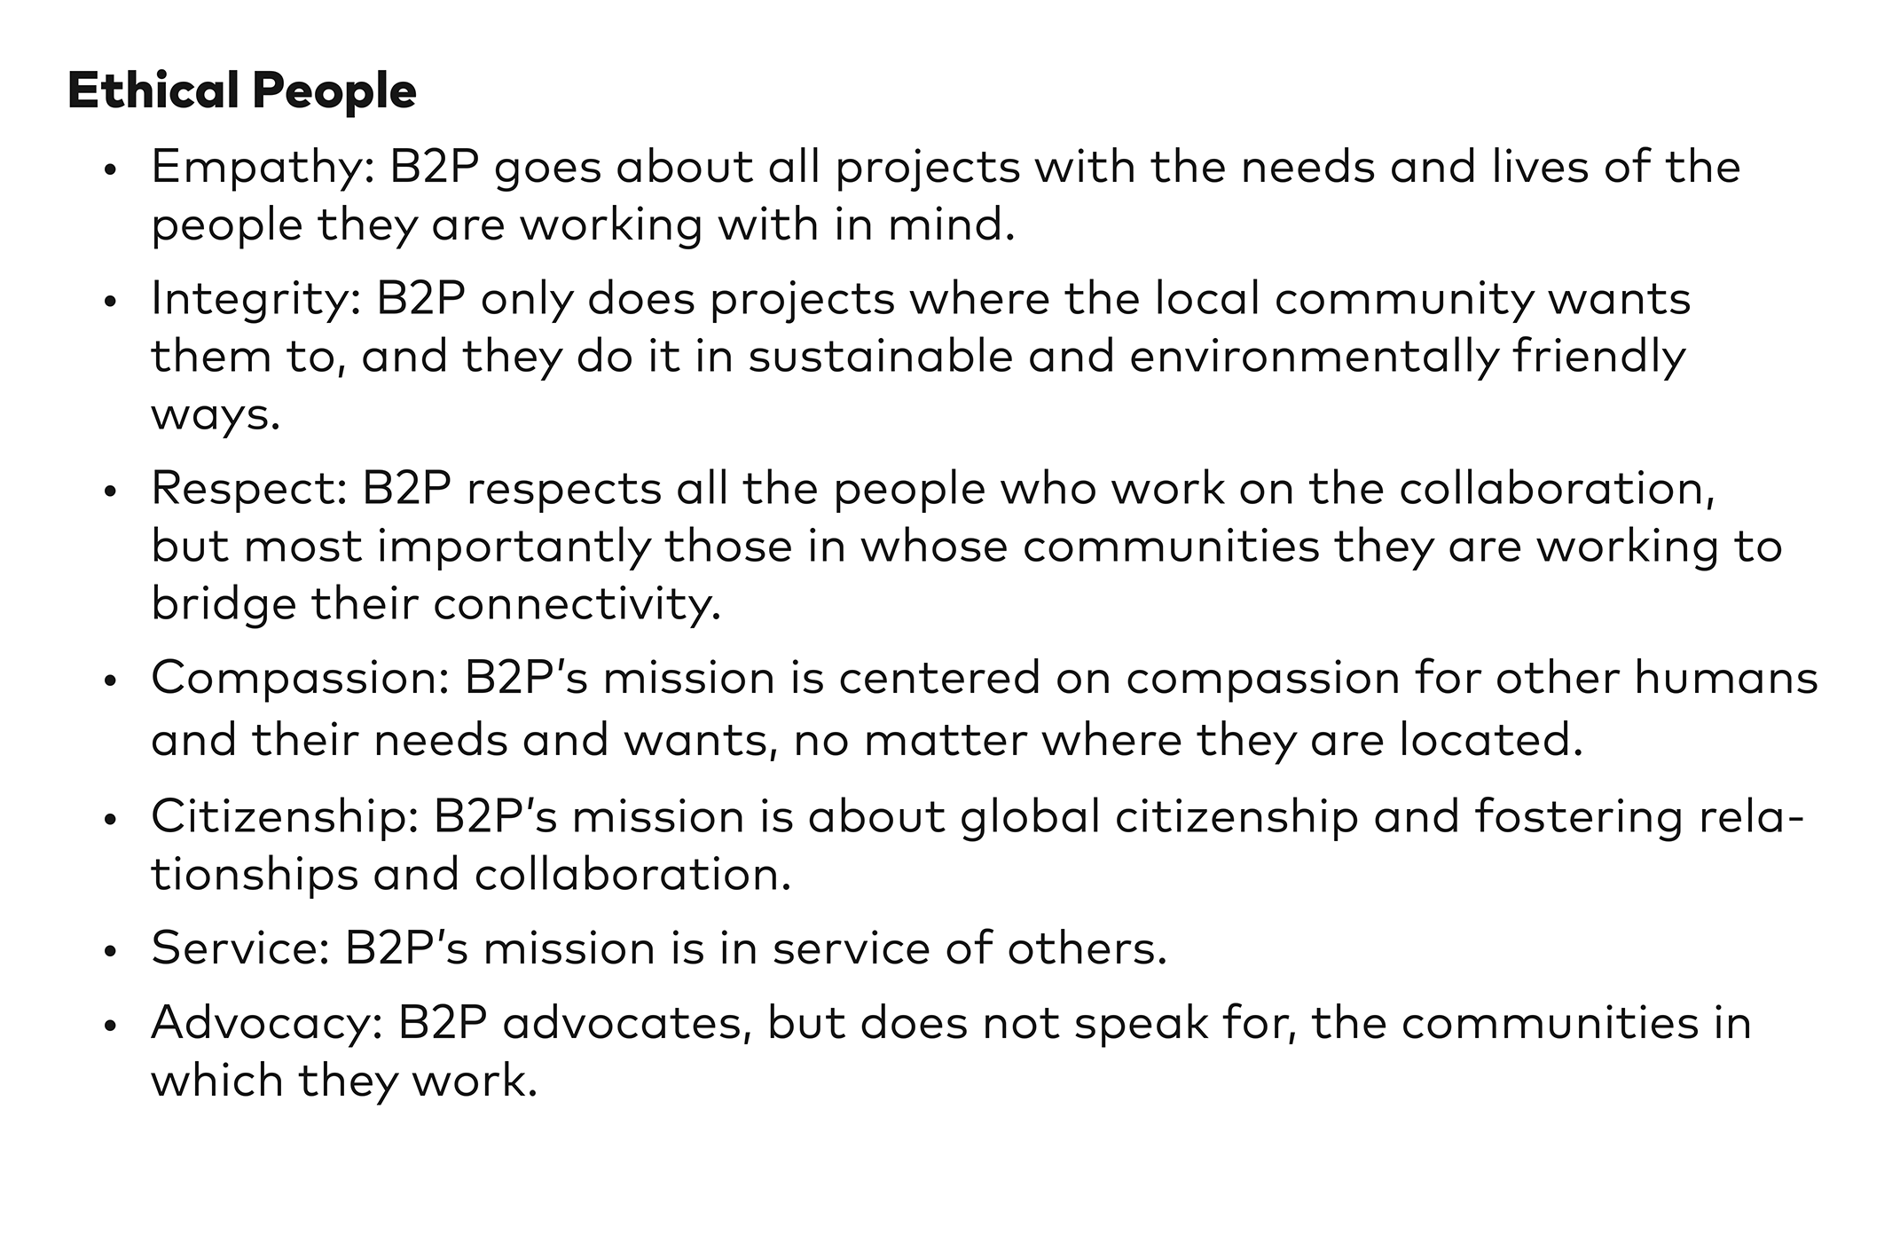
Solution Symposium Note-Catcher
RI.6.7, SL.6.1, SL.6.2
(Example for Teacher Reference)
Directions: Complete a note-catcher for the first three presentations you see during the Solution Symposium Presentations.
Solution Symposium Presenter: Student name
Who  Who is working on this problem-solution? | Kenneth Shinozuka
Critical Problem  Explain the critical problem in a few words. | Safety of Alzheimer’s patients due to night wandering
What specific information did you get from the visual about the problem? | The image showed an elderly person wandering in the street. This shows how vulnerable people with Alzheimer’s can be. It made clear how devastating it is when an adult cannot take care of him/herself anymore.
Design Solution  Explain the solution in a few words. | Pressure monitor in sock of Alzheimer’s patient that sends a notification to the caregiver’s smartphone. The notification lets the caregiver know that the patient’s foot is on the floor and the patient may be planning to leave their bed. This gives the caregiver a chance to check on them and make sure they do not wander.
What specific information did you get from the visual about the solution? | The visual showed the actual device. I couldn’t picture it before. The image makes clear that it’s a very small device that can be easily and comfortably attached to the sock.
Habits of Character  Check off each habit of character that is evident in the innovator’s work. Include and explain specific evidence for at least three habits of character. | ✓ Initiative ___ Responsibility  ✓ Perseverance ___ Collaboration  ✓ Empathy ___ Integrity ___ Respect ✓ Compassion  ___ Service ✓ Citizenship  Habit of character:  Compassion  Explanation:  Kenneth’s invention came from his desire to make sure Alzheimer’s patients like his grandfather are safe. He cares about their well-being.  Habit of character:  Perseverance  Explanation:  Kenneth did lots of research to find a way to help. Even when no solution was available, Kenneth did not give up.  Habit of character:  Initiative  Explanation:  Kenneth could not find a solution that already existed, so he decided to develop his own. He was the first person to think of a brand-new idea.

Source:
Shinozuka, Kenneth. “My Simple Invention, Designed to Keep My Grandfather Safe.” TedYouth, Nov. 2014.
Solution Symposium Note-Catcher
RI.6.7, SL.6.1, SL.6.2
Name: Date:
Directions: Complete a note-catcher for the first three presentations you see during the Solution Symposium Presentations.
Solution Symposium Presenter 1:
Who
Who is working on this problem-solution?
Critical Problem
Explain the critical problem in a few words.
What specific information did you get from the visual about the problem?
Design Solution
Explain the solution in a few words.
What specific information did you get from the visual about the solution?
Solution Symposium Presenter 1:
Habits of Character  Check off each habit of character that is evident in the innovator’s work. Include and explain specific evidence for at least three habits of character. | ___ Initiative ___ Responsibility ___ Perseverance ___ Collaboration  ___ Empathy ___ Integrity ___ Respect ___ Compassion  ___ Service ___ Citizenship  Habit of character:  Explanation:  Habit of character:  Explanation:  Habit of character:  Explanation:
Solution Symposium Presenter 2:
Who
Who is working on this problem-solution?
Critical Problem
Explain the critical problem in a few words.
What specific information did you get from the visual about the problem?
Design Solution
Explain the solution in a few words.
What specific information did you get from the visual about the solution?
Solution Symposium Presenter 2:
Habits of Character  Check off each habit of character that is evident in the innovator’s work. Include and explain specific evidence for at least three habits of character. | ___ Initiative ___ Responsibility ___ Perseverance ___ Collaboration  ___ Empathy ___ Integrity ___ Respect ___ Compassion  ___ Service ___ Citizenship  Habit of character:  Explanation:  Habit of character:  Explanation:  Habit of character:  Explanation:
Solution Symposium Presenter 3:
Who
Who is working on this problem-solution?
Critical Problem
Explain the critical problem in a few words.
What specific information did you get from the visual about the problem?
Design Solution
Explain the solution in a few words.

What specific information did you get from the visual about the solution?

Solution Symposium Presenter 3:
Habits of Character  Check off each habit of character that is evident in the innovator’s work. Include and explain specific evidence for at least three habits of character. | ___ Initiative ___ Responsibility ___ Perseverance ___ Collaboration  ___ Empathy ___ Integrity ___ Respect ___ Compassion  ___ Service ___ Citizenship  Habit of character:  Explanation:  Habit of character:  Explanation:  Habit of character:  Explanation:

Solution Symposium: Presentation Prompt Cards
Teacher Directions: Print and distribute Presentation Prompt Cards to guests to remind them of their role during the Solution Symposium.
Presentation Prompts  Interact with each presenter by following the steps below and asking the specific prompts given.  - Brainstorm some solutions to the problem presented.  - Listen respectfully as the presenter explains the work of the innovator.  - Ask: How was design thinking used to solve this problem?  - Ask: How were habits of character used to solve this problem?  - Record on a sticky note one insight you gained from the presentation, and leave it with the presenter. | Presentation Prompts  Interact with each presenter by following the steps below and asking the specific prompts given.  - Brainstorm some solutions to the problem presented.  - Listen respectfully as the presenter explains the work of the innovator.  - Ask: How was design thinking used to solve this problem?  - Ask: How were habits of character used to solve this problem?  - Record on a sticky note one insight you gained from the presentation, and leave it with the presenter.
Presentation Prompts  Interact with each presenter by following the steps below and asking the specific prompts given.  - Brainstorm some solutions to the problem presented.  - Listen respectfully as the presenter explains the work of the innovator.  - Ask: How was design thinking used to solve this problem?  - Ask: How were habits of character used to solve this problem?  - Record on a sticky note one insight you gained from the presentation, and leave it with the presenter. | Presentation Prompts  Interact with each presenter by following the steps below and asking the specific prompts given.  - Brainstorm some solutions to the problem presented.  - Listen respectfully as the presenter explains the work of the innovator.  - Ask: How was design thinking used to solve this problem?  - Ask: How were habits of character used to solve this problem?  - Record on a sticky note one insight you gained from the presentation, and leave it with the presenter.

Solution Symposium Presentation Steps
Name: Date:
- First, welcome your guests, introduce yourself, and describe the problem you researched. The top of your visual should cover the solution underneath.
- Ask the guests to guess one or two possible solutions to the problem.
- Flip down the top layer (the problem) of the visual to reveal the bottom layer (the solution). Explain the solution to the guest.
- Listen respectfully as the guest asks the Presentation Prompts: (1) how was design thinking used to solve this problem and (2) how were habits of character used to solve this problem? Answer the questions one at a time.
- Offer each guest a sticky note on which to record their favorite insight they learned from your presentation. Thank your guests as they leave the sticky note with you and move on to the next station. Get ready for your next guest, and the process starts again!
Copyright License
Except where otherwise noted, EL Education’s Language Arts Curriculum is published under a Creative Commons Attribution-NonCommercial 4.0 International (CC BY-NC 4.0) License. To view a copy of this license, visit https://creativecommons.org/licenses/by-nc/4.0/.

Licensed third party content noted as such in this curriculum is the property of the respective copyright owner. Responsibility for securing any necessary permissions as to such third party content rests with parties desiring to use such content. For example, certain third party content may not be reproduced or distributed (outside the scope of fair use) without additional permissions from the content owner and it is the responsibility of the person seeking to reproduce or distribute this curriculum to either secure those permissions or remove the applicable content before reproduction or distribution.

For more information, visit our Terms of Use at https://curriculum.eleducation.org/terms-of-use.

