Performance Task Overview
Summary of Task
Presentation: Revised Scene of The Lightning Thief
Throughout Unit 3, students plan, write, and revise a scene from The Lightning Thief written from the perspective of a new character who is the child of a Greek god, or another figure from a traditional story, and therefore has some of the powers of that chosen character. For the performance task, students create a multimedia presentation explaining their narrative choices: choice of Greek god (or a character from another traditional story), new character choices, choice of scene from The Lightning Thief to revise, and how and why they revised that scene. Students present to a live audience, such as members of the school community or parents, including reading aloud their revised scene.
Format
Multimedia presentation to a live audience
Standards Addressed through This Task
The performance tasks at the end of every module are neither formative nor summative assessments. They are not formative since they come at the end of the module, concluding students’ learning about the module topic and the literacy skills they have built over eight or nine weeks. However, they are also not summative because they are heavily scaffolded to help students create high-quality work, and so are not a strong measure of what students can do independently. For these reasons, we do not recommend analyzing performance tasks with the same lens used to analyze assessments. Look at students’ performance tasks through the lens of the attributes of high-quality student work (authenticity, complexity, craftsmanship):
- SL.6.4: Present claims and findings, sequencing ideas logically and using pertinent descriptions, facts, and details to accentuate main ideas or themes; use appropriate eye contact, adequate volume, and clear pronunciation.
- SL.6.5: Include multimedia components (e.g., graphics, images, music, sound) and visual displays in presentations to clarify information.
- SL.6.6: Adapt speech to a variety of contexts and tasks, demonstrating command of formal English when indicated or appropriate. (See Grade 6 Language standards 1 and 3 for specific expectations.)
Student-Friendly Writing Invitation/Task Description
Throughout Unit 3, you wrote and revised a scene of The Lightning Thief told from the point of view of a new character—the child of one of the Greek gods or another figure from a traditional story—who is a friend of Percy Jackson. Now you are going to create a multimedia presentation explaining your narrative choices: choice of Greek god (or a character from another traditional story), new character choices, choice of scene from The Lightning Thief to revise, and how and why you revised that scene. You will present to a live audience.
 Key Criteria for Success (Aligned with CCSS ELA)
Below are key criteria students need to address when completing this task. Specific lessons during the module build in opportunities for students to understand the criteria, offer additional criteria, and work with support to construct a criteria list by which their work will be critiqued and formally assessed.
Your multimedia presentation will include:
- a description of your new character,
- a description of the Greek god or traditional figure who is the parent of the new character,
- a description of the scene you have chosen from The Lightning Thief,
- an explanation of why you chose that scene,
- reading aloud your revised scene, and
- any relevant media (e.g., images) you would like to include.
Options for Students
- Extension (literacy): Students could record an audio version of their revised scene, including sound effects and music to build suspense.
- Extension (digital): Students could create an animated or illustrated version of their narrative on slides within slideshow software.
- Students could record their presentations rather than present them to a live audience, or deliver to a smaller, specifically selected audience.
Options for Teachers
- Students will have varying levels of comfort producing illustrations of their new character. Provide options so that all students can feel successful. Determine specific criteria for this aspect of the performance task. Collaborate with an art teacher or parent with artistic ability to practice illustrating figures. Consider also allowing students to use and/or modify royalty-free images online (e.g., http://eled.org/0147 or http://eled.org/0181) as an alternative to hand drawing.
- Presentations may take longer than the allocated 30 minutes, depending on the number of students in the class. This event could work in different ways and can be altered if there is additional available time than what is allocated here. Students could present in a “poster session,” for example, with students stationed around the room with laptops and the audience circulating around to listen. Alternatively, students could present to the audience one by one or present to their own small groups. Consider ways to best set up students for success.
- If technology is not available for students to create multimedia slideshows, students could create presentation materials by hand and pass them around to audience members.
- Students could present to an audience including their own class, other classes in the school, teachers, family members, or community members.
Performance Task Anchor Chart
SL.6.4, SL.6.5, SL.6.6
(Example for Teacher Reference)
Throughout Unit 3, you wrote and revised a scene of The Lightning Thief told from the point of view of a new character—the child of one of the Greek gods or another figure from a traditional story—who is a friend of Percy Jackson. Now you are going to create a multimedia presentation explaining your narrative choices: choice of Greek god (or a character from another traditional story), new character choices, choice of scene from The Lightning Thief to revise, and how and why you revised that scene. You will present to a live audience.
Key Criteria for Success
Your multimedia presentation will include
- a description of your new character,
- a description of the Greek god or traditional figure who is the parent of the new character,
- a description of the scene you have chosen from The Lightning Thief,
- an explanation of why you chose that scene,
- reading aloud your revised scene, and
- any relevant media (for example, images) you would like to include.

Performance Task Anchor Chart
SL.6.4, SL.6.5, SL.6.6
Name: Date:
Throughout Unit 3, you wrote and revised a scene of The Lightning Thief told from the point of view of a new character—the child of one of the Greek gods or another figure from a traditional story—who is a friend of Percy Jackson. Now you are going to create a multimedia presentation explaining your narrative choices: choice of Greek god (or a character from another traditional story), new character choices, choice of scene from The Lightning Thief to revise, and how and why you revised that scene. You will present to a live audience.
Key Criteria for Success
Your multimedia presentation will include
- a description of your new character,
- a description of the Greek god or traditional figure who is the parent of the new character,
- a description of the scene you have chosen from The Lightning Thief,
- an explanation of why you chose that scene,
- reading aloud your revised scene, and
- any relevant media (for example, images) you would like to include.
Model Performance Task Slideshow
Model: Greek Mythology and The Lightning Thief Character Presentation

Greek Mythology and The Lightning Thief Character Presentation

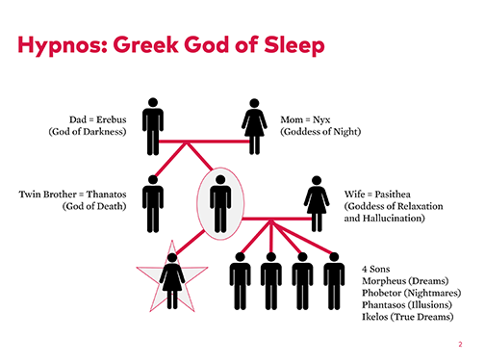

I chose Hypnos because I really like to sleep, and he seemed like an interesting god to find out more about. He is the son of Erebus and Nyx. He has a twin brother—the god of death. He has four sons—all gods of dreams. And for my narrative, he also has a daughter, whom you’ll learn more about shortly!
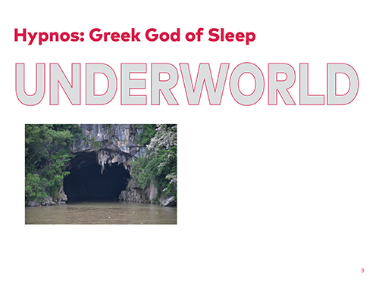

He lives in a cave in the underworld with his twin brother—in Erebus, where the River Lethe (which means forgetfulness) starts and where night and day meet. He can use sleep for good or for bad. He carries a poppy stem and a branch (or cup) with water from the River Lethe. He has wings sprouting from the sides of his head, near his temples, or sometimes shown near his eyebrows. He is thought to be a calm and gentle god, helping humans in need.

Shankar s. “A closer view of the cave entrance.” Photograph. Flickr. May 2017. Web. Used under CC BY 2.0.

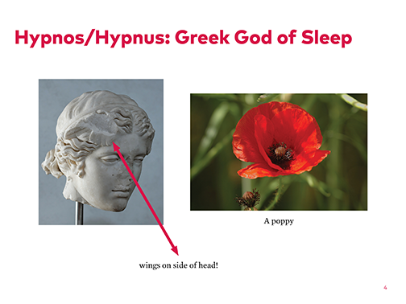

Here is a bust of Hypnos. If you look closely, you can see a wing on the side of his head. And here is an image of a poppy, Hypnos’s secret ingredient for putting people to sleep.

“Hypnos (Somnus).” Sculpture. c. 117-138. Villa Adriana in Tivoli. Wikimedia. Web. Public domain.
Gary Houston. “20050613-019-poppy.” Photograph. Wikimedia. 13 June 2005. Web. Used under CC0 1.0.

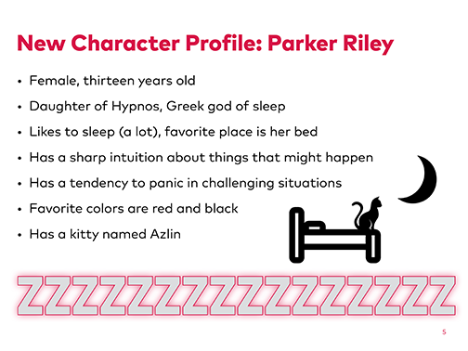

I based this character on myself and my own characteristics. I like all of the things that she likes, especially sleep! As I was writing the story I was thinking about how I might behave in that situation. A lot of what she experiences is what I would experience in the same situation, like panicking in challenging situations. Her kitty’s name is Azlin, which means a night vision or dream.
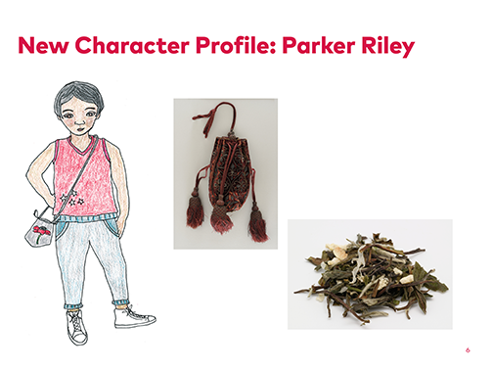

This is what Parker looks like: 5’6”, short black hair, athletic build, brown eyes. She likes to wear comfortable but modern, sporty clothing with high-top sneakers. She carries dried plants and flowers, ground into a powder that can be used quickly to induce sleep. She keeps these in a small drawstring bag.

Anna Loring for EL Education.
“Woman’s Purse LACMA M.91.165.” Textile. c. 1595. LA County Museum of Art. Web. Public domain.
Marie-Lan Nguyen. “Great Earl Grey Damann.” Photograph. Wikimedia. 24 Jan. 2013. Web. Used under CC BY 2.5.

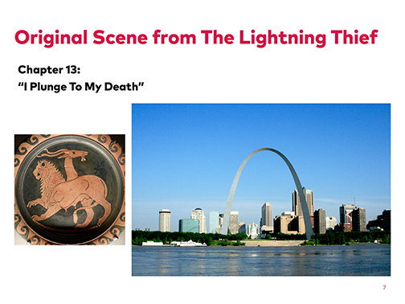
I chose this scene because I felt like what happened to all of the characters besides Percy was unresolved, so I realized that the powers my character has could be used to resolve this scene and maybe help Percy.
Echidna is the Mother of Monsters. Her son the Chimera has the head of a lion and the body of a giant goat. It has a serpent for a tail. Summary of scene:
- Annabeth wants to ride to the top of the Gateway Arch in St. Louis.
- They all go to the top of the arch.
- When they want to leave, Percy can’t fit into the elevator car going back down and so gets left at the top with some tourists.
- One of the tourists is actually Echidna and has the Chimera disguised as a Chihuahua.
- When Percy gets left behind, Echidna reveals herself, and the Chihuahua grows into the Chimera and attacks Percy.
- Percy tries to fight back but gets bitten by the venomous serpent tail and has to jump into the Mississippi River to escape.
- We never know the fate of the other characters in the scene . . .

Lampas Group. “Chimera.” Dish. 350-340 BCE. Louvre Museum, Paris. Wikimedia. Web. Public domain.
Jefferson National Expansion Memorial, NPS. “Gateway Arch as seen from East St. Louis, IL.” Photograph. Flickr. 12 June 2008. Web. Used under CC BY 2.0.

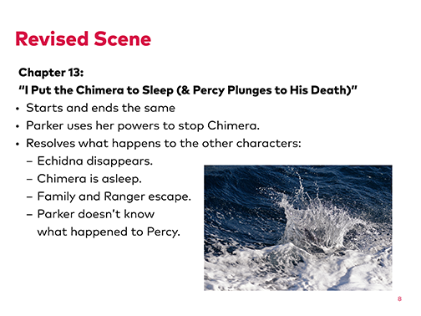

Read narrative.

Ed Dunens. “Common Dolphin.” Photograph. Flickr. 2 Apr. 2017. Web. Used under CC BY 2.0.


Copyright License
Except where otherwise noted, EL Education’s Language Arts Curriculum is published under a Creative Commons Attribution-NonCommercial 4.0 International (CC BY-NC 4.0) License. To view a copy of this license, visit https://creativecommons.org/licenses/by-nc/4.0/.

Licensed third party content noted as such in this curriculum is the property of the respective copyright owner. Responsibility for securing any necessary permissions as to such third party content rests with parties desiring to use such content. For example, certain third party content may not be reproduced or distributed (outside the scope of fair use) without additional permissions from the content owner and it is the responsibility of the person seeking to reproduce or distribute this curriculum to either secure those permissions or remove the applicable content before reproduction or distribution.

For more information, visit our Terms of Use at https://curriculum.eleducation.org/terms-of-use.

