MODULE LESSONS
Grade K: Module 1: Unit 2: Lesson 2
Reading and Discussion: Describing the Color and Size of Toys
Language Arts Curriculum

Toy Riddles, Pages 1–6
Pages 1–2
A classroom is full of so many toys!

Some are big, some are small,

Some have wheels, some build tall.

Do you know each one’s name?

Let’s play a little guessing game.

Toy Riddles, Pages 1–6
Page 3
What is brown and soft and always fun?

Toy Riddles, Pages 1–6
Page 4
I’m a teddy bear! I love to hug everyone.

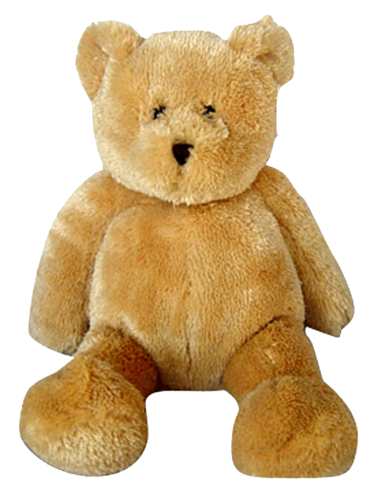

Toy Riddles, Pages 1–6
Page 5
What is colorful and small enough to fit into your hand?

Toy Riddles, Pages 1–6
Page 6
We are crayons! Use us to draw a fairy tale land.

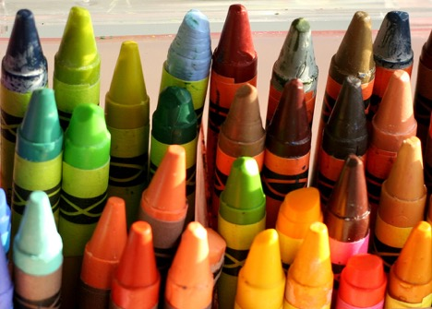

Attributes of Toys, pages 1–4
Page 1
Toys can be many colors. Look at the Lego pieces.
What colors do you see?

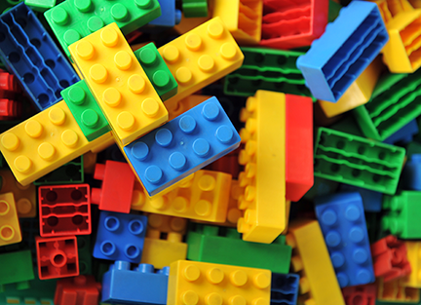

Attributes of Toys, pages 1–4
Page 2
Some colors look light, and other colors look dark.
Some are bright! Some toys have a pattern on them.
Polka dots, stripes, and plaid are all patterns.

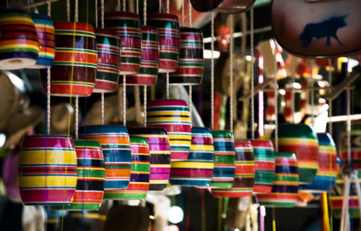

Attributes of Toys, pages 1–4
Page 3
Toys can be many sizes. Some toys are large, and some toys are small. If something is very small, it is tiny. Look at the dollhouse. There are many tiny pieces inside.

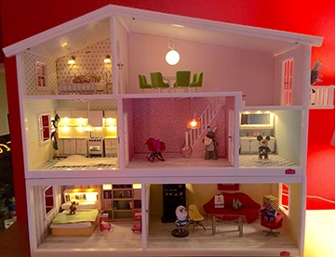

Attributes of Toys, pages 1–4
Page 4
If something is very large, it is gigantic! The teddy bear is as large as the door . . . a gigantic toy!

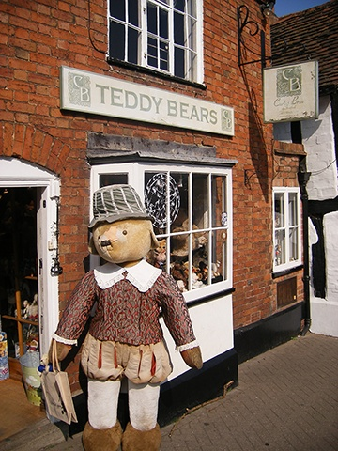
Color Cards
Note to Teachers: Print on cardstock, if possible, and cut out along the dotted line. One set is enough for a class to play the Attributes I Spy game.

Red | Orange | Yellow

Green | Blue | Purple

White | Brown | Black

Size Cards
Note to Teachers: Print on cardstock, if possible, and cut out along the dotted line. One set is enough for a class to play the I Spy game.

Big/Large | Little/Small


Tiny | Huge

Medium

Color Words Anchor Chart
(For Teacher Reference)

Color Words
(sample student responses)
Green
Yellow
Red
Blue
Black
Purple

Size Words Anchor Chart
(For Teacher Reference)

Size Words
(sample student responses)
Big
Little
Small
Huge

Image Credits
Matthew. “teddy bear 1.” Photograph. Flickr. 23 Feb 2009. Web. 9 June 2016.
Morgan, John. “Crayons.” Photograph. Flickr. 27 May 2008. Web. 9 June 2016.
Hxdbzxy. “Plastic toy blocks on white background.” Photograph. Shutterstock. n.d. Web. 9 June 2016.
De Troya, Eneas. “La mexicaneidad.” Photograph. Flickr. 9 May 2009. Web. 9 June 2016.
Ackerman, Sarah. “Lundby Dollhouse – Smaland.” Photograph. Flickr. 3 July 2015. Web. 9 June 2016.
Brown, Elliott. “Teddy Bears.” Photograph. Flickr. 3 April 2009. Web. 9 June 2016.

