Grade 4: Life Science Module
Lesson Sequence 6: Structures of Body Coverings
Life Science Module
Student Jigsaw Groups
(For Teacher Reference)
Directions: After familiarizing yourself with the body covering texts, use this chart to decide how best to group students for Jigsaw: Part 1 in Section 1. Because there are five students in each ecosystem expert group, intentionally create a pair of students who can work together in one of the body covering expert groups.
 | Body Covering Expert  Group 1  (Scales) | Body Covering Expert  Group 2  (Feathers) | Body Covering Expert  Group 3  (Fur) | Body Covering Expert  Group 4  (Exoskeleton)
Ecosystem Expert
Group 1
(Desert)
Ecosystem Expert Group 2
(Tundra)
Ecosystem Expert Group 3
(Grassland)
Ecosystem Expert Group 4
(Desert)
Ecosystem Expert Group 5
(Tundra)
Ecosystem Expert Group 6
(Grassland)
“Fun Fur Facts”
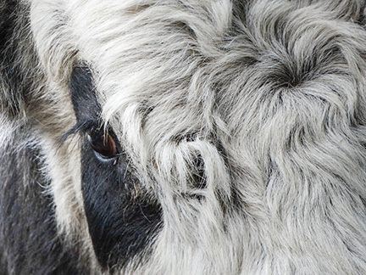
Slihto, Jevgenijs. “Domestic Yak close-up.” Photograph. 15 July 2015. Flickr. Web. 5 Feb 2016.
Do you know what makes a mammal a mammal? One of the things is hair. Hair is closely related to fingernails, snake scales, and feathers because all are made of keratin. Hair does a number of things for mammals. It protects the skin from sun and scrapes, sends sensory messages to the brain, and provides insulation from cold and heat. The shape of hair also gives a mammal a unique look with its different shapes: Round hairs tend to be straight, and oval or flattened hairs are curly.

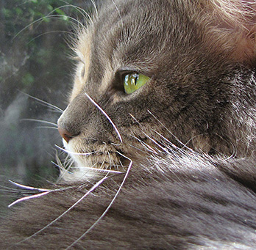
Images from: Hamme, Trish. “Wacky Whiskers.” Photograph. 18 Aug 2014. Flickr. Web. 5 Feb 2016.

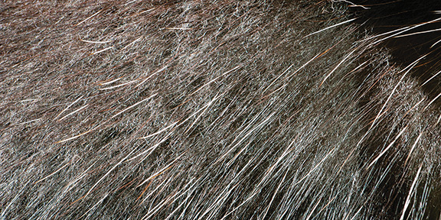
Kuchera, Holly. “Porcupine Quills.” Photograph. 12 April 2011. Flickr. Web. 5 Feb 2016
Hair Types
Not all hair is the same. If you have a dog or cat at home, take a close look and see if you can find these different types of hair:
- Guard hairs are the ones most obvious to see. They are protective, or “guard,” outer hairs of a mammal’s coat. They are typically firm and glossy. Some hairs grow to a particular length and stop; others grow continually, like human head hair, horse manes, and the quills of a porcupine.
- Whiskers are stiff hairs, usually long, with many nerves at their base. They are extremely sensitive to touch. These hairs give the mammal clues about its immediate surroundings. Facial whiskers are most familiar, but they also appear in other places on a mammal’s body, such as on the ankles of a squirrel or the rump of some crevice-roosting bats.
- Underhairs are short, curly, wooly, and are called down or fuzz. Insulation is the most important role of these hairs. Special glands secrete oil to waterproof the skin and hair. Deer have hollow hairs in winter, which provides more warmth.
Coats of Color
Pigments in the inner layers of hair filter harmful ultraviolet radiation just like sunscreen, and may help regulate body temperature. Dark hairs absorb heat, warming an animal, while light colors reflect sun, keeping an animal cooler.
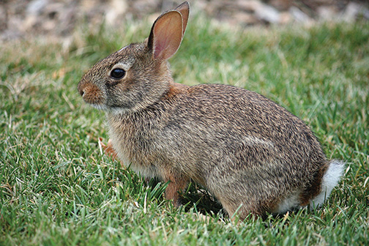

Hinnosaar, Marit & Toomas. “Eastern Cottontail.” Photograph. 1 Aug 2009. Flickr. Web. 5 Feb 2016.

Hair color helps camouflage animals from predators or prey by matching the environment they live in. Some northern animals, like the snowshoe hare, alternate between brown and white as the seasons change in order to be concealed against their surroundings. Patterns in the hair or fur also help protect mammals. Think of a fawn’s spots, which help hide it from predators. Color can also provide a warning, like a skunk’s stripe—which announces the presence of an especially good and stinky defense system. The under-color of a white-tailed deer’s tail serves as a flag to warn other deer of danger. Hair can also communicate social information about a mammal’s state of mind, such as the hair standing up on the back of a wolf or dog, which indicates that it feels threatened or is ready to attack. And, in the case of the porcupine and its quills, hair can provide protection from predators.

Adapted from Wisconsin Department of Natural Resources. “Fun Fur Facts.” EEK! Environmental Education for Kids. Web. 5 Feb 2016.

“Flights of Fantasy”
Almost everyone has wished at one time or another to be able to fly like a bird. Just the thought of soaring above your city or town without any mechanical device gives us a reason to envy these feathered animals.
So why can’t humans fly, and what makes birds so special that they are able to take to the air without needing a plane or a glider? The basic answer is birds have feathers and also bones that are hollow, making them light and still strong. But there is more to the story of feathers than just flying. In fact, bird feathers have a lot of different uses.
Not Just for Flying?
While feathers are needed to fly, they also have a lot of other uses. Not all birds use their feathers in the same way, but as a group they use their feathers in many creative and interesting ways.
Types of Feathers
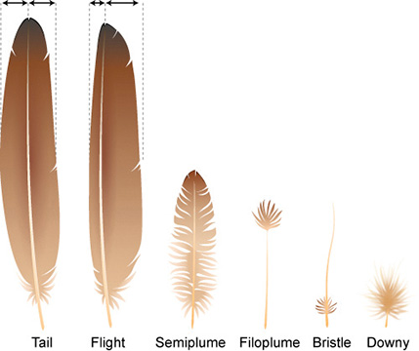
Because feathers do so many jobs, there needs to be more than one type of feather. Some of them are long and strong for flying and steering. Others are soft and fuzzy. These feathers are very good for keeping the bird warm. In fact, we have learned to use these soft feathers in our clothing and bedding to help keep us warm too. You might have had a down comforter on your bed or worn a down jacket when it is cold outside. These are things that are filled with soft, downy feathers.
If you look at the different feather types above, you will see that they come in many shapes and sizes. The types we see the most often are tail and flight feathers (also called veined or contour feathers). At first look, they may seem the same, but actually they are different. Tail feathers are balanced left and right of the center.
Flight feathers have a wider and narrower side. This makes them better for flying because they can cut through the air with very little resistance (also called drag).
Other types of feathers are made for use on the body of the bird. The downy feathers are good for warmth. Semiplume feathers also help to keep birds warm and they help water birds float. The bristle feathers are found around the eyes and nostrils, and for some birds that like to catch flying insects they can be seen around their mouths. Filoplume (file-o-ploom) feathers can be found around the tail and flight feathers. They are thought to be used to sense when the flight feathers need to be maintained.
No matter what type of feather, they all have similar parts. Below is a drawing showing all the parts that you might find on a feather. Not all feathers have all the parts. For example, downy feathers are missing the stiff barbs and vane. You will also see that flight feathers have very little or no downy barbs.
Flying
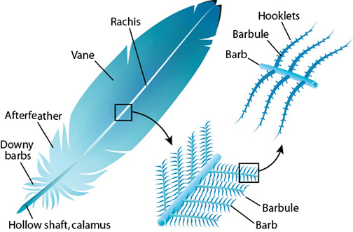
Flight feathers are very strong and stiff feathers that are found on the wings of birds.
Help Keep Them Warm
Downy feathers as well as semiplume feathers are able to trap pockets of air close to the bird’s body to help keep it warm. How much body heat they keep can be adjusted by arranging their feathers to trap more or less air. If you see birds fluffing their feathers in the cold, that is their way of adding extra air to trap body heat and stay warmer.
Controlling Body Temperature
To keep body temperature steady, birds can either expose their heads and feet to the air or water to cool down, or tuck them into their feathers to help keep warm.
Protection from Wind, Moisture, and Sun
The strong and ridged contour feathers shield birds from wind. The tough material they are made from, beta keratin, is water and wear resistant. Darker-colored feathers might also provide protection from the sun. Feathers also work to keep water out, keeping birds dry in the rain. The interlocking feather barbs and a special coating that is either oily or waxy create a shield that water runs off of.
Swimming and Diving
Some birds use their half-spread out wings in a flying motion to swim in water. Penguins have developed their wings into stiff, flat flippers that make them great swimmers.
Floating
Using the trapped air in downy feathers, water birds like ducks can float on water as well as add protection from cold water.
Aiding Digestion
Some fish-eating birds also eat their own feathers to line their digestive area. This helps to protect the bird from sharp fish bones.
Constructing Nests
Many birds (especially water birds) line their nests with bird feathers. This helps to keep their eggs warm and also provides a soft padding. Some birds like parakeets actually use the feathers located on their bottom and lower back to move grass and leaves to their nest.
Transporting Water
When raising eggs and baby chicks, many adult birds will soak the feathers on their belly before returning to the nest. They can then use the water to keep the eggs from drying out and to give their chicks a drink. Some birds that live in the desert (like the sandgrouse) have special belly feathers that are very good at holding water. This adaptation lets them nest further away from water holes, to avoid the higher numbers of predators found in areas near water holes.
Escaping from Predators
When birds are attacked or frightened, they can drop some of their tail feathers. This is called fright molt. This sometimes helps the bird get away, leaving the attacker with only a mouth or foot full of feathers.
Sending Visual Signals
Feather colors and patterns are used to send signals to mates and rivals. This is likely the largest and most used function of feathers.
Camouflage
Sometimes bright colors are not good. To keep from being seen by predators, many birds have feathers that look like dead leaves or other parts of the surroundings they live in so that predators cannot see them. Some predators also like to blend in so that their prey may come closer, making the prey easier to catch.
Adapted from Kazilek, CJ. “Feather Biology.” Illus. Sabine Deviche. Ask a Biologist. ASU School of Life Sciences. Web. 5 Feb 2016.

“Scales: Coats of Armor”
Do you know that all animals need some type of body covering to help them survive? Humans have skin. Other animals have fur, scales, or feathers. These different body coverings all have some similar functions. They help protect animals from disease, injury, and changes in temperature. Some body coverings serve other purposes. Bright colors or fancy markings may attract mates, camouflage an animal, or send warning signals. Let’s learn more about one of these body coverings—scales.
What Are Scales?
Scales are thin, flat, strong, and sometimes bony plates that cover the bodies of reptiles and fish. Even some insects and birds have scales. They vary in size, shape, and color. Some scales are very large. Others are almost too small to be seen with the human eye. Scales are made from a hard, flexible material called keratin. Parts of your body are actually made with keratin. One part in particular is similar to the scales on animals. Can you guess what it is? You can find the answer at the end of this article.
A Protective “Coat” for Fish
The scales on fish overlap to make a sturdy coat of armor. This coat protects the soft skin underneath. Different fish, however, have different types of scales. Some scales are smooth with rounded edges. Others, like the scales of sharks, are small and tooth-like in shape. Sharks scales are very rough. They can even injure an animal that brushes up against them. Petting sharks is certainly not a good idea!
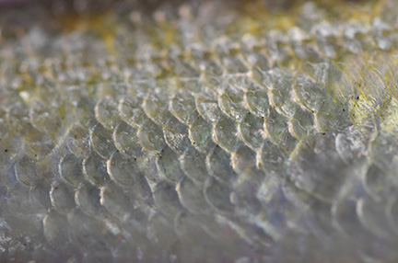
USFWSmidwest. “Bloater Scales.” Photograph. 21 Jan 2015. Flickr. Web. 5 Feb 2016.

Larger scales provide the most protection for fish, but they make it difficult for the fish to move quickly. Smaller, lighter scales are more flexible but less dependable for protection. This difference in scale size can be a clue about where a fish lives. Fish living in fast-flowing waters need to swim quickly. They often have smaller scales. Those living in slow-moving water with less need for speed usually have larger scales.
Looking closely at scales may allow us to learn more about an animal. Some people believe that the growth rings on the scales of fish are similar to the rings within a tree trunk. These can be counted to find the age of some fish.
Some fish scales are covered with “slime.” This thin layer of mucus allows fish to glide through the water. The mucus layer also helps prevent disease. How do you think it would feel to swim through the water with a covering of slime on your body?
Reptiles: Scales and Scutes
How many reptiles can you name? There are a lot! Turtles, alligators, crocodiles, snakes, and lizards are all reptiles. Even though they do not look the same, they have something in common: All reptiles have scales.
The scales of reptiles are strong, hard, and provide protection. This makes them similar to the scales on fish. The scales on reptiles, however, are not covered with mucus. They are dry. These scales help keep moisture inside the bodies of reptiles. This is an important function of scales for animals in dry places. Reptiles need water just like you do. Without the protective layer of scales, reptiles would dry out and die.
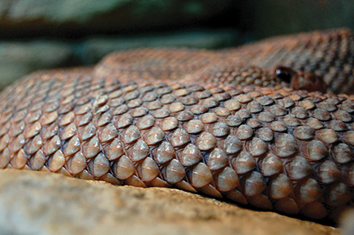
Minars, Kelley. “1413 – Scales.” Photograph. 4 April 2009. Flickr. Web. 5 Feb 2016.

Reptile scales come in a variety of colors, shapes, and sizes. They cannot be separated from the reptiles’ skin—the scales are actually the outer layer of skin. This layer is shed and replaced from time to time. Some reptiles, like snakes, lose all of their skin in one full piece. Why does that happen? The snake’s body grows throughout its lifetime, but its skin does not grow. This is like wearing clothes that are too small. Rather than changing clothes, snakes simply grow a new layer of skin under the old one. Because younger reptiles are still growing, they shed their scales more often than older reptiles. Look closely the next time you are in the woods. Maybe you will be lucky enough to find skin shed from a snake!
Scales are extremely important to snakes. A body covering of scales allows snakes to move along rough surfaces, hot desert sand, and jagged rocks. Rough scales on their bellies help them grip branches. Snakes even have spectacle scales. “Spectacles” is another word for glasses. Do you think this means snakes wear glasses? Of course not! Spectacle scales are clear scales that can cover the snake’s eyes. Because snakes don’t have eyelids, this specialized scale helps protect their eyes.
Although scales overlap for most reptiles, the scales on crocodiles are a little different. Their scales are hard, bony, and can be quite big. These scales are called scutes. The smaller ones on the crocodile’s side allow for fast, flexible movements. The biggest scutes are on the back of the crocodile. Scientists think these scutes are big because the crocodile’s back gets the most sun. The large scutes create a waterproof seal so water cannot escape from the crocodile’s body. This is an adaptation that allows crocodiles to survive in hot places where water evaporates quickly.
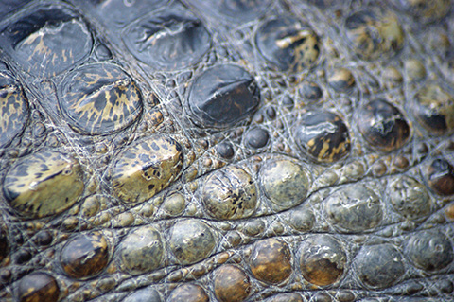
Wright, Spencer. “Spectacled Caiman (Caiman crocodilus) Study.”
Photograph. 16 Sept 2011. Flickr. Web. 17 Feb 2016.
Turtles are lucky. They carry their body armor on their back! Their tough shells are made up of bones and scales. This makes their shells very strong. Similar to the crocodile’s scales, their scales are called scutes and do not overlap. Turtles do not have teeth like crocodiles, though. Instead, they have a powerful beak. Their beak is actually made from specialized scales. Scientists think that the width of rings on scutes may tell us how well an animal has eaten. When there is a lot of food, the scales grow quickly. The ring would be thick. When there is a lack of food, growth slows down. The ring would be thin. The type of food that turtles eat may also affect the growth of these rings. Some people even think the turtle’s age can be determined by counting the rings. Not everyone agrees. What do you think? How could you test if your guess was correct?

Hint: Our fingernails are also made of keratin!
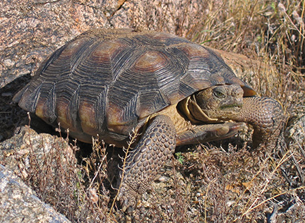
USFWS Southwest Region. “Sonoran Desert Tortoise.” Flickr. 9 April 2004.
https://www.flickr.com/photos/usfws_southwest/5257640897/
Written by Pat Fitzsimmons for EL Education

“Animals with Skeletons on the Outside:
The Exoskeleton”
You have probably noticed all the different kinds of body coverings that animals have. Fur, feathers, and scales cover the bodies of vertebrates like mammals, fish, and reptiles. Invertebrates have a body covering, too. It is called an exoskeleton. The prefix “exo” means “outside,” and so exoskeleton means “skeleton on the outside.” You have an endoskeleton. “Endo” means “inside.” An exoskeleton is a hard covering on the outside of many types of animals, like insects, spiders, centipedes, and snails.
How Does an Exoskeleton Provide Protection?
Exoskeletons are very strong and tough. They are up to six times stronger than a tendon! This strong body covering protects the soft bodies inside from other animals trying to eat them.
The hard body covering often grows in segments, or smaller parts. This allows animals with exoskeletons to move in unique ways, like curling up to protect themselves. Think about a centipede. Because its body is segmented, it can roll up, as seen here.
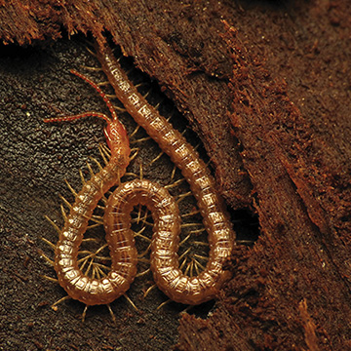
Schulz, Katja. “Soil Centipede.” Photograph. 11 July 2015. Flickr. Web. 5 Feb 2016
Another great way an exoskeleton can provide protection is because of its shape. Animals with exoskeletons have unique shapes. Sometimes the hard skeleton on the outside grows into a shape that camouflages the animal or helps it blend into its environment, like this stick insect and leaf bug.
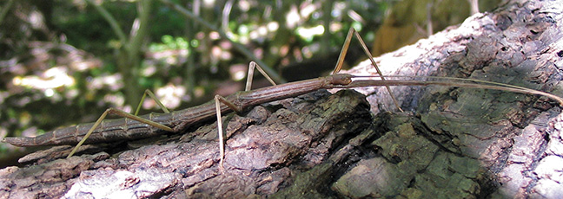
Zen, Dan. “Stick Bug 2.” Photograph. 29 Sept 2005. Flickr. Web. 5 Feb 2016.

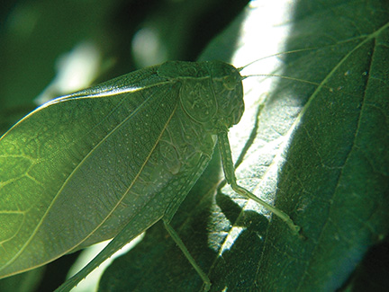
Amanda. “Bug Eyes.” Photograph. 28 Aug 2008. Flickr. Web. 5 Feb 2016.
Animals with exoskeletons don’t always try to camouflage themselves. Sometimes they have bright colors to warn predators that they are poisonous.

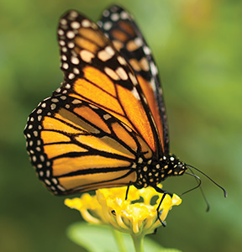 | Another coloring of the exoskeleton that helps protect the animal are things like eye spots. These spots look like eyes, but they are not eyes. They are just colors that look like eyes to trick predators into thinking that they are bigger animals than they really are!  The Exoskeleton and the Environment  The exoskeleton does more than just help the animal stay protected. It also helps the animal control how much water is going in and out. The hard skeleton on the outside keeps water in to keep the animal healthy and hydrated. The exoskeleton also controls too much water from the surroundings from entering the animal, much like our skin protects us from water entering our bodies.  But an exoskeleton can also be hot. Invertebrates with exoskeletons have many ways to control their body heat. Most of the time, they behave in a certain way, or do something to control their body heat. For example, lots of worker honeybees will flap their wings at the same time in a beehive to keep the hive cool. It makes it feel like someone turned on a fan! If it’s cold, the exoskeleton doesn’t provide much heat. So some insects, like butterflies, will rest in the sun to warm up. They spread out their wings to absorb the sun’s warm rays. Then they will fly away.
Warby, William. “Monarch Butterfly.”
Photograph. 5 Nov 2012. Flickr. Web.
5 Feb 2016.
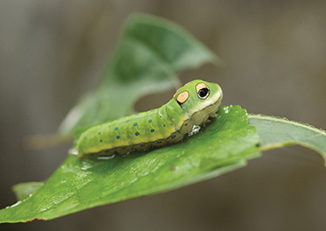
U.S. Fish and Wildlife Service Headquarters. “spicebush swallowtail caterpillar.”
Photograph. 6 Sept 2008. Flickr.
Web. 5 Feb 2016.
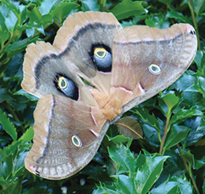
Sarah. “Antheraea Polyphemus.”
Photograph. 27 June 2008. Flickr. Web.
5 Feb 2016.

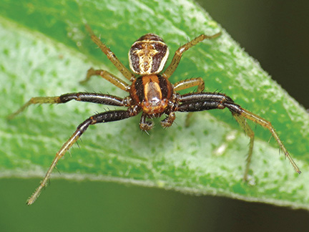 | Exoskeletons are amazing animal body coverings. Check out the pictures to think about the different ways exoskeletons provide protection, camouflage, and control water and heat.  Spiders have exoskeletons, too. Imagine a spider trapping a wasp. The wasp would have a hard time getting its stinger through the hard exoskeleton.
Cooper, Martin. “Crab Spider (Xysticus sp).”
Photograph. 8 May 2015. Flickr. Web. 5 Feb 2016.
You can imagine a snail curling back into its shell for protection.
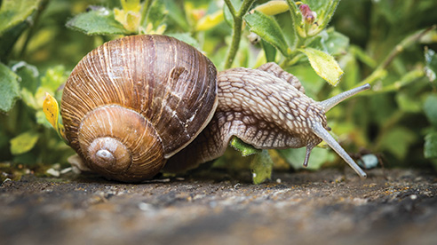
Sandrine Neel. “Je Te Vois.” Flickr.  8 May 2017. | Many invertebrates have modified (slightly changed) exoskeletons that help them survive, like the pincers on this earwig. Don’t worry! They only use their pincers when fighting other earwigs!  Written by Jessica Kauffman for EL Education
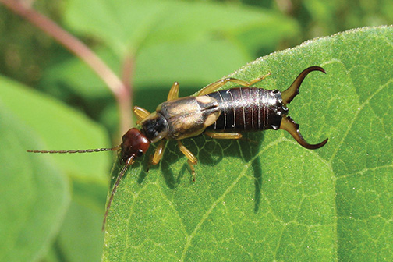
Gonthier, Giles. “Forficula auricularia.”
Photograph. 6 Nov 2007. Flickr. Web. 5 Feb 2016.

Scientists Do These Things Anchor Chart
Scientists Do These Things anchor chart
Engaging in Argument  What’s needed for a scientific argument?  Preparing for the argument:  - Pose the question.  - Identify evidence that answers the question.  - Evaluate whether or not that evidence is sufficient to support the claim. “Is this good evidence?”  Making the argument:  - Make a claim.  I’m arguing that…  - Use the evidence and scientific reasoning to support the claim.  The evidence I have is…  This evidence shows...  - Explain why the evidence is sufficient and relevant.  This evidence is sufficient because… | Modeling  - A model has limitations because it is used to study one part of a system or object while not paying attention to other parts.  - A model can be a drawing or diagram, a physical replica, or a simulation. | Planning an Investigation:  - Pose a question that can be investigated with trials.  - Decide what can be changed (variables).  - Set up the procedure.  - Record observations.

Scientists Do These Things anchor chart
Example:  Ecosystem and organism argument  Example:  Body covering in my ecosystem argument | Example:  Obtaining food simulation  Explanatory model of chicken wing:  - All important parts of the system are labeled  - Explains how the parts work together  - Does not show parts that are not important to movement (example: doesn’t show mouthparts) | Example:  Earthworm investigation
Concepts Scientists Think About Anchor Chart
Concepts Scientists Think About
Systems | Cause and Effect
Definition:  A set of different parts that work together | Definition:  Studying the relationship between the actions or events of at least two things.
Examples:  Human Body:  Feet work with the legs to help a body move.  Ecosystem:  Plants use water to survive well.  Animals eat plants to survive well.  Nervous System  Musculoskeletal System | There is a relationship between getting enough food and surviving well.  There is a relationship between having a body covering that functions correctly for the ecosystem the animal lives in and the animal’s ability to survive well.

