MODULE LESSONS
Grade 1: Module 1: Unit 1: Lesson 6
Speaking and Listening: Why Do We Need Tools?
Language Arts Curriculum
Sorting Protocol Anchor Chart
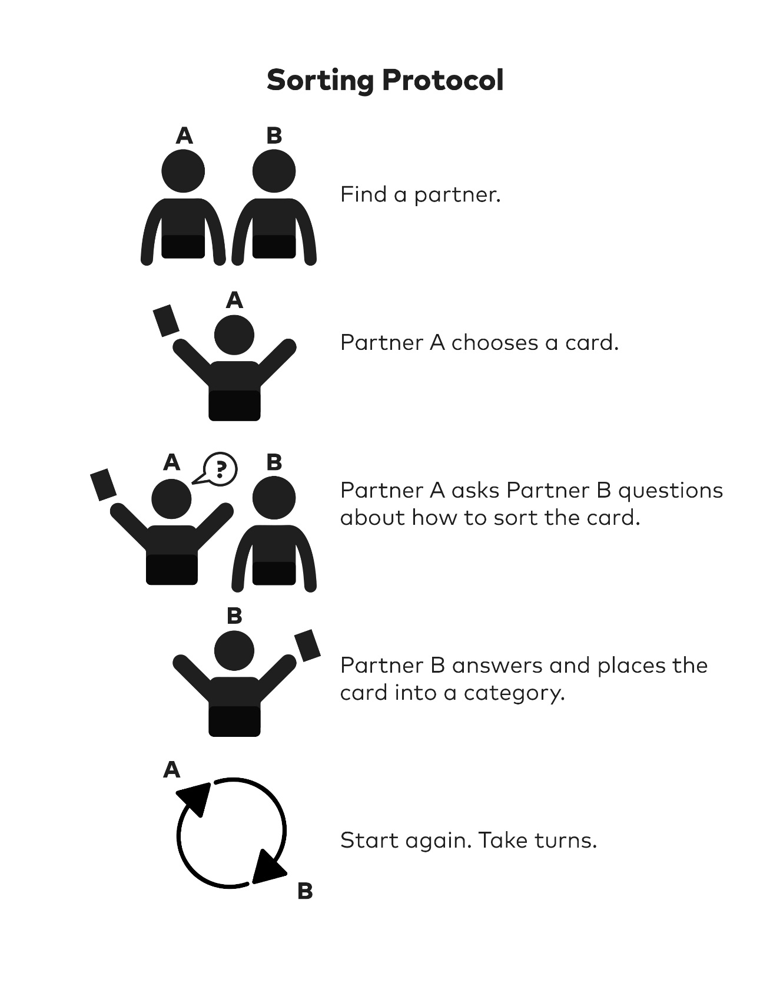

Types of Tools, Picture Set 1

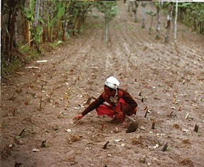

Types of Tools, Picture Set 1

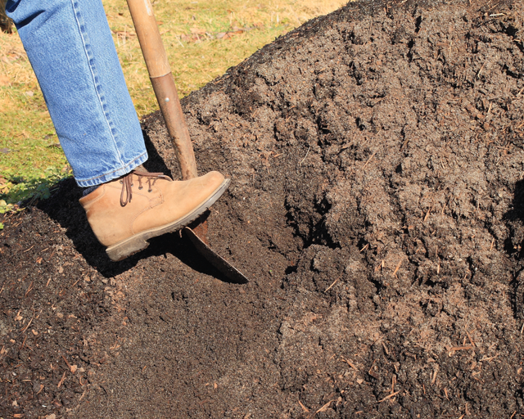

Cutting/Farming Tools
Model Response Sheet
(For Teacher Reference)
Name: __________________________ Date: ______________
Cutting Tools
Labeled: Razor
Example Sentence: The razor helps the man shave.
Farming Tools
Labeled: Hoe
Example Sentence: The woman uses a hoe to farm crops.

Cutting/Farming Tools
Model Response Sheet
Name: __________________________ Date: ______________
Cutting Tools
Farming Tools

Image Credits
Images from Tools, copyright (c) 1992 by Ann Morris. Photographs copyright (c) 1992 by Ken Heyman. Used by permission of HarperCollins Publishers.
m01229. "Cutting wrapping paper with scissors." Photograph. Flickr. 14 December 2013.

“Stock photo of ‘woman wearing denims and workbooks, digging in a pile of topsoil’.” Photograph. Shutterstock. Web. June 2017.

Images from Tools, copyright (c) 1992 by Ann Morris. Photographs copyright (c) 1992 by Ken Heyman. Used by permission of HarperCollins Publishers.

